the Big Knit 2018-19
Reindeer Hat
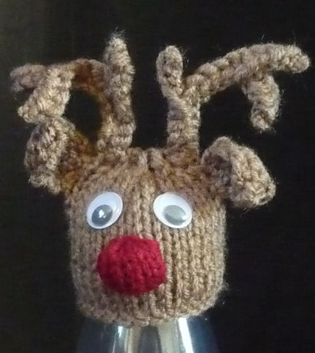
Head
Using 4mm needles cast on 28 in brown
Start with a K row and SS 14 rows.
(K2 tog) repeat to end
(P2 tog) repeat to end. B & T tightly
Ears (x2)
Cast on 4 in brown
Row 1: inc, K2, inc
Beg with a purl row, SS 4 rows
Row 6: P2, P2tog, P2
Row 7: K2, K2tog, K1
Row 8: P2tog, P2 tog
Row 9: K2tog. B & T tightly
Nose
Cast on 4 in red
Inc in every stitch Starting with a P row, SS 5 rows
(K2tog) repeat to end. Cast off
Antlers (x2)
Start casting on 1 metre from the end of the wool you are going to use. You need a long end to make the antlers and will gradually use it up as the antlers are formed.
Using 4mm needles cast on 15 in brown using the thumb method. With both ends of the wool cast off 4
Cast off the next stitch with one end of wool. Transfer this stitch back to the main needle with the other stitches.
Cast on 5 more stitches using your thumb. With both ends of the wool cast off 9
Cast off the next stitch with one end of wool. Transfer this stitch back to the main needle with the other stitches.
Cast on 5 more stitches using your thumb. With both ends of the wool cast off the last remaining 10 stitches.
Fingers crossed ...... you should end up with an antler!!

Making Up:
Sew the row ends of the head. Attach the antlers as illustrated. Sew the cast on edge of the ears to the head and pull up the outside edge of the ear to give it some form. Gather around the edge of the nose, fill with a few wool ends and sew to the face as illustrated. Finish with some googly eyes.
Please send your completed hats to:
Age UK Herefordshire & Worcestershire, Malvern Gate, Bromwich Road, Worcester, WR2 4BN (and include a reply name and address)
THANK YOU!

