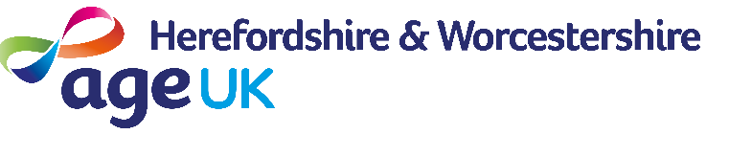
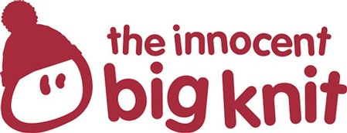

the Big Knit 2018-19
Robin Hat
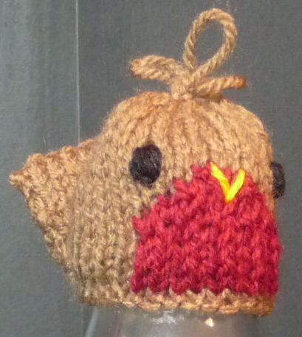
Head
Using 4mm needles
Cast on 28 in brown
Row 1: K9 in brown, K10 in red, K9 in brown
Rows 2 - 5: 9 brown, 10 red, 9 brown in SS
Row 6: P10 in brown, P8 in red, P10 brown
Row 7: K11 in brown, K6 in red, K11 brown
Row 8: P12 in brown, P4 in red, P12 brown
Work 6 more rows in brown SS
Next row: (K2 tog) repeat to end
Next row: (P2 tog) repeat to end
B&T tightly
Tail
Cast on 4
Starting with a K row, SS 2 rows
Next row: Knit 1, inc, inc, Knit 1
SS 6 rows then P3 rows then SS 6 rows
Knit 1, K2tog, K2tog, Knit 1
SS 2 rows
Cast off
Sew up the row ends of the head. Create three loops on top of the head and secure. Work the face as illustrated using wool. Fold tail in half, oversew row ends and attach to back of bird.
http://www.thebigknit.devonartist.co.uk/Robin.html
Please send your completed hats to:
Age UK Herefordshire & Worcestershire, Malvern Gate, Bromwich Road, Worcester, WR2 4BN (and include a reply name and address)
THANK YOU!

