the Big Knit 2018-19
Snowflake Hat
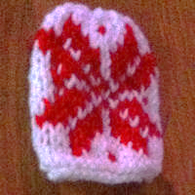
By Mandy Lee
With white cast on 28 stitches in background colour and Knit 2 rows
Follow the chart below - working from the bottom up.
Knit odd rows and Purl even rows
Row 18: Purl
Row 19: K2tog to end.
Row 20: P2tog to end. B&T
Making Up
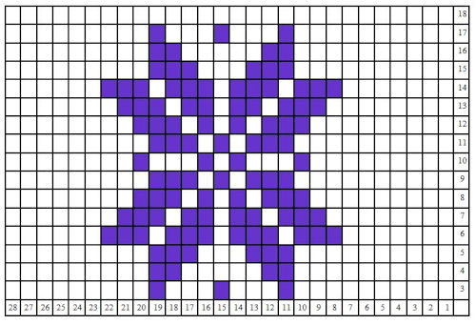
Sew in thread ends and back seam.

http://www.thebigknit.devonartist.co.uk/YourPatterns/Snowflake.html

Please send your completed hats to:
Age UK Herefordshire & Worcestershire, Malvern Gate, Bromwich Road, Worcester, WR2 4BN (and include a reply name and address)
THANK YOU!

