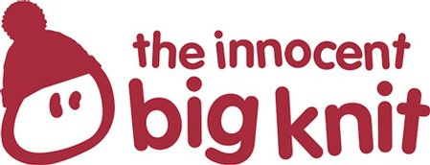

the Big Knit
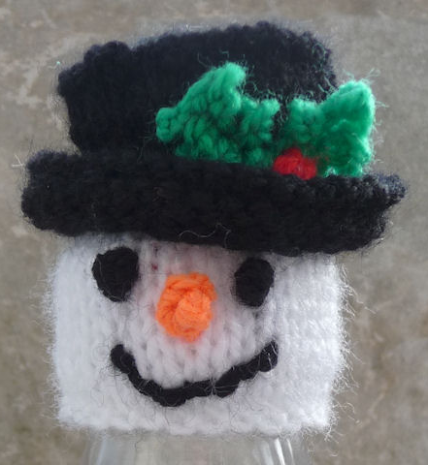
Snowman Hat
Face and Top of Hat
Cast on 28 in white, beg with a K row SS 9 rows
Change to black and SS 5 rows
Next Row: (K6, inc) repeat to end
Next Row: Purl
Next Row: (K7, inc) repeat to end
Knit next 2 rows.
Next Row: (P1, P2tog) repeat to end
Next Row: (K1, K2tog) repeat to end
Next Row: Purl
Next Row: (K2tog) repeat to end
B&T tightly
Brim of Hat
Cast on 45 in black and P 2 rows. K the next row.
(P1, P2tog) repeat to end
Holly
Work 2 holly leaves as detailed in the Pudding pattern
Making Up: It is easier to do in the following order!
1. Using 40cm of yarn doubled in needle work 2 French knots for the eyes winding the wool 4 times, and embroider a mouth.
2. Use 30cm of orange yarn doubled over in the needle for the nose - I did a French Knot with 4 winds of the wool with a second knot on top with three winds of the wool.
3. Sew the holly to the hat and work 3 French Knots using 50cm red wool doubled over.
4. Now sew the brim on to the snowman's head, before joining the row ends of the head.
5. Finally turn the head right side out and oversew the row ends of the hat.
http://www.thebigknit.devonartist.co.uk/Snowman.html
Please send your completed hats to:
Age UK Herefordshire & Worcestershire, Malvern Gate, Bromwich Road, Worcester, WR2 4BN (and include a reply name and address)
THANK YOU!

