
WINTER WELFARE REFERRAL FORM
Please complete all parts of this referral including the demographic information.
(This is a free service funded by Hertfordshire County Council under the Household Support Fund).
Client Details
Title:

First Name:

Surname:

Address (including postcode):

Telephone Number:
Does the client live alone? | Yes No
Has the client consented to this referral? | Yes No
D.O.B:
Ethnicity: (see codes below)
Does the client suffer from mental ill health or memory loss? * | Yes No
Does the client have any hearing or sight impairment or a physical disability? | Yes No
Does the client have any alcohol &/or drug issues? * | Yes No
If anyone else is likely to be in the property, do they have a mental &/or physical health disability, drink &/or drug issue? * | Yes No
Is the client a smoker? | Yes No
Are there any animals on the premises? | Yes No
If the answer is yes to any of the above marked * please supply further information:

NOK Details
Title:

First Name:

Surname:

Address (including postcode):

Telephone Number:
Reason for referral (please see images below for info on available items)
Draught excluder “P” Strips
Radiator reflector strip
Energy Efficient Light bulbs – only 1 type – screw-in or bayonet
Electric blanket
Winter Duvet – single.
Night lights
Electric Heaters – oil filled type – will need HP to set up.
Any other information that you feel may be useful, please enter it here:

Referrers Details
Name
Contact Details
Date of referral

Please email the completed referral form (password protected) with the subject heading WWC : HPG@ageukherts.org.uk

W1 White British
W2 White Irish
W3 White other
A1 Asian/Asian British/Bangladeshi
A2 Asian/Asian British/Indian
A3 Asian/Asian British/Pakistani
A4 Asian/Asian British/ any other
B1 Black or Black British African
B2 Black or Black British Caribbean
B3 Black British any other background
1 Chinese
3 Traveller
2 Other Ethnic Groups

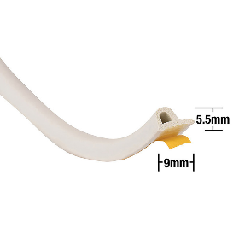

P-Strip draught excluder. Applied between a door / window and frame

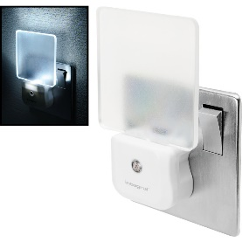 Plug in night light.
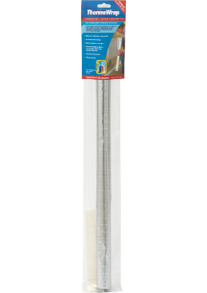

Radiator reflector.

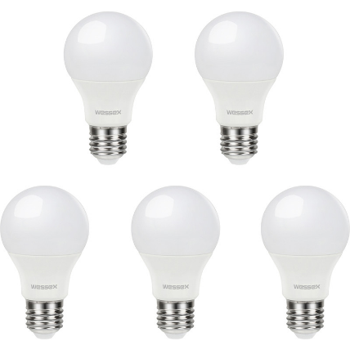

Screw in LED bulbs.

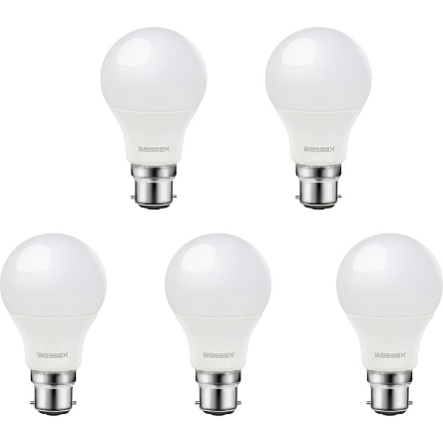

Bayonet LED bulbs.

(These are all subject to change depending on their availability throughout the duration of the scheme. Age UK Hertfordshire can only advise residents based on current government guidelines as published. For example, “consider turning down the thermostat by a degree” or “consider turning down or off radiators in rooms you don’t use”. We cannot replace the expertise of a Gas safe engineer, plumber or other trade professionals and as such where specific situations or questions arise, we may refer the resident to contact a professional trade).
Correct at the time of launch 26/10/2025.
For HP&G office use only.  Do you consent to us holding your information?  Consent for I&A audit?  Consent for external referral to third parties? | Yes No  Yes No  Yes No

