Exercises for over 70s in self-isolation by Nuffield Health

Chair squats (sit to stand)

To strengthen the muscles of the lower body, bones and joints
- Stand in front of a chair with your feet as far apart as your hips
- Bend your knees while keeping your shoulders and chest upright
- Lower your bottom slowly (4 seconds) so you sit down
- Then push your body back up to return to a standing position (2-4 seconds)
- Try to avoid using your hands
- Perform this 5-10 times or for a duration of 20-60 seconds, take a rest after for 40-60 seconds
- Repeat this action 2-5 times.

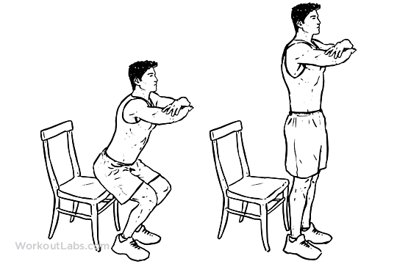

The stork (single leg stands)

To improve balance and bone strength
- Stand facing a non-moveable chair or surface for support if you need it
- Warm up with a slow march for 1 minute, gradually raising your knees higher
- With your arms at your side, slowly lift your left foot and balance on your right foot for 10 seconds
- Slowly lower your left foot and repeat with your right foot
- Aim to build up the duration by 5 seconds each time as you feel more comfortable
- To increase difficulty, try raising your hand above your head on the same side or slowly swinging your arms like you’re running
- Repeat on both legs 3-5 times each.

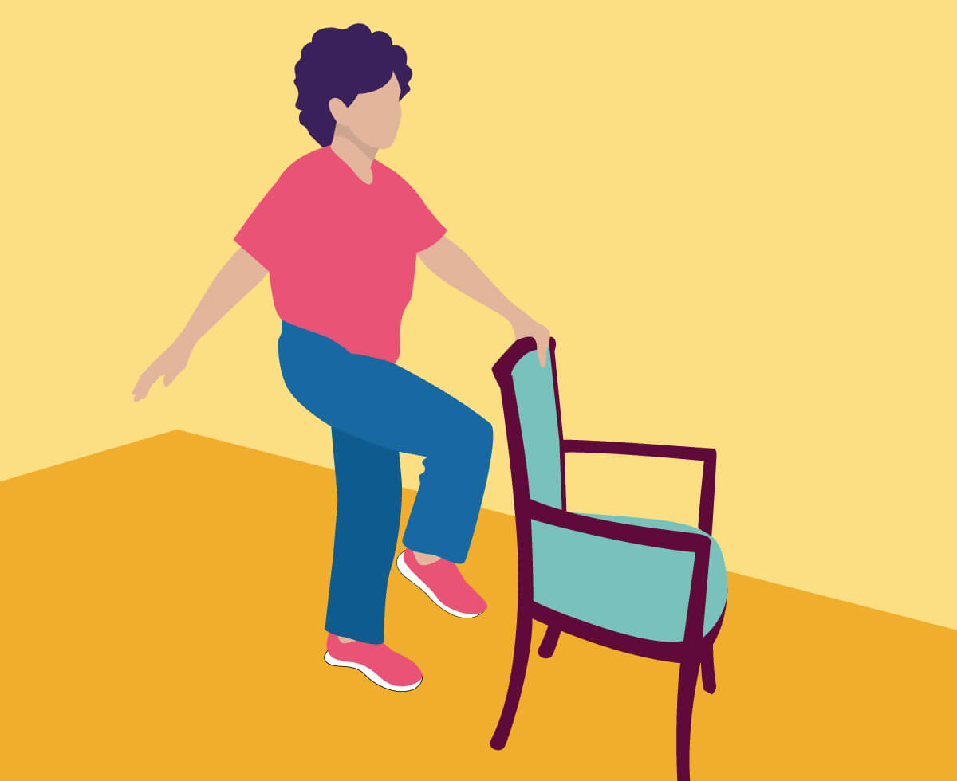

Wall snow angels

To improve mobility, posture and strength
- Stand with your upper back, head, bum and heels against the wall
- Start with your hands out to the side with your palms facing outwards
- Whilst maintaining contact with the wall, slowly raise your hands above your head, stretching as wide and as high as possible
- Slowly return to your starting position and then repeat – aim to complete 5-10 times
- Perform this 2-3 times, take a break for 40-60 seconds before repeating again.

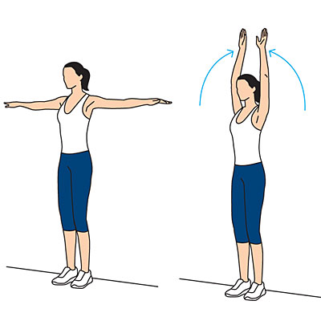

Rotations

To improve upper body and back mobility
- Holding a stick or broom horizontally behind your head, stand with your feet hip width apart and your knees slightly bent or sit on a chair.
- If you don’t have a broom, put your hands on your shoulders keeping your arms at 90 degrees
- Keeping the broom straight, turn to your right as far as comfortable, twisting through your hips
- Then slowly turn to the other side, building up your range of movement
- Repeat 10-20 times
- Perform this 2-5 times, take a break for 40-60 seconds before repeating again.

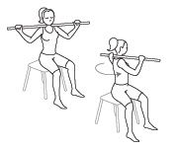

Wall push-ups

To maintain upper body strength and bone mineral density
- Stand at arm’s length in front of a wall which is safe
- Lean forward slightly and put your palms flat on the wall at shoulder height
- If you are just starting out have your feet closer to the wall
- If you want more of a challenge have your feet further back form the wall
- Keep your feet planted as you slowly bring your body towards the wall, aiming to keep your body straight
- Gently push yourself back so that your arms are straight again
- Aim for 5-10 slow repetitions
- Perform this 2-5 times, take a break for 40-60 seconds before repeating again.

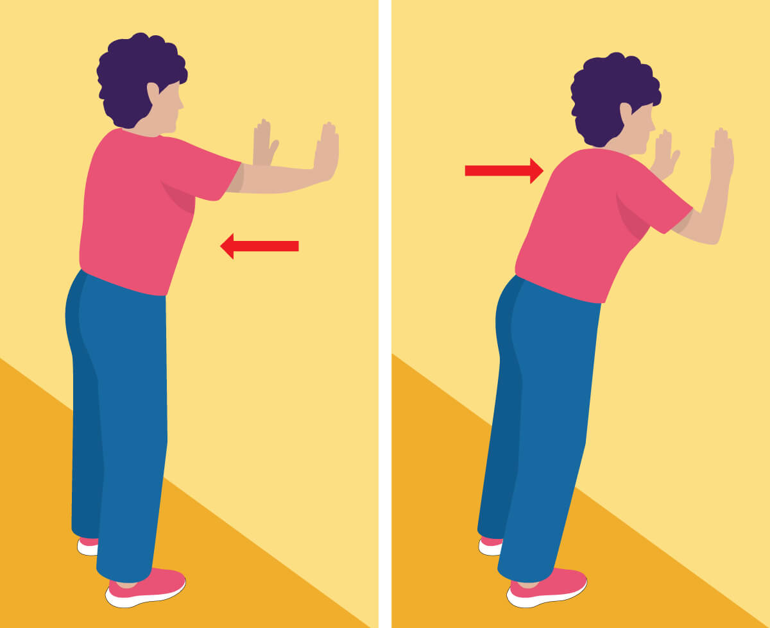

Overhead lifts

To improve upper body strength and daily functional movement
- In a standing position hold 2 evenly weighted objects like cans of beans or bottles
- Start with your hands down by your sides and your palms facing away from you
- Keeping your elbows by your side, slowly bring the objects up to your shoulders then slowly extend your arms above your head
- Reverse the action until your hands are back by your side
- Repeat the movement 5-10 times
- Perform this 2-5 times, take a break for 40-60 seconds before repeating again.
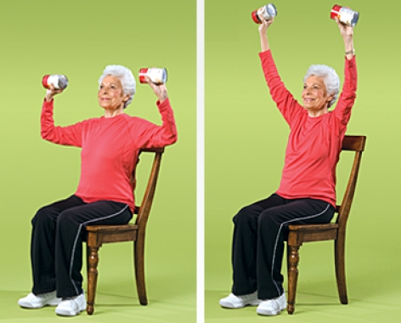

Stair stepping

To improve coordination, aerobic fitness for heart health and lower body strength
- Stand in front of a staircase or step and step up with your right foot, then up with your left
- Then step back down with your right, then back down with your left. Repeat 10 times or for a period of 20-60 seconds
- Take a rest before changing the leading foot
- If you need a little support, hold on gently to the railing, or gently touch the wall with your finger tip
- If this is comfortable, to increase difficulty, hold some weight in each hand such as a bottle of water
- Perform this 2-5 times, take a break for 40-60 seconds before repeating again.

