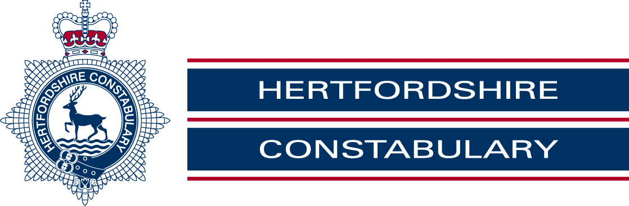 | Advice from Hertfordshire constabulary
It’s a scam
Residents across Hertfordshire, and nationally, have been receiving telephone calls from people claiming to be from the police or, in some cases, claiming to be from their bank.
The phoney police officer says they are investigating fraudulent activity on your bank account. They ask you to assist the “police investigation” by withdrawing large sums of money and handing it to a courier. They may also instruct you not to tell the bank why you are withdrawing the money, giving the reason that the bank might be involved in the fraud.
In some cases, victims have been asked to purchase foreign currency or high value goods, such as designer watches, as part of the “police investigation”.
While many people recognise these as scam calls, there have been occasions when people have fallen prey to the highly persuasive nature of these fraudsters and have lost thousands of pounds.
The fraudsters may try to gain your trust by asking you to dial another number to speak to another police officer who will corroborate their story. In reality, the phone line is held open and you are simply speaking to the fraudster’s accomplice.
We would like to stress that the police or your bank would never ask you to withdraw large sums of cash and hand it over to anyone.
What to do if you get a call
If you receive a call you’re not expecting, you should be suspicious. The vital things to remember are that your bank and the police would:
• NEVER ask for your bank account details or PIN number over the phone.
• NEVER call to ask you to withdraw your money or transfer it to another “safe” account.
• NEVER ask you to purchase items or foreign currency as part of an investigation.
• NEVER send someone to your home to collect money, your bank cards, foreign currency
or any other items they have asked you to purchase.
If you are not happy with a phone call or are suspicious of a conversation you have with a caller then please end the call and contact police via the non-emergency number, 101. Remember to wait a few minutes before dialling to ensure you are not reconnected to the fraudster.

