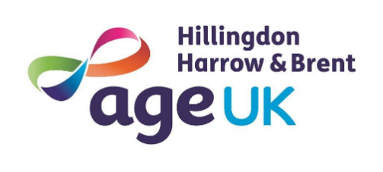
Equal Opportunities Monitoring Form
Age UK Hillingdon, Harrow and Brent is committed to eliminating discrimination and encouraging volunteering from all sections of the community. The information gained will be combined and examined regularly to check if we are fulfilling that aim and help us make changes where needed. The information gained is held securely and will only be shared anonymously. Please mark the relevant boxes.
Name:
Gender
Male |  | Female |  | Non-Binary
Other |  | Prefer not to specify

Health/Disability
Do you consider yourself to have a disability or health condition?
Yes No Prefer not to say
What is the effect or impact of your disability or health condition on your ability to give your best when volunteering?

Ethnicity 1
White |  | Mixed |  | Asian or Asian British
Black or Black British |  | Other
Ethnicity 2
English |  | Welsh |  | Scottish
Northern Irish |  | British |  | Irish
Any other White |  | White & Black Caribbean |  | White & Black African
Arab |  | White & Asian |  | Indian
Pakistani |  | Bangladeshi |  | Any other Asian
Caribbean |  | African |  | Black, British or Caribbean
Chinese |  | Gypsy or Irish traveller |  | Roma
Any other Ethnic Group
Any other mixed or multiple ethnicity

Religion
Baha’i |  | Buddhist |  | Christian
Hindu |  | Jain |  | Jehovah’s witness
Jewish |  | Muslim |  | None
Other |  | Pagan |  | Sikh
Zoroastrian |  | Unknown |  | Atheist
Rastafarian |  | Declines to say

Sexual Orientation
Heterosexual |  | Gay/Lesbian |  | Bisexual
Other sex and orientation |  | Not stated |  | Does not know
Declined response

Marital Status
Single |  | Married |  | Civil Partnership
Co-habiting/common law |  | Separated |  | Widowed
Prefer not to say |  | Other (Specify if you wish) |  | Divorced

