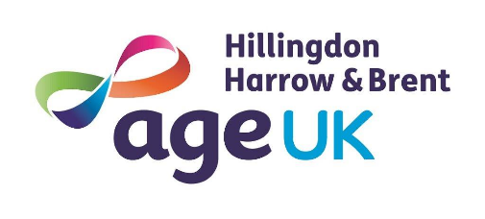
Equal Opportunities Monitoring Form

We are committed to ensuring that all job applicants and members of staff are treated equally and in accordance with our equal opportunities policy. We will not discriminate (either directly or indirectly) because of gender, sexual orientation, marital or civil partner status, gender reassignment, race, colour, nationality, ethnic or national origin, religion or belief, age, disability, pregnancy or maternity.
[Please complete this form and return it with your application. The form will be separated from your application on receipt. The information on this form will be used for monitoring purposes only and will play no part in the recruitment process.]
Thank you for your assistance.

1. Position

Job applied for:

2. Gender (please tick as appropriate)

Male
Female

Prefer not to say

Other

Do you identify as transgender/transsexual?

Yes

No

Prefer not to say

3. Age
What is your age (please tick as appropriate)?

16 – 17 18 – 25 26 – 35 36 – 45 46 – 55 56 – 65

66 – 75 76 – 85 85 + Prefer not to say

4. Ethnic Background
A – White: D – Black or Black British:

British Caribbean

Irish African

Other White background Other Black background

B – Mixed Race: E- Chinese and other groups:
– Prefer not to say:
– Prefer not to say:
White and Black Caribbean Chinese
– Prefer not to say:

White and Black African Other Ethnic Groups

White and Asian
– Prefer not to say:

Other Mixed background F – Prefer not to say:
– Prefer not to say:
C – Asian or Asian British: G – Other

Indian Please specify

Pakistani

Bangladeshi

Other Asian Background

5. Sexual Orientation
How would you describe your sexual orientation (please tick as appropriate)?

Heterosexual/ straight Bisexual Gay Man Gay woman/lesbian

Prefer not to say

6. Marital Status

Married (opposite sex) Married (same sex)

Civil partner Single

Other

7. Religion or belief
Please describe your religion or other strongly-held belief
I would describe my religion or belief as:
I have no particular religion or belief

I prefer not to say

8. Disability
The Equality Act 2010 defines a disability as a “physical or mental impairment which has a substantial and long-term adverse effect on a person’s ability to carry out normal day to day activities”.
Substantial
Is more than minor or trivial, eg it takes much longer than it usually would to complete a daily task like getting dressed.

Long-term
Means 12 months or more, eg a breathing condition that develops as a result of a lung infection

Do you consider that you have a disability under the Equality Act (please tick as appropriate)?

Yes

No

I am unsure if my condition is classed as a disability

I prefer not to say

9. Where did you see this post advertised?

Data Protection: Information from this application may be processed for purposes registered by the employer under the Data Protection Act 2018. On written request, individuals have the right of access to personal data held about them.
I hereby give my consent to Age UK HHB to process the data supplied in this form for the purposes of recruitment and selection.
Applicant’s signature:
Date:

