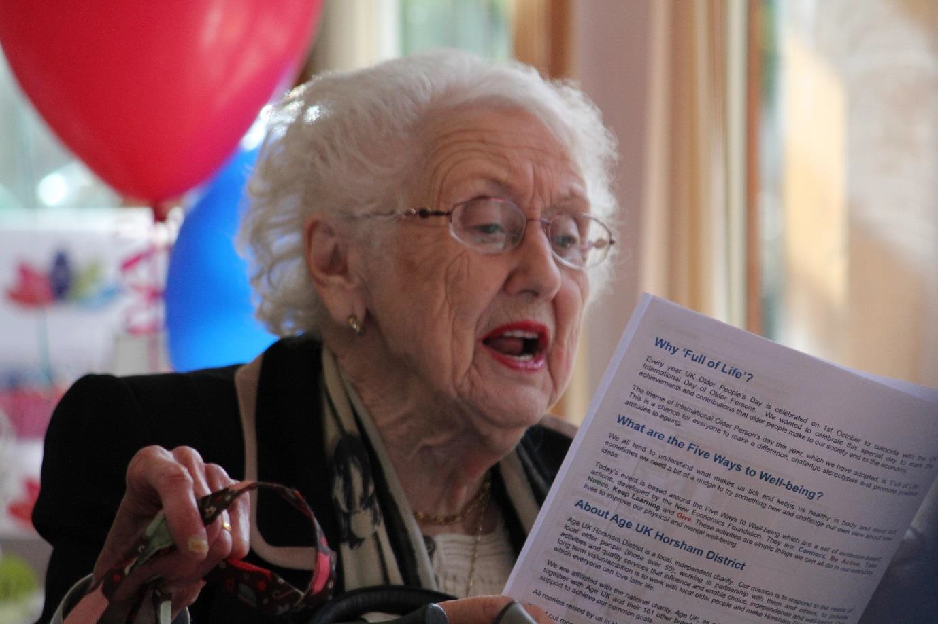

Candidate Information Pack

Team Leader – Lavinia House Club

June 2019

Table of Contents

Message from the CEO

1.0 About Age UK Horsham District
  - What we do across Horsham District
  - Working with and on behalf of local older people

2.0 Governance

  - Lavinia House Club Team Leader
    - Job description
    - Person specification

4.0 How to apply

Appendix 1 – Application form

Appendix 2 – Equal Opportunities Monitoring Form

Message from the Chief Executive Officer

As a local Age UK covering the Horsham District area we want to be famous for:
- Being the first point of contact for older people;
- Delivering services that both meet needs and are person centred
- Tackling loneliness.
Underpinning all of this we want to be famous for being the employer of choice locally. Our vision is that together with communities and older people we want to create a district in which everyone can love later life.

We offer many services for the older people of the district including Information and Advice, Visiting Service, Help at Home, Home from Hospital, Clubs for people with Dementia, Village Agents and Community clubs.

In addition we run social clubs from our hub at Lavinia House and it is these services that we are planning to relaunch in summer 2019. We are now seeking an experienced Team Leader to offer activities and events based on the Five Ways to Wellbeing: Connect, Be Active, Take Notice, Keep Learning and Give.

We are looking for a Team Leader to manage all aspects of the day to day running of the club. From working with the cook to ensure older people attending Lavinia House have a choice of nutritious meals and snacks available to developing an exciting activities programme for the members. You will also be working with the Clubs Manager to ensure we are increasing our reach to older people in the Horsham area.

If this is something that you are keen to be part of, we are looking forward to meeting you.

Sonia Mangan
CEO - Age UK Horsham District

  - About Age UK Horsham District
Age UK Horsham District is an independent local charity (and company limited by guarantee) which is a full brand partner of Age UK. Age UK Horsham District is a local, independent charity. We are affiliated with the national charity, Age UK, as a brand partner. This means that we work together with Age UK and their 140 other brand partners in a spirit of collaboration and mutual support to achieve our common goals, this also entitles us to use their brand within our the geographical area of Horsham District.

Our Vision
Horsham District is a place where everyone has the opportunity for good quality of life in later life.

Our Mission
To provide services and activities to promote and improve wellbeing and quality of later life in Horsham District

Our Values

Respect

Fairness

Integrity

Professionalism

Commitment

Teamwork

Recognition

1.2 What we do across Horsham District?
In December 2017 the Trustees revisited and reaffirmed our five Strategic objectives and developed a strategic plan for 2020.

Our strategic plan is to grow our activity, impact and income by 20% by 2020.

The ambitions within the plan are realistic and fit with the needs and aspirations of the demographic of Age UK Horsham District.

- Horsham District population currently around 138,000
- Over 50 population is 43% or 59,514
- Over 65 population is 22% or 30,514

Our ambition for growth fits with our understanding of need, for example we have seen a 44% growth in activity for our community officer team providing information, and advice for an average of 141 people per month. This new partnership providing community link specialist services in Horsham will enhance our existing services:

Information and Advice is a free service providing essential advice, assistance and support to those needing help with a range of issues, including: finances, housing and health. This is facilitated by the Community Officer Team as they provide expert advice to maximise income and benefits entitlements; in addition Advisory Volunteers will support lower level needs such as Attendance Allowance claims and Blue Badge applications, out in the community.

Home Visiting is a free service for the most lonely, isolated and vulnerable people. A volunteer is carefully matched to provide friendly companionship and support, offering a lifeline to the outside world. This support can help build confidence, improve mental well- being and encourage a sense of security and independence.

Help at Home signposts to reliable sources of help and support in the home, to enable the individual to remain independent and in their own home for longer.

Home from Hospital and Relative Support is a free service for older people with no one to help them when they return home from an unplanned hospital stay. This service provides a support network upon discharge from hospital, enabling them to get back on their feet, improve their well-being and ensure they have the necessary means to access services and support to help them to continue living well. Support is also available to help families make informed choices about future care for their loved ones.

A Village Agent scheme, based on tested models from other rural communities across the UK – a village agent is a single point of contact in a community for local older people and families, local groups, public sector colleagues and the business sector; they work on what is important to help us all to live independently in later life.

Local day-clubs and clubs for people with dementia, where those over 50, their families and carers can receive support, enjoy social activities and interaction.

Working with and on behalf of local older people
Involvement and seeking and listening to the views of local older people, including:

    - Participating in National Campaigns

    - Influencing our MPs and local government

    - Informing local media

    - Linking with Horsham District Older Peoples Forum and using every opportunity to work with the many local organisations and decision-making groups, to ensure that our people and communities are equipped to make the most of later life.

For further information about our work visit www.ageukhorshamdistrict.org.uk

  - Governance, Structure and Management
Age UK Horsham District (AUKHD) was registered as a charity in 1983. It was established under a Memorandum of Association and is governed by its Articles of Association. The directors of the company are also the charity trustees and Board is diverse and represents people from across Horsham District to reflect and represent the rural/urban dynamic of the district.

New employees joining AUKHD undergo a comprehensive induction and training available via Age UK, nationally and locally.

The charity employs 30 members of staff, 150 volunteers and 60 local self-employed people to deliver its work. The day to day responsibility of the Charity’s operation is delegated to the Chief Executive Officer.

About Sonia Mangan (CEO)

Sonia has been with the Charity since June 2016 and is relatively new to Horsham district but not new to Voluntary Sector leadership. She was Chief Executive Officer for Age UK South Lakeland in Cumbria for eleven years, led a small team working with people with sight problems in the same area and latterly led a team of 200 staff, working across Cumbria with people with a range of mental health problems. Her value is to make a difference and Sonia has a lot of experience of the needs and issues older people navigate as they move through their later life. Last year Sonia completed her Masters in Dementia Studies with the University of Stirling. She started her career as a nurse and has worked in NHS management and private sector care home management.

The charity has five key goals:

    - Goal 1: Increase our impact
    - Goal 2: Develop financial stability
    - Goal 3: Work in Partnership
    - Goal 4: Raise our profile
    - Goal 5: Develop the internal capacity we need to deliver

Clubs Coordinator – Lavinia House

Lavinia House, Duke Square Horsham RH12 1GZ
28 hours Tuesday – Friday (8.30 – 4.30)
Reports to the Clubs Manager

JOB PURPOSE SUMMARY

We are looking for a Team Leader to manage all aspects of the day to day running of the club. From working with the cook to ensure older people attending Lavinia House have a choice of nutritious meals and snacks available to developing exciting activities programmes for the members. Your role will also include increasing our reach across the Horsham area and monitoring/reporting on our impact to ensure we are maximising benefit for local older people.

JOB DIMENSIONS: Responsible for a team of three staff members and up to 20 volunteers

KEY RESPONSIBILITIES

Services

To work with the local community to develop and provide a regular programme of client led activities for people attending Lavinia House. This should include daily, weekly and monthly activities as well as opportunities to participate in other community activities or visit other areas of local interest.

To provide activities that are developed around the five ways to wellbeing programme and will include activities and clubs in the lounge, main club space, rainbow room and garden.

To identify and liaise with a range of external partners and volunteers who will deliver activities and groups at the club.

To liaise with the Cook to ensure that the Café provides a choice of hot nutritious meals and snacks throughout the day and to provide freshly baked goods to sell in the café.

To co-ordinate the catering requirements for Age UK Horsham District events and for those who hire the meeting room when Lavinia House is open.

To ensure that the club appearance is welcoming, professional and has up to date information on relevant notice boards. Ensure all relevant literature displayed is compliant with Age UK brand guidelines.

People

To ensure that we involve our service users in a meaningful way when planning the activities menu, enabling us to offer a person centred approach to those attending the club.

To ensure that each club activity participant has a support plan which is reviewed regularly, and each member uses the wellbeing star throughout the year to track the impact of our service to their wellbeing. Ensure all information is uploaded to our client recording management system – Charity log.

To manage the induction of all new members, which will include inviting those considering joining the club to attend a free taster day.

Maintain continual professional development by attending relevant mandatory learning and development as well as taking advantage of the range of other person-centred learning and development options.

To line manages two Activity/Catering Assistants and the Cook, ensuring that they have regular supervision meetings and appraisals in accordance with our HR policy and procedures.

To supervise and support all volunteers to ensure that they are having a meaningful volunteering experience and that they are carrying out their roles effectively.

To attend staff meetings and training as required.

To provide cover for other members of staff (potentially at other sites) when required.

Finance and Administration

To ensure appropriate cover is in place to maintain service delivery during staff / volunteer absence.

To ensure that the catering service complies with all relevant legislation and best practice with relevant documentation kept in a safe place.

Implement Health and safety and food hygiene policies and procedure; ensuring risk assessments are carried out on all aspects of food preparation and activities in the club; the kitchen and club cleanliness is maintained to a high standard and that all kitchen and club equipment is safe to use and regularly serviced.

To conduct regular pricing and quality reviews of suppliers (including a six-monthly review of 3 competitive suppliers) and work closely with the Cook to maximise innovative ideas and networking potential in support of food quality and budget maintenance.

To monitor and work within the agreed budget for the service.

To promote and help participate in fundraising events.

To ensure all new members are made aware of any potential risks involved in activities and that a risk assessment is undertaken for all activities provided.

To ensure that all standard agreements are in place for all the activities provided by external providers e.g. Entertainers, Zumba, etc. and that the fees have been clearly set and agreed in writing.

To liaise with community transport providers regarding transport as required for outings and to help those who may have difficulty arranging transport for themselves to attend the club.

To conduct regular customer satisfaction evaluation throughout the year using surveys that are consistent with the policies and procedures

To liaise with the Clubs administrator to provide data, case studies and reports needed to fulfil our internal and external requirements.

To comply with the policies and practices of Age UK Horsham District as set out in the Staff Handbook.

To take responsibility for cashing up the till each day and handle petty cash as required, ensuring that all financial paper work related to this task is completed within the time frame required and using the correct forms. When needed the post holder will be required to bank finances following the Age UK Horsham District policy.

Community

To effectively promote the service, working with the First Point of Contact team and the charity promotions and Marketing Officer to provide publicity materials, flyers, etc..

To liaise with other service providers, benefitting from sharing good practice.

To develop excellent working relationships with other agencies such as Action for Deafness, Adult Social care team, G.P surgeries, Care Coordinators, etc. as well as developing excellent relationships with key voluntary organisations to help promote the service.

To conduct any other duties required by the Clubs Manager which are commensurate with the responsibilities of the post.

Quality

To ensure compliance with internal Quality Assurance standards and comply to Age UK National standards and guidelines.

To collect and act upon regular customer satisfaction monitoring – ensuring that there are effective and regular processes in place for customer feedback. All suggestion, comments and complaints are recorded, communicated and acted upon.

The post holder will be subject to an enhanced DBS check.

Please also refer to the Person Specifications shown in Appendix 1.

How to Apply
Applications need to include:

    - A covering letter explaining:

      - a) Why you wish to be considered for this role

      - b) How will your skills and experience make a difference and add value

    - The completed AUKHD application form – see separate Word document
(Please kindly note that we do not accept CVs)

    - Completed Equal Opportunities form (Appendix 2)

Please email your completed application to: finance@ageukhorshamdistrict.org.uk

Or post to:

Judy Maiden
Finance & Operations Manager
Age UK Horsham District
Lavinia House
Dukes Square
Horsham
West Sussex
RH12 1GZ

Closing date for applications: 23rd June 2019

Interview date: 3rd July 2019

Age UK Horsham District welcomes applications regardless of gender, age, ethnic background, disability, sexuality or religion.

Appendix 1 – Person Specifications

PERSON SPECIFICATION
Job title: Lavinia House and Catering coordinator
Criteria:-  E= Essential D = Desirable | E or  D
Experience  Developing and delivering activities and clubs for vulnerable adults  Experience of planning a programme of activities  Experience of working with older people and/or vulnerable adults  Experience of supervising staff/volunteers  Experience of handling administrative function e.g. collecting data, handling confidential records, providing data reports etc.  Experience of supervising and/or coordinating a catering setting | E  E  E  E  E  E
Knowledge & Skills  Experience of line managing people in an encouraging manner  Ability to communicate with a wide variety of people both verbally and in writing  Excellent planning, organisational and administration skills  Articulate, well organised and enthusiastic  Ability to take initiative in both familiar and unexpected situations  Hospitality and/or catering qualification  Food Hygiene qualification  First Aid qualification  Understanding of Equal opportunities policy and practice and a commitment to its implementation  Demonstrate an understanding of Health and Safety and Risk assessment policies and practice  An understanding of confidentiality and commitment to uphold professional and organisational values and standards  IT literate  Ability to use client recoding management system | E  E  E  E  E  D  D  D  D  E  E  E  D
Competencies  Patience and a sense of humour  An understanding of the need for discretion and confidentiality  Problem solver, pragmatic and resilient  The initiative and vision to develop the role  Calm approach in pressured situations  An understanding and empathy of those living with dementia and other health conditions | E  E  E  E  E  D
Other Requirements  Full driving licence and access to a car for work purposes  Commitment to equal opportunities  Ability to work flexibly with occasional evening or weekend work if required | D  E  E

Appendix 2

Age UK Horsham District welcomes applications regardless of gender, age, ethnic background, disability, sexuality or religion. Please ensure that you also complete the Age UK Horsham District equal opportunities form.

Equal opportunities Monitoring Form

Please help us by completing this form. We use this information to monitor the effectiveness of our equal opportunities policy. Your answers will be treated as confidential. This form will be filed separately from your application.
Name and the job applied for
Name: |  | Which role have you applied for?
Are you: | Male | Female | (please circle)
Do you have: | Dependent children? | and/or | Other dependents
Your ethnic origin
How would you describe your ethnic origin?
Ethnic origin refers to members of an ethnic group who share the same cultural background and identity. These categories are approved by the Commission for Racial Equality.
Black African |  | Black Caribbean
Bangladeshi |  | Black other (please specify)
Chinese |  | Indian
Pakistani |  | White
Any other ethnic group (please specify)
Do you consider yourself to be disabled? (please circle) |  |  | Yes No
If “Yes” please give details of any special equipment or arrangements that would help you to do your job most effectively.
Signature: Date:

Thank you for completing this form.

