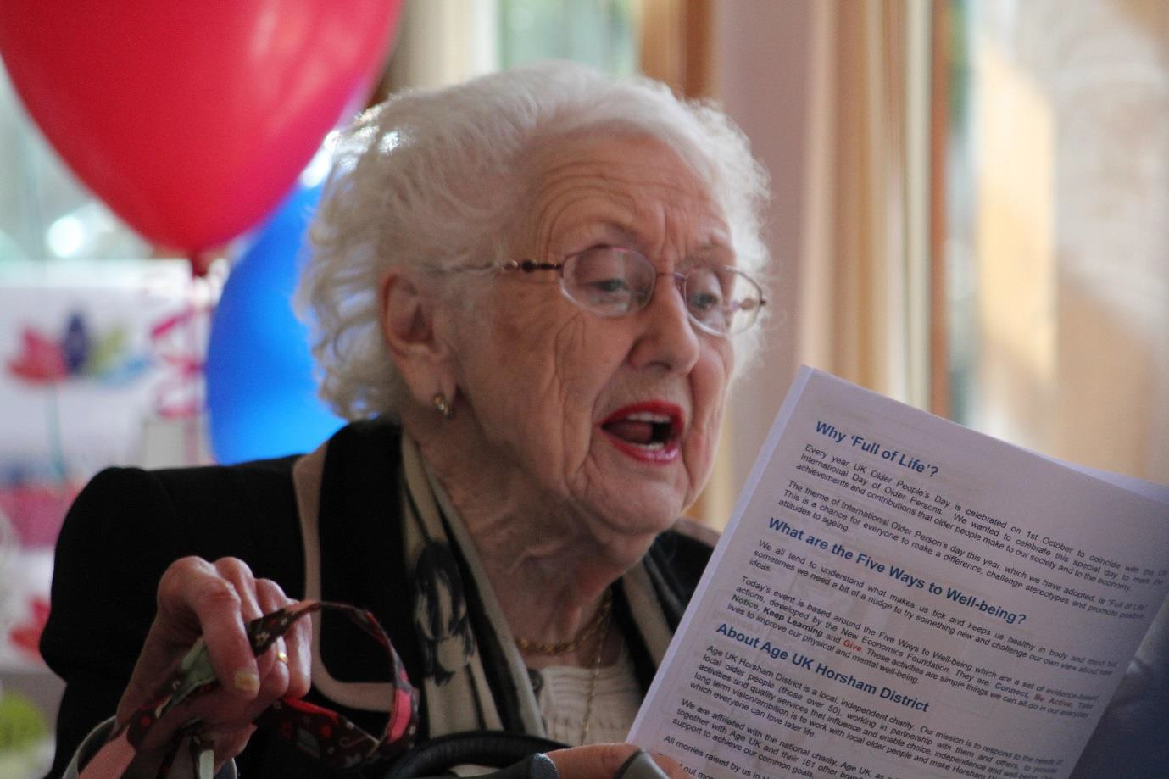

Candidate Information Pack

Cook – Lavinia House

June 2019

Table of Contents

Message from the CEO

1.0 About Age UK Horsham District
  - What we do across Horsham District
  - Working with and on behalf of local older people

2.0 Governance

  - Clubs Coordinator
    - Job description
    - Person specification

4.0 How to apply

Appendix 1 – Application form

Appendix 2 – Equal Opportunities Monitoring Form

Message from the Chief Executive Officer

As a local Age UK covering the Horsham District area we want to be famous for:
- Being the first point of contact for older people;
- Delivering services that both meet needs and are person centred
- Tackling loneliness.
Underpinning all of this we want to be famous for being the employer of choice locally. Our vision is that together with communities and older people we want to create a district in which everyone can love later life.

We offer many services for the older people of the district including Information and Advice, Visiting Service, Help at Home, Home from Hospital, Clubs for people with Dementia, Village Agents and Community clubs.

In addition we run social clubs from our hub at Lavinia House and it is these services that we are planning to relaunch from June 2019 and we are now seeking an experienced team to offer activities and events based on the Five Ways to Well-being: Connect, Be Active, Take Notice, Keep Learning and Give.

We are looking for a Co-ordinator to manage the day to day running of the club, a Cook to prepare delicious snack and lunch meals and an Activities Assistant to support the coordinator in developing an exciting activities programme for the members.

If this is something that you are keen to be part of, we are looking forward to meeting you.

Sonia Mangan
CEO - Age UK Horsham District

  - About Age UK Horsham District
Age UK Horsham District is an independent local charity (and company limited by guarantee) which is a full brand partner of Age UK. Age UK Horsham District is a local, independent charity. We are affiliated with the national charity, Age UK, as a brand partner. This means that we work together with Age UK and their 160 other brand partners in a spirit of collaboration and mutual support to achieve our common goals, this also entitles us to use their brand within our the geographical area of Horsham District.

Our Vision
Horsham District is a place where everyone has the opportunity for good quality of life in later life.

Our Mission
To provide services and activities to promote and improve wellbeing and quality of later life in Horsham District

Our Values

Respect

Fairness

Integrity

Professionalism

Commitment

Teamwork

Recognition

1.2 What we do across Horsham District?
In December 2017 the Trustees revisited and reaffirmed our five Strategic objectives and developed a strategic plan for 2020.

Our strategic plan is to grow our activity, impact and income by 20% by 2020.

The ambitions within the plan are realistic and fit with the needs and aspirations of the demographic of Age UK Horsham District.

- Horsham District population currently around 138,000
- Over 50 population is 43% or 59,514
- Over 65 population is 22% or 30,514

Our ambition for growth fits with our understanding of need, for example we have seen a 44% growth in activity for our community officer team providing information, and advice for an average of 141 people per month. This new partnership providing community link specialist services in Horsham will enhance our existing services:

Information and Advice is a free service providing essential advice, assistance and support to those needing help with a range of issues, including: finances, housing and health. This is facilitated by the Community Officer Team as they provide expert advice to maximise income and benefits entitlements; in addition Advisory Volunteers will support lower level needs such as Attendance Allowance claims and Blue Badge applications, out in the community.

Home Visiting is a free service for the most lonely, isolated and vulnerable people. A volunteer is carefully matched to provide friendly companionship and support, offering a lifeline to the outside world. This support can help build confidence, improve mental well- being and encourage a sense of security and independence.

Help at Home signposts to reliable sources of help and support in the home, to enable the individual to remain independent and in their own home for longer.

Home from Hospital and Relative Support is a free service for older people with no one to help them when they return home from an unplanned hospital stay. This service provides a support network upon discharge from hospital, enabling them to get back on their feet, improve their well-being and ensure they have the necessary means to access services and support to help them to continue living well. Support is also available to help families make informed choices about future care for their loved ones.

A Village Agent scheme, based on tested models from other rural communities across the UK – a village agent is a single point of contact in a community for local older people and families, local groups, public sector colleagues and the business sector; they work on what is important to help us all to live independently in later life.

Local day-clubs and clubs for people with dementia, where those over 50, their families and carers can receive support, enjoy social activities and interaction.

Working with and on behalf of local older people
Involvement and seeking and listening to the views of local older people, including:

    - Participating in National Campaigns

    - Influencing our MPs and local government

    - Informing local media

    - Linking with Horsham District Older Peoples Forum and using every opportunity to work with the many local organisations and decision-making groups, to ensure that our people and communities are equipped to make the most of later life.

For further information about our work visit www.ageukhorshamdistrict.org.uk

  - Governance, Structure and Management
Age UK Horsham District (AUKHD) was registered as a charity in 1983. It was established under a Memorandum of Association and is governed by its Articles of Association. The directors of the company are also the charity trustees and Board is diverse and represents people from across Horsham District to reflect and represent the rural/urban dynamic of the district.

New employees joining AUKHD undergo a comprehensive induction and training available via Age UK, nationally and locally.

The charity employs 30 members of staff, 150 volunteers and 60 local self-employed people to deliver its work. The day to day responsibility of the Charity’s operation is delegated to the Chief Executive Officer.

About Sonia Mangan (CEO)

Sonia has been with the Charity since June 2016 and is new to Horsham district but not new to Voluntary Sector leadership. She has been Chief Executive Officer for an Age UK in the South Lakeland in Cumbria for eleven years, led a small team working with people with sight problems in the same area and latterly led a team of 200 staff, working across Cumbria with people with a range of mental health problems. Her value is to make a difference and Sonia has a lot of experience of the needs and issues older people navigate as they move through their later life. Last year Sonia completed her Masters in Dementia Studies with the University of Stirling. She started her career as a nurse and has worked in NHS management and private sector care home management.

The charity has five key goals:

    - Goal 1: Increase our impact
    - Goal 2: Develop financial stability
    - Goal 3: Work in Partnership
    - Goal 4: Raise our profile
    - Goal 5: Develop the internal capacity we need to deliver

Cook – Lavinia House

Lavinia House, Duke Square, Horsham, RH12 1GZ
20 hours (Tuesday – Friday), 8am -1pm
Reports to the Club Team Leader

JOB PURPOSE SUMMARY

The cook will prepare nutritious, delicious lunches and snacks to be served from our Garden View Café.

The cook will work with the Club Team Leader to plan menus and ensure that all meals are ready to serve as required.

The goal is to help preserve and enhance our reputation so we can expand our clientele and the Charity’s reach.

JOB DIMENSIONS

The cook will work as part of the Lavinia House Club team which includes both staff and volunteers.

KEY RESPONSIBILITIES

Services

*Ensure the Charity offers a creative menu at all times, to compete with other local competitors.
*Portion, arrange and garnish food based on clients’ preferences.

* Write new recipes to ensure menus are kept in line with clients’ wishes, budget constraints and any seasonal themes.

* Plan and bake a selection of cakes and pastries to ensure that the Garden View Café has enough available to sell throughout the week.

* Estimate expected food consumption and ordering new menu items for Specials and best deals.

* Ensure all food preparation areas are cleaned and maintained, as determined by law and company policy.

* Prepare all meals to the specifications of the customers’ needs and likes.

* Manage the preparation of food before the arrival of guests/customers.

* Manage adjustments to food items to accommodate guests with allergies or specific dietary requirements.

* Act as liaison to front-of-house employees and volunteers to ensure food is served at the correct temperature.

* Operate all kitchen appliances safely and ensure all appliances are kept in good working order and report any faults promptly.

*Ensure that the kitchen cleaning Rota is completed and information is correctly recorded.

* Seek regular feedback from all customers using the Garden View Café to ensure that they are happy with the service and implement any changes as appropriate.

*Provide catering for Hirers using Lavinia House, as required.

* Provide catering for Lavinia House events, as required.

People

*Ensure that volunteers helping in the kitchen know what their responsibilities are, and that they have a positive volunteering experience.

* Attend training as required to keep up-to-date with legislation around food hygiene and food handling.

*Attend training as required for all other aspects relevant to this role.

* Maintain daily contact with the Lavinia House Club Team Leader, with a view to provide the best service possible to our customers and review all opportunities for improvement.

* Attend all staff meetings as required

Finance and Administration

* Manage food and ingredient orders, in collaboration with the Lavinia House Club Team Leader, working together to ensure it is done within budget.

*Process weekly food orders and keep accurate records and accounts of all food purchases.

*Take responsibility for all aspects of stock control in the kitchen.

* Work as part of the team to plan catering for special events such as Christmas

Community

* Help promote the services and activities of Age UK Horsham District within the District.

*Conduct any other duties as required by the Clubs Manager, which are commensurate with the responsibilities of this post.

Quality

*Adhere to quality assurance standards and comply with Age UK National Standards and Guidelines.

* Comply with the policies and practices of Age UK Horsham District

Please also refer to the Person Specifications shown in Appendix 1.

How to Apply
Applications need to include:

    - A covering letter explaining:

      - a) Why you wish to be considered for this role

      - b) How will your skills and experience make a difference and add value

    - The completed AUKHD application form – see separate Word document
(Please kindly note that we do not accept CVs)

    - Completed Equal Opportunities form (Appendix 2)

Please email your completed application to: finance@ageukhorshamdistrict.org.uk

Or post to:

Judy Maiden
Finance & Operations Manager
Age UK Horsham District
Lavinia House
Dukes Square
Horsham
West Sussex
RH12 1GZ

Closing date for applications: 23rd June 2019

Interview date: week beginning 15th July 2019

Age UK Horsham District welcomes applications regardless of gender, age, ethnic background, disability, sexuality or religion.

Appendix 1 – Person Specifications

PERSON SPECIFICATION
Job title: COOK
Criteria:-  E= Essential D = Desirable | E or  D
Experience  Experience of working in a day club or similar environment  Experience of cooking a variety of meals, including animal and plant-based ingredients  Awareness of dietary allergies and cooking alternatives  Worked as part of a team  Worked as a Cook (and preferably for large numbers)  Experience of catering for and working with older people  Experience of supervising staff and volunteers in a catering environment  Excellent customer service, communication and interpersonal skills  Skills  Hold a catering qualification (BTEC/NVQ level 2 minimum)  Hold a food hygiene qualification  First Aid qualification  IT skills and ability to manage ordering, stock control etc. using a variety of software tools  Good organisational skills to manage a team of staff and volunteers in a busy kitchen environment  Kitchen equipment knowledge | D  E  D  E  D  E  E  E  E  E  D  E  E  E
Understanding of Equal opportunities policy and practice and a commitment to its implementation  Demonstrate a understanding of Health & Safety, and Risk assessment policies and practice  An understanding of confidentiality and commitment to uphold professional and organizational values and standards | E  E  E
Competencies  Excellent planning skills  Patience and a sense of humour  An understanding of the need for discretion and confidentiality  Problem solver, pragmatic and resilient, self-motivated and able to use own initiative  The initiative and vision to develop the role  Calm approach in pressured situations  An understanding and empathy of those living with dementia and other health conditions | E  E  E  E  E  E  D
Other Requirements  Ability to work flexibly with occasional evening or weekend work if required | E

Appendix 2

Age UK Horsham District welcomes applications regardless of gender, age, ethnic background, disability, sexuality or religion. Please ensure that you also complete the Age UK Horsham District equal opportunities form.

Equal opportunities Monitoring Form

Please help us by completing this form. We use this information to monitor the effectiveness of our equal opportunities policy. Your answers will be treated as confidential. This form will be filed separately from your application.
Name and the job applied for
Name: |  | Which role have you applied for?
Are you: | Male | Female | (please circle)
Do you have: | Dependent children? | and/or | Other dependents
Your ethnic origin
How would you describe your ethnic origin?
Ethnic origin refers to members of an ethnic group who share the same cultural background and identity. These categories are approved by the Commission for Racial Equality.
Black African |  | Black Caribbean
Bangladeshi |  | Black other (please specify)
Chinese |  | Indian
Pakistani |  | White
Any other ethnic group (please specify)
Do you consider yourself to be disabled? (please circle) |  |  | Yes No
If “Yes” please give details of any special equipment or arrangements that would help you to do your job most effectively.
Signature: Date:

Thank you for completing this form.

