Age UK Hounslow - The Southville Vintage Club Day Provision Service V20
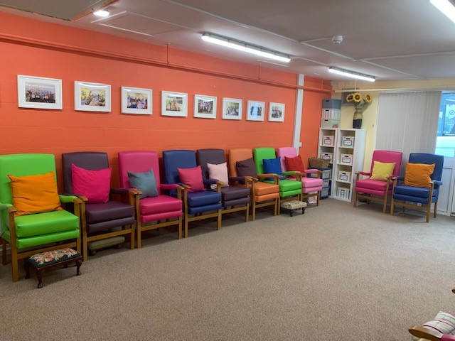
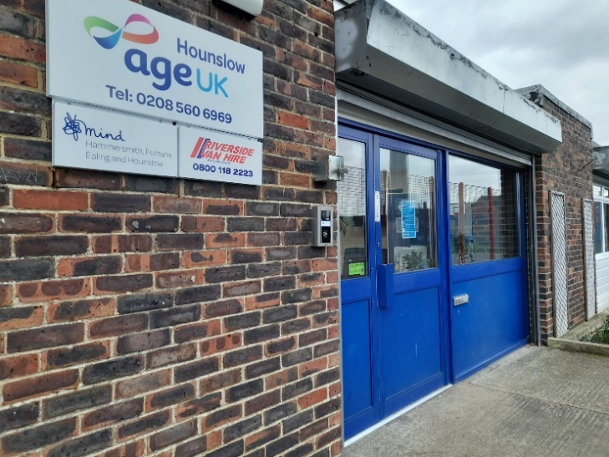

Southville Community Centre
Southville Road
Feltham
Middlesex
TW14 8AP
Telephone 020 8560 6969
Website www.ageuk.org.uk/hounslow
Email info@ageukhounslow.org.uk
Search ‘Age UK Hounslow’ in Socials

Registered Charity Number 1061681
Contents
3
1. AIMS AND OBJECTIVES 4
Values and Standards 4
Fulfilment 4
Dignity and Respect 4
Independence 4
Rights 4
Equality and Diversity 5
Choice 5
Consent 5
Safety 5
Confidentiality 5
2. APPLICATION PROCESS 5
CRITERIA OF APPLICANT 6
RELIGION 7
3. SERVICE USERS PACK 7
4. NEEDS ASSESSMENT PLAN 7
5. MEDICATION 7
6. MONITORING OF THE INDIVIDUAL 8
7. BEHAVIOUR OF THE SERVICE USER 8
8. REPORTS AND RECORDS 9
9. SERVICE USERS’ OUTCOMES PLAN 9
10. SERVICE USERS INVOLVEMENT 9
11. SMOKING and VAPING 10
12. ACTIVITIES AND EVENTS 10
13. MEALS 11
14. TRANSPORT 11
15. SERVICES USERS’ OWN EQUIPMENT 11
16. RISK ASSESSMENTS 12
17. COST OF SERVICE 12
18. SAFEGUARDING VULNERABLE ADULTS 12
19. ACCIDENT / EMERGENCY PROCEDURES 13
20. COMPLAINTS 13
21. SUGGESTION BOX 13
22. LEAVING THE DAY PROVISION SERVICE SETTING 13
23. TIMETABLE OF CURRENT ACTIVITIES 13
24. MANAGEMENT AND CONTROL OF OPERATIONS 14
25. DATA PROTECTION 16
26. POLICIES AND PROCEDURES 16
27. MANAGEMENT OF RECORDS 16
28. RECRUITMENT / INDUCTION AND TRAINING OF STAFF 16
29. VOLUNTEERS 16
30. PREMISES, GROUNDS, SUITABILITY AND ACCESS 17
31. HEALTH & SAFETY / FIRE SAFETY 17
32. FIRST AID 17
33. INCIDENTS 17
34. STAFF & VOLUNTEER JOB SPECIFICATIONS 17
35. WEBSITE DETAILS 17

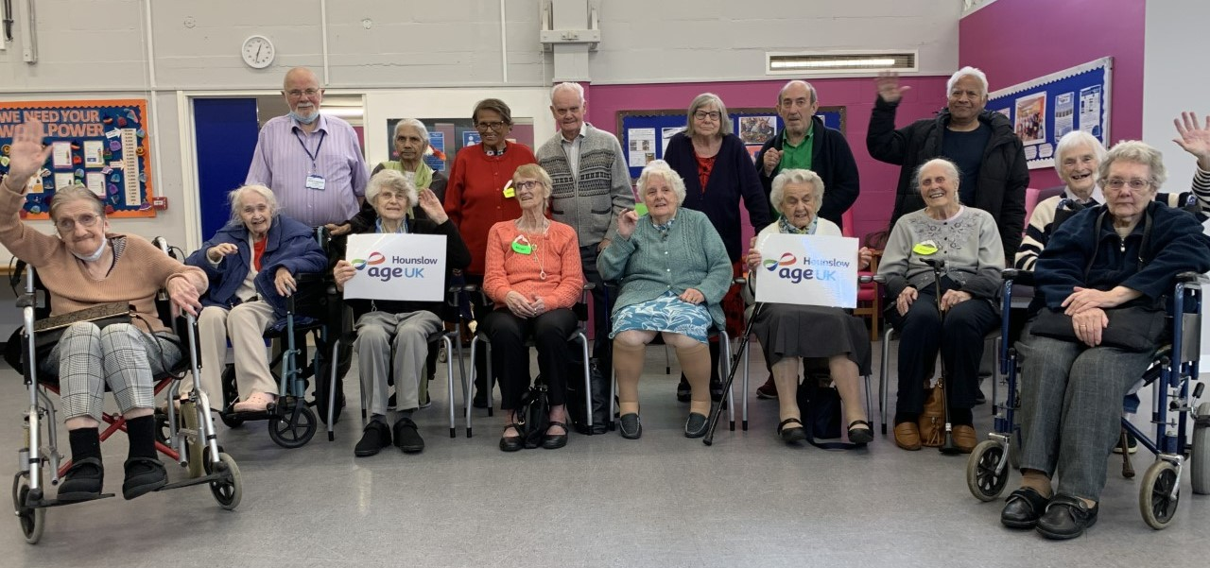

1. AIMS AND OBJECTIVES

The Age UK Hounslow Day Provision Service facility at Southville Community Centre is “a place where persons in need of prescribed services may attend for the purposes of low level day provision service where they are not provided with accommodation”; No personal care is provided and medications are not administered.

These services are targeted at persons aged 65+.

They are designed to meet the assessed needs of individuals for care, support, supervision or rehabilitation by reason of low level functional impairment, cognitive impairment, learning disability, age and frailty, family, or life circumstances.

Values and Standards
The philosophy and practice within a day provision service setting should lead to a friendly, caring and stimulating atmosphere where Service Users are listened to and feel valued, their rights are upheld, their cultural and religious beliefs are respected and participation in the day provision service is a positive and beneficial experience. In order to achieve this, managers and staff working in the day provision service must at all times have the following values firmly embedded in their practice.

Fulfilment
Service Users are enabled and supported to lead full and purposeful lives and realise their ability and potential.

Dignity and Respect
The uniqueness and intrinsic value of individual Service Users is acknowledged and each person is treated with respect.

Independence
Service Users have as much control as possible over their lives whilst being protected against unreasonable risks.

Rights
The individual and human rights of Service Users are safeguarded and actively promoted within the context of services delivered.

Equality and Diversity
Service Users are treated equally, their background and culture are valued, and services provided fit within a framework of equal opportunities and anti-discriminatory practice.

Choice
Service Users are offered, wherever possible, the opportunity to select independently from a range of options based on clear and accurate information.

Consent
Service Users have a legal right to determine what happens to them, and their informed, genuine and valid consent to the care and support they receive is essential.

Safety
Service Users feel as safe as possible in all aspects of their care and support, and are free from abuse, exploitation or neglect.

Confidentiality
Service Users know that information about them is managed appropriately and everyone involved in and with the day provision service setting respects confidential matters.

When these values are fully integrated into all aspects of planning, delivery and review of services, and the minimum standards are being met, the day provision service setting will be a resource that delivers the best possible outcomes for its Service Users.

2. APPLICATION PROCESS
Referrals are made via the London Borough of Hounslow, from GP’s and other health professionals as well as self-referrals and referrals from family and friends. Irrespective of the channel of communication to Age UK Hounslow the admission criteria need to be met.

All applicants are required to have completed an Application Form (Appendix A) which is generally completed by Social Services, GP, Health Practitioner, next of kin or family members and on occasion by the individual themselves.

Age UK Hounslow (AUKH), upon receipt of the application, ensures that the criteria are met for the application process to continue.

CRITERIA OF APPLICANT
The applicant needs to reside in the London Borough of Hounslow and if transport is required would live within the AUKH designated transport area (details available upon request). If outside this limit the applicant would need to arrange their own transport to and from the Day Provision Service. This criterion is necessary to fit in with current arrangements for the collection and return of Service Users.

- No medications are administered by Day Provision Service staff.
- No personal care is offered.
- No toileting assistance is provided (emergencies of course are assisted).
- Applicants with incontinence issues are not offered a place.
- Applicants assessed with high-level medical / mental needs are
not offered a place.
- Members taking medication must be able to self-medicate, and must sign a declaration confirming their ability to do so.
- Any temporary medication requirements must be notified to AUKH staff in writing.
- Low-level to moderate-level Dementia / Alzheimer’s is acceptable.
- Mobility frailty is common in old age, and applicants with walking sticks or frames are acceptable.
- Wheelchair users are acceptable.
- If a Service User suffers one or more falls, a Risk Assessment for both the Service User and AUKH staff and volunteers may prohibit the member’s continued use of the service.
- The individual needs to be able to mobilise themselves.
- The individual must agree to become a member of AUKH.

Staff members do not administer medication or creams and lotions.

No alcohol is permitted on site at any time.

Anyone wishing to attend the Day Provision Service would have a pre- visit and attend for a trial day. They may be accompanied by a relative or friend of their choice to assist them in the decision as to whether the Day Provision Service is suitable for their needs.

In some circumstances Service Users may be required to undertake a professional assessment of their physical and mental health needs in order to continue their attendance at the centre.

RELIGION
Service Users are encouraged to observe their religious and cultural activities if they choose to.

3. SERVICE USERS PACK
Anyone wishing to consider attending the Day Provision Service will be given the following, either in advance or during a visit :

- Age UK Hounslow – The Southville Vintage Club Day Provision Service Booklet
- Application Form with criteria
- Transport information
- Emergency Contact Form
- Activities Programme
- Details of all Policies and Procedures of Age UK Hounslow
- Copy of Complaints Procedure
- Gifts and Bequest Policy
- AUKH Membership Form
- Privacy Notice
- Marketing & Digital Consent Form

4. NEEDS ASSESSMENT PLAN
Detailed information is provided in advance of agreeing the individual service plan. The application process identifies any specific needs of the applicant. Additional information is collected in certain cases. The applicant is expected to be `low level’ and to be able to mobilise themselves, feed themselves and perform all their own personal care requirements.

5. MEDICATION
AUKH staff do not administer medication to Service Users.

All medication required must be notified to the staff in writing together with a copy of the prescription - this includes any medication taken on a temporary basis. This information will be kept on the Service Users file.
If medication is required, the Service User needs to be able to self-medicate. Preferably medication is taken outside the hours of the Day Provision Service.

Changes of medication can affect a person in a variety of ways and this is an important consideration in the monitoring of the individual.

6. MONITORING OF THE INDIVIDUAL
Daily observation is made of the person and identifiable changes are noted on the Service Users file. Engagement would be made with the individual to discuss any issues. Contact is made with the person and family members to update any changes in their requirements. In the event that any of the criteria points are no longer being met, engagement is made with Social Services and the family to seek alternative day/nursing care.

If a member’s mental or physical needs are re-assessed as high-level, that member would no longer be considered eligible to continue their attendance at the Day Provision Service.

7. BEHAVIOUR OF THE SERVICE USER
Staff need to have knowledge and understanding of each individual Service User’s usual conduct, behaviour and means of communication. The Support Worker needs to be aware of any changes affecting the person’s normal behaviour. The Support Worker would follow the procedure of notification to next of kin, to discuss reasons for any changes and deal accordingly.

Each Service User has the right to develop and maintain personal
relationships with people of his or her choice and this is respected. If a Service User is assessed as lacking the capacity to consent to such a relationship the Support Worker should be notified who in turn will communicate with the next of kin or social services as required, and the appropriate action would be taken.

When a Service User’s behaviour is uncharacteristic and causes concern, staff will respond sensitively, provide appropriate reassurance and report the matter to the Support Worker. There may be many reasons for such behavioural changes, and engagement with next of kin or social services may reveal issues which can then be managed appropriately.

Restraint and seclusion shall be used only for controlling any violent behaviour or to protect the Service User or other persons, and then only as a last resort when other less restrictive strategies have been unsuccessful. Any intervention used is proportionate to the risk of harm, and any situation that led to use of restraint or seclusion is subject to multi-disciplinary review, with a view to avoiding the need for such intervention in the future. Records are kept of all instances when
restraint or seclusion is used, and of the review of their use.

8. REPORTS AND RECORDS
Each Service User has a named file which contains a series of documents:-
- Photograph of the Service User
- Original application form
- Next of Kin Form
- Medication Form / copy of prescriptions
- Copies of any medical documentation
- Other documentation as relevant to the individual
- Dietary needs
- Religion
- Code of Conduct signed document
- Allergies are noted on file and any requirement made known to all staff and volunteers.
- Notes as taken by the Support Worker on any developing needs or special requirements.

9. SERVICE USERS’ OUTCOMES PLAN
The intention for the stay of every elderly person is that their daily engagement should improve their quality of life physically, socially and educationally.

10. SERVICE USERS INVOLVEMENT
Every effort is made to overcome any barriers to full involvement due to diversity e.g. communication, physical disability, mental health.

Service Users, Next of Kin or Carers are expected to notify AUKH of any changes that would place doubt on whether the Service User continues to meet the Service criteria.

Service Users, Next of Kin or Carers on their behalf are expected to sign the Code of Conduct Document (Appendix B) which clearly identifies the criteria of expectation

Service Users are expected to treat the staff and volunteers with dignity and respect.

11. SMOKING and VAPING
No smoking or vaping is permitted on the premises (including the garden and car park areas).

12. ACTIVITIES AND EVENTS
AUKH provide activities for the Service Users on a daily basis. The proposed Activity Programme is discussed with the staff, volunteers and Service Users and is defined on the basis of the Service User’s requests.

A balance is obtained between social, physical and educational needs. All physical activities are provided by fully qualified tutors. All activities commence following a risk assessment.

Service Users do not have to participate in the day’s activities and events but are encouraged for their wellbeing to do so.

There are different activities and events each day, and a balance of mental / physical / educational and social activities is written into the programme.

All activities have a risk assessment performed prior to being introduced to the Service Users.

Activities such as Bingo are led by Day Provision Service Staff, but physical exercise is led by qualified paid tutors to deliver. Tutors are made aware of the needs of the individual Service Users they have in their group.

All exercise is performed as a group exercise but the needs of the individual are met by the qualified tutor.

Any equipment required for the performance of activities is purchased under BS standards. All equipment is regularly checked.

All Service Users are involved in the planned programme.

AUKH have provided a raised garden bed in the gardens to enable Service Users to perform small gardening tasks.

13. MEALS
Southville Community Centre has a staffed kitchen, and hot meals are prepared on a daily basis. Our kitchen currently holds the maximum 5 Star food standard qualification.

Details of any Service User’s special meal requirements are kept on file and would be dealt with and accommodated where possible.

14. TRANSPORT
AUKH provides a Minibus service with an automatic tail lift for the purpose of transporting members to and from the day provision service.

The minibus provider allocates an appropriate amount of time to check the mini bus and perform a risk assessment, dealing with anything relevant as required.

Regular service checks are completed and recorded, and any requirements are acted upon. Full vehicle records are available to view from the minibus provider.

An Escort is allocated to each journey to assist the Service User from the front door of their property to the mini bus and the reverse for the return journey.

Walking frames and walking sticks are the property of the Service User.

The journey each day has a set pattern dependent on attendees for that day.

The collection and return of Service Users is intended to happen at the same time each day (depending on traffic)

15. SERVICES USERS’ OWN EQUIPMENT
AUKH do not take any responsibility for the Service User’s own equipment, but would highlight any concerns to the Support Worker who in turn would notify the next of kin. AUKH would require confirmation that this was understood by the Service User before using the equipment.

There are currently no facilities to accommodate mobility scooters.

Service Users are responsible for their own money and valuables on site. AUKH do not take any responsibility for the Service User’s own property.

16. RISK ASSESSMENTS
Robust risk assessment processes are in place. Regular risk assessments take place of the premises, activities and the Service Users themselves to ensure that AUKH can meet all requirements in a safe controlled environment. Any issues identified are immediately dealt with. Reports are available to view as required.

17. COST OF SERVICE
The cost of attending the Age UK Hounslow – Day Provision Service is £25 per day. This includes transport costs for those living within a certain radius of the centre (details available upon request), a hot two-course lunch, tea and toast in the mornings and afternoon tea, and all daily activities.
Attendees of the service are required to become members of AUKH, as this enables them to receive information and services as part of the AUKH organisational assistance to older people in Hounslow.
The cost of membership is £10.00 per annum.

18. SAFEGUARDING VULNERABLE ADULTS
AUKH holds clear Safeguarding policies and procedures that embody all relevant legislation and links to local procedures. The AUKH Safeguarding Policy has been agreed by the London Borough of Hounslow, and copies are available online at www.ageuk.org.uk/hounslow .
Enhanced DBS certification is in place for all staff and for all regular volunteers. Any visiting volunteers are escorted at all times.

19. ACCIDENT / EMERGENCY PROCEDURES
Age UK Hounslow has Accident and Emergency Procedures

20. COMPLAINTS
All Service Users are provided with a copy of the Complaints Procedure which is displayed at the AUKH Day Provision Service. Copies are also available online at www.ageuk.org.uk/hounslow

21. SUGGESTION BOX
There is a Suggestion Box situated in the Day Room for the use of Service Users to suggest anything they wish to be considered regarding the Day Provision Service. Management have the responsibility to acknowledge every comment within 2 weeks of receipt.

22. LEAVING THE DAY PROVISION SERVICE SETTING
Where the person is assessed as lacking capacity to consent, a best-interest decision is to be made by professionals in a position to do so. AUKH and London Borough of Hounslow Social Services would engage with the next of kin and deal appropriately with the individual situation.
Places are offered and withdrawn at the discretion of the Board of Trustees which has full authority over attendance matters.
Policy guidelines on Mental Capacity and procedural guidelines for staff are available.
As an alternative AUKH will, where possible, offer the AUKH Befriending Service (telephone befriending or face-to-face visits) on a regular basis.

23. TIMETABLE OF CURRENT ACTIVITIES

10:00 am – Commencement of service for Service Users
(Refreshments of toast, tea and coffee available)

Activities (Daily programme is followed)

1:00pm - Hot cooked Lunch

Activities (Daily programme is followed)

2:30pm – Afternoon Tea and Refreshments

4:30pm – End of day
Daily activities include Social / Educational and Physical activities such as the following:

- Chair Based Exercises
- Tai Chi
- Fun and Fitness
- Gentle Exercises
- Falls Prevention
- Gardening (recently installed raised garden beds)
- Brain Teasers / Quizzes
- Reminiscence Sessions
- Board Games
- Singing
- Arts and Crafts
- Outings
- Painting
- Awareness Talks
This is a selection and not an exhaustive list. The activities are designed around the capabilities, needs and wishes of the daily audience.
Other events and activities (including Day Trips) take place throughout the year based on the religious calendar, the season, and any special anniversaries.

24. MANAGEMENT AND CONTROL OF OPERATIONS
AUKH employs Support Workers to run the day-to-day management of the Day Provision Service. Service hours are Monday to Wednesday inclusive from 9:00am to 4.30 pm.

The Support Workers are able to communicate daily with the Chief Executive Officer of AUKH by email, mobile, office telephone or in person.

All others at the Day Provision Service work with the Support Workers on day-to-day operations but report to the Chief Executive Officer in respect of all other issues.

25. DATA PROTECTION
All the requirements of data protection are followed in respect of Service Users attending the centre

26. POLICIES AND PROCEDURES
AUKH maintains and follows many Policies, with particular attention being given to those concerning Confidentiality, Data Protection, Safeguarding and Health & Safety. Staff, volunteers and Service Users are also covered by particular Policies. In addition there are documented a number of Processes and Procedures that are required to be followed. Certain of all these documents are available online at www.ageuk.org.uk/hounslow

27. MANAGEMENT OF RECORDS
Both manual and electronic records are kept, dependent on content. All data protection rules are followed to ensure security of data. Access to data is granted only to staff members who need access for the proper fulfilment of their roles and responsibilities. Data sharing outside of the AUKH organisation is only permitted with the full knowledge and agreement of the Service User or next of kin. Support Workers are responsible for completing, maintaining and monitoring all records. The Chief Executive Officer and/or Trustees of the Organisation are to be informed of any issue considered to be of an incident level for appropriate action.

All issues or matters relevant to the London Borough of Hounslow’s Social Services (or other) departments are documented as required and notified to the CEO.

28. RECRUITMENT / INDUCTION AND TRAINING OF STAFF
All staff are recruited, inducted and trained in line with the Organisation’s relevant Processes and Procedures, details of which are given in the AUKH Staff Handbook.

29. VOLUNTEERS
All volunteers are recruited, inducted and trained in line with the Organisation’s relevant Processes and Procedures, details of which are given in the AUKH Volunteer Handbook.

30. PREMISES, GROUNDS, SUITABILITY AND ACCESS
Southville Day Provision Service is a purpose-built Day Provision Service facility. Regular Premises and Health & Safety checks are performed and recorded.

31. HEALTH & SAFETY / FIRE SAFETY
AUKH performs regular Health & Safety and Fire Safety checks of all the facilities at the Southville Community Centre, including the Day Provision Service, and reports accordingly.

32. FIRST AID
There are a number of fully qualified staff First Aiders on site.

An Accident Book is kept in the Staff Office and procedures are followed. Copies of any reports are forwarded to the Chief Executive Officer at AUKH Southville Community Centre.

33. INCIDENTS
All incidents are written into the Incident Book and made known to the Support Workers. The Chief Executive Officer is immediately notified of any high level incidents and they are dealt with as required. The Incident Book is kept in the Staff Office at AUKH Southville Community Centre.

34. STAFF & VOLUNTEER JOB SPECIFICATIONS
Details of all staff and volunteer job descriptions are available upon request.

35. WEBSITE DETAILS
Age UK Hounslow’s homepage is at www.ageuk.org.uk/hounslow

Age UK Hounslow has a webpage dedicated to the Southville Vintage Club Day Provision Service. This can be found online at :

https://www.ageuk.org.uk/hounslow/our-services/southville

