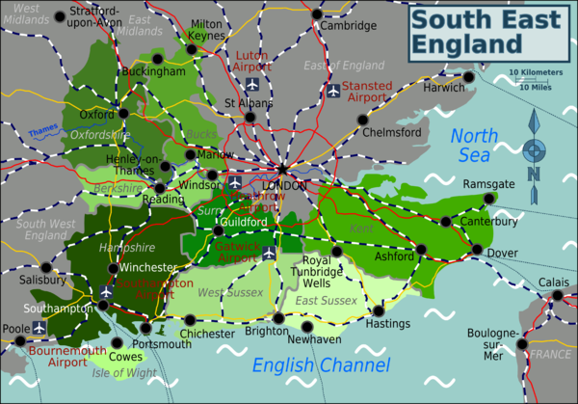



**Day Trips**

We will be organising our Day Trips soon.

Please let us know where you would like to go!

**Come to our centre, look online at** [**www.ageuk.org.uk/hounslow**](http://www.ageuk.org.uk/hounslow)or phone 020 8560 6969

**Southville Community Centre**

**Southville Road**

**Feltham**

**TW14 8AP**

**020 8560 6969**



Charity no 1061681

