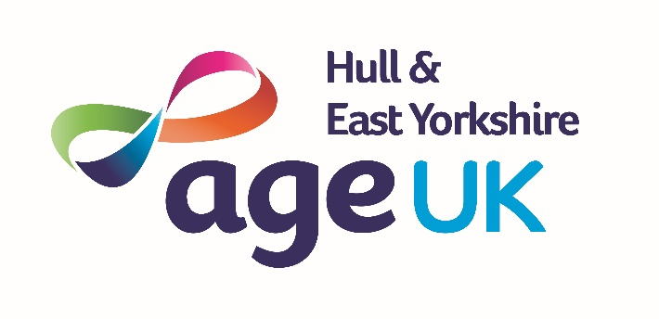
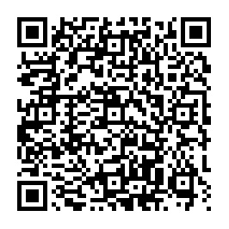

SPONSORSHIP FORM

Age UK Hull & East Yorkshire is a registered local, independent charity promoting the wellbeing of older people Hull and East Yorkshire. We are here to make later life a fulfilling and enjoyable experience for local people. Ensuring they get the services and support they need.
Name of Fundraiser:
Fundraising Event (including date):
Contact Details:

Use Gift Aid and you can make your donation worth more. For every pound you give to us, we get an extra 25p from the Inland Revenue. So, if you are a UK taxpayer just tick the Gift Aid box and give us your full name and address. It’s that simple.

Full name and title | Full home address  if you tick the gift aid box on the right, please ensure you have given us your  full name and address | Postcode | Gift Aid | Amount | Date Paid
Mr John Smith | 12 Sample Street, Hull | HU11 111 | ✓ | £5.00

Full name and title | Full home address  if you tick the gift aid box on the right, please ensure you have given us your full name and address | Postcode | Gift Aid | Amount | Paid

Thank you for supporting Age UK Hull & East Yorkshire. Your small change makes a big change to local older people.
All forms should be returned to:
Fundraising Co-ordinator, Age UK Hull & East Yorkshire, 350 Preston Road, HULL, HU9 5HH

01482 324644 www.ageuk.org.uk/hull e: fundraising@ageukhull.org.uk
Registered Charity No: 1101418. Company Number 04792749. Registered in England and Wales.

