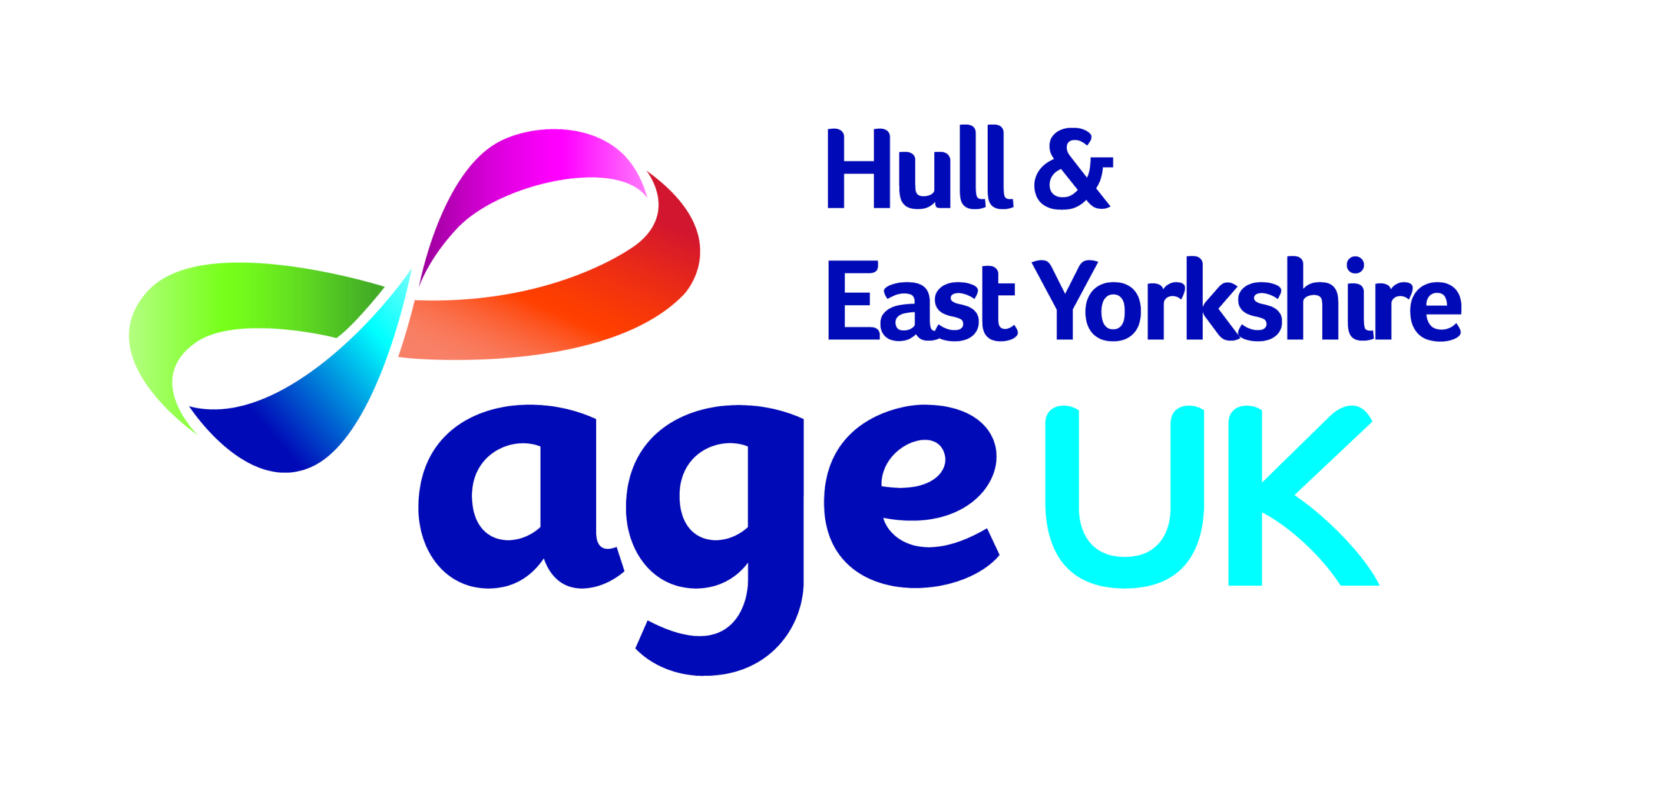
Equal Opportunities Monitoring Form

We ask you to respond to this information request positively as it will help us ensure that our policies and practices do not inadvertently discriminate against you because of your ethnicity.

Age UK Hull assures you that any information you provide here will only be used to monitor the effectiveness of our policies and we will take steps to ensure this information remains confidential.

Monitoring Questions:
How would you describe yourself?
Choose ONE section from A to E, and then tick the appropriate box
A
- Asian or Asian British
- Bangladeshi
- Indian
- Pakistani
- Any other Asian background, please write in box
B
- Black or Black British
- African
- Caribbean
- Any other Black background, please write in box
C
- Chinese or another ethnic group
- Chinese
- Any other, please write in box
D
- Mixed Heritage
- White and Asian
- White and Black African
- White and Black Caribbean
- Any other Mixed background, please write in box
E
- White
- British
- English
- Irish
- Scottish
- Welsh
- Any other White background, please write in box
F
- Prefer not to say

Disability Monitoring
To make positive changes, Age UK Hull wants to address the different barriers faced by disabled people. Many people who do not consider themselves to be disabled may be covered by the Equality Act 2010 because they have a health condition that has an impact on their lives.
What do we mean when we say disability?
- Do you have a physical or mental impairment?
- Is it long term?
- Does this make it difficult for you to do the things that most people do on a regular and frequent basis?
If so, you may have rights under the Equality Act 2010. This includes people who are receiving treatment or using equipment (except glasses or contact lenses) that alleviates the effects of an impairment or a condition, people with an impairment or condition that is likely to recur, people who have conditions that will get worse over time and people with severe disfigurements.
Employees with a disability or health condition are entitled in law to ‘reasonable adjustments’ to address their needs for support in the workplace. Therefore, we are interested in any disability or health condition that may require a reasonable adjustment to overcome any such barriers.

Monitoring questions:
Do you consider yourself to have a disability or a long-term health condition?
YES NO
What is the effect or impact of your disability or health condition? (You can put ‘prefer not to say’)
…………………………………………….
If you would like to discuss your response or are unsure of the types of reasonable adjustment that might be possible, please contact your Line Manager who is trained to help and support you.

Age UK Hull is committed to creating an environment where barriers are removed for disabled people, and they can give of their best to succeed in our organisations.
Age UK Hull gives a commitment that this information will remain confidential.

Gender Monitoring
Concentrations of either men or women into certain jobs, the impact of family commitments are some reasons why men and women experience the workplace differently. Gender monitoring is key to ensuring that all employees have access to the same opportunities and Age UK Hull is committed to work at achieving this.

Monitoring question:
Would you describe yourself as: Female Male

