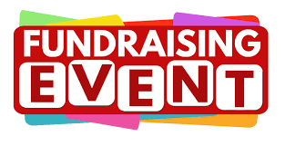
UPCOMING FUNDRAISING EVENTS

Every event is a chance to raise funds, build connections, and spread a little joy. Check out what’s next…

Event | Location | Date and time
Bingo – £2 entry Bingo cards £2 a book (6 Games) | The Pheasant, Trinity Road,  Ashford, TN25 4BY | Tuesday, 3rd March 2026  6.30pm - 9.00pm
Bingo – Free entry Bingo cards £11 Games | Hythe Hub, Sanford House, Stade Street, Hythe,  CT21 6BD | Thursday, 5th March 2026  6.00pm - 8.30pm
Italian Night £35.00 per person – Booking Essential | Hythe Hub, Sanford House, Stade Street, Hythe,  CT21 6BD | Friday 6th March 2026  From 6.30pm  Food served from 7.00pm
Spring Party £15.00 per person booking essential | Hythe Hub, Sanford House, Stade Street, Hythe,  CT21 6BD | Saturday 28th March 2026  7.00pm - 11.00pm
Bingo – Free entry Bingo cards £11 Games | Hythe Hub, Sanford House, Stade Street, Hythe,  CT21 6BD | Thursday, 2nd April 2026  6.00pm - 8.30pm
Bingo – £2 entry Bingo cards £2 a book (6 Games) | The Pheasant, Trinity Road,  Ashford, TN25 4BY | Tuesday, 7th April 2026  6.30pm - 9.00pm
Keep an eye on this space for more exciting fundraising events throughout the year!
For further information or to book on any of our events please call us on
01303 269602

