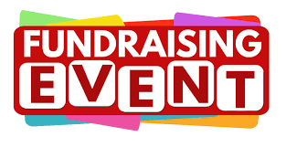
UPCOMING FUNDRAISING EVENTS

Every event is a chance to raise funds, build connections, and spread a little joy. Check out what’s next…

🎁 Raffle & Tombola Prizes Wanted 🎁
We need unopened gifts, bottles, and treats to make our Christmas events sparkle ✨
Ideas: bottles (shampoo to wine), sauces & pickles, chocolates & biscuits, candles, toys & games.

📅 Drop donations at either centre by
14th November
📞 Call 01303 269602 for details
💜 Thank you for supporting local older people!

Event | Location | Date and time
Bingo | The Pheasant, Trinity Road,  Ashford, TN25 4BY | Tuesday, 4th November 2025  6.30pm - 9.00pm
Bingo | Hythe  Hub | Thursday, 6th November 2025  6.00pm - 8.30pm
Wine Tasting | Hythe  Hub | Friday, 7th November 2025  7.00pm - 10.00pm
Christmas Fair | Hythe  Hub | Saturday, 29th November 2025  10.00am - 2.00pm
Bingo | The Pheasant, Trinity Road,  Ashford, TN25 4BY | Tuesday, 2nd December 2025  6.30pm - 9.00pm
Bingo | Hythe  Hub | Thursday, 4th December 2025  6.00pm - 8.30pm
Chef on the Run – Final Total!
Our Head Chef, Joe, completed the Folkestone Half Marathon on 28th September 2025 and raised an incredible £1,630.00! 👨‍🍳🎉 A special thank you to Sylvia, one of our amazing volunteers, for her generous donation, and to everyone who supported Joe.
Every penny will help us continue providing vital services in our community. 💙
