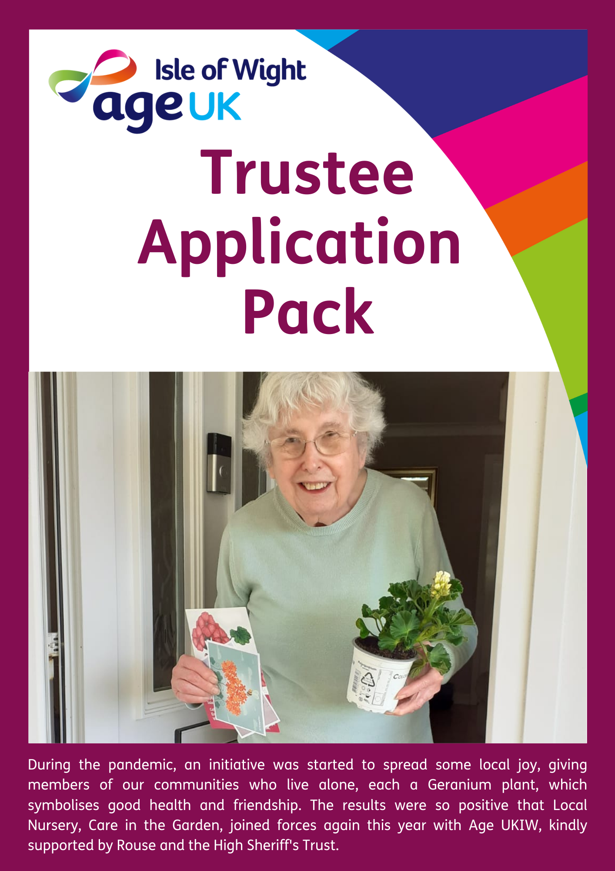

This pack contains the following:
Message from the Co-Chairs | Page 3
Could you be a Trustee for Age UK Isle of Wight? | Page 4
AUKIW Trustee Board Specification | Page 5-6
Role of a Trustee and Role of a Chairman | Page 7-9
AUKIW Trustee Application Form | Page 10-12

Dear Applicant

Thank you for showing an interest in becoming a Trustee of Age UK Isle of Wight.

In this application pack, we have included key information both about the charity and what it strives to achieve, the Trustee Board and the Trustee vacancies which currently exist.

Being a Trustee and thereby contributing to our local Island community is valuable time well spent and personally rewarding. It is also enjoyable to work alongside an enthusiastic and talented senior leadership team. We are individuals drawing upon our combined experience and skills and our ability to take sound, challenging decisions can generate positive outcomes for the wellbeing of the charity. But the real differences are those made by our staff and volunteers, who every day in a variety of ways, support older people to keep healthy, remain independent and included.

Our older population is growing and demand for our services is increasing. The pandemic has left a legacy that needs to be addressed including social isolation, mobility and mental health. Age UKIW is constantly exploring opportunities for public and private sector funding to deliver help to greatest effect. Volunteers are vital in providing much-valued community lifelines. Collaboration with other charities ensures we are cost effective, and our priorities are appropriately focused. A range of client paid-for services, continuously reviewed to ensure that it meets needs, aims to keep people independent. Fundraising in its many forms is rightly the concern of Trustees, to ensure that it has the confidence of our donors and meets our longer-term needs.

To underpin this, the Trustee Board is committed to ensuring that it demonstrates good practice through strong and effective governance.

Having read this application pack we hope that you will apply for one of our Board vacancies, and we look forward to hearing from you.

Yours sincerely

Sheila Evans and Lorraine Buckman
Co-Chairs, Age UK Isle of Wight

Could you be a Trustee for Age UK Isle of Wight?
Are you looking for a new challenge and willing to contribute your time and life experience to your community?

About Age UK Isle of Wight
Age UK Isle of Wight has been caring for older Islanders since 1973. We are an independent registered local charity, responsible for our own funding and services, and money raised is spent locally. We are a brand partner of the national Age UK organisation. We aim to deliver services across the Island to encourage and assist older people keep healthy, remain independent, improve their quality of life and feel socially included. Click here to read more about the Services we provide.

Due to the retirement of a number our Trustees we are seeking several people to join us from a variety of backgrounds, to strengthen our Board, and possibly one to undertake the role of Chairman from November. Professional qualifications aren’t important, and you should just be willing to support the Age UKIW management team plan and deliver their charitable purpose. Trustees approve the strategic direction and priorities of the charity, monitor risk and ensure legislative compliance. New Trustees will be supported in their new roles through a comprehensive induction programme and with peer support to enable them to become effective members of the team of Trustees.
What are we looking for in new Trustees?
- A desire to improve the lives of older people
- To contribute one or more of the specific skills and experience identified in red within the AUKIW Trustee Board Specification (detailed on page 5)
- The ability to attend up to eight meetings/events each year (we will try to be flexible around your availability)
- Willingness to commit to an initial appointment of three years
- To perform the role without remuneration (however, Trustees can claim reasonable expenses in accordance with our expenses policy).
- To ideally either live or work on the Island and are familiar with its way of life

Click here to read short biographies of our current Trustees

How to apply to be a Trustee?
If you would like more information, please contact Amy Gallop via email amy.gallop@ageukiw.org.uk Alternatively, please complete the Application Form and Declaration at the end of this Pack and send to amy.gallop@ageukiw.org.uk

AUKIW Trustee Board Specification
The ideal Trustee Board will comprise of individuals bringing diverse skills, work and life experiences, personal qualities and motivation, who work together in the charity’s best interests. This specification identifies the various skills, backgrounds and attributes that the Trustee Board as a whole will possess. Regular audits will clarify where shortfalls exist at various times to assist in future Trustee recruitment.

Due to the retirement of a number of Trustees we have undertaken a skills audit to identify the current gaps within our Board and in order to ensure we have the right breadth of skills and experience our initial focus will be on recruiting Trustees who meet at least one of the criteria identified in red on pages 5 and 6:

Management Skills and Experience  - Management/organisational leadership/Change Management  - Strategic Planning/policy development  - Team working  - Commercial/ Local Government/ Public Sector or Charity Sector  - Monitoring and evaluating performance | Human Resources  - HR, workforce planning experience  - Appraisal, training, development, mentoring  - Discipline, grievance, investigations  - Selection and interviewing processes  - Equality/diversity policy development and implementation
Finance Experience  - Managing Budgets  - Finance Strategy  - Audit and Risk management  - Performance Indicators  - Quality Assurance | Relevant work, personal or voluntary experience  - Work with older people  - Work with carers/families  - Voluntary sector experience  - Personal caring responsibility/service user  - Community knowledge and developed local networks
Information and Communications Technology  - Strategy  - Knowledge and experience of prevailing trends in systems technology  - Informed on equipment needs and opportunities | Income Generation/Funding  - Commercial Business development  - Statutory/public sector funding  - Fundraising from the public  - Grant awarding bodies and trusts
Legal Knowledge  - Company and Employment Law  - Charity Law, Contract Law  - Financial Regulations  - Health/Safety Regulations  - Trustee responsibilities | External Communication/Marketing  - Presentations to large audiences  - Presentations to the Press  - Communications strategy development  - Marketing experience  - Communications experience (Media/PR)
Attributes of all Trustees:
- Willing to give personal, unpaid time to benefit AUKIW and its clients
- Motivated to support the needs and concerns of older, vulnerable Islanders
- Commit to regularly prepare for and attend Board and other Committee meetings
- Ambassador for Fundraising and promotion of AUKIW
- For Board continuity, prepared to serve for at least one three-year term, preferably longer

In addition, the Chairman will have the following qualities:
- Leadership skills
- Experience of committee work
- Tact and diplomacy
- Good communication and interpersonal skills
- Impartiality, fairness and the ability to respect confidences

Role of a Trustee

The key responsibilities of a Trustee are as follows:
- Ensuring that Age UKIW pursues its stated objects, as defined in its latest Memorandum and Articles of Association by developing and agreeing its long-term strategic direction with a clear vision and mission.
- Ensuring that Age UKIW complies with its governing document, Charity Law, Company Law and any other relevant legislation or regulations.
- Ensuring that Age UKIW applies its resources exclusively in pursuance of its charitable objects for the benefit of the public.
- Being responsible for the performance of Age UKIW and for its culture. Ensuring that the organisation defines its goals and evaluates performance against agreed targets.
- Safeguarding the good name and values of Age UKIW.
- Ensuring that the Charity’s governance is of the highest possible standard. Ensuring the effective and efficient administration of the organisation, including having appropriate policies and procedures in place in accordance with the organisations quality standards.
- Setting the expectation for a Quality Framework within Age UKIW and monitoring its implementation.
- Ensuring the financial stability of Age UKIW and its future sustainability
- Ensuring AUKIW’s approach to fundraising is in keeping with its purpose and values. Raising funds in a way that secures public trust and confidence, by adhering to the Code of Fundraising Practice and other important guidance around direct marketing and donor consent.
- Protecting and managing the property of Age UKIW and ensuring the proper investment of the Charity’s funds.
- Following proper and formal arrangements for the appointment, supervision, support, appraisal and remuneration of the Chief Executive Officer

In addition to the above statutory duties, each Trustee will need to use any specific skills, knowledge or experience they have to help the Board of Trustees reach sound decisions. This may involve reviewing and commenting on Board papers, participating and sometimes leading discussions, focusing on key issues, providing advice and guidance on new initiatives, or other issues in which the Trustee has special expertise.

In order to carry out your responsibilities as a trustee, you should;
- be committed to the purpose, objects and values of the organisation
- be constructive about other trustees’ opinions in discussions (and in response to staff members’ contributions at meetings)
- maintain confidentiality on sensitive and confidential information at all times
- understand the importance and purpose of the meetings, and be committed to preparing for them adequately and attending them regularly
- be able to analyse information and, when necessary, challenge constructively
- participate in making collective decisions and be prepared to stand by them
- at all times respect boundaries between executive and governance functions

Role of a Chairman
In addition to the general responsibilities of a Trustee, responsibilities of the Chairman include the following;
- Providing leadership to Age UKIW and the Board by ensuring that everyone remains focused on the delivery of the organisation’s charitable purposes in order to provide greater public benefit
- Ensure Trustees fulfil their duties and responsibilities for the proper governance of the Charity
- Chairing and facilitating Board meetings
- Giving direction to Board policy-making
- Checking that decisions taken at meetings are implemented
- Monitor the progress of the organisation against its strategic objectives
- Representing and promoting Age UKIW at functions and meetings, and acting as a spokesperson as appropriate
- Bringing impartiality and objectivity to decision-making
- To support and where appropriate, to challenge the Chief Executive Officer and to ensure the Board as a whole works in partnership with the senior leadership team
- With the Chief Executive Officer;
  - Ensures effective communication between Board and Staff
  - Plans the annual cycle of Board meetings and other general meetings where required
  - Sets agendas for Board and other general meetings
  - Develops the Board of Trustees including recruitment, induction, training, appraisal and succession planning
  - Ensures the Board regularly reviews its structure, role, relationship to staff and implements any necessary changes
  - Addresses conflict within the Board and within the organisation
  - Keeps an overview of the organisation’s affairs and to provide support as appropriate
- Leads the process of supporting and appraising the performance of the Chief Executive Officer
- Sits on appointment and disciplinary panels
- The Vice Chair acts for the Chairman when the Chairman is not available and undertakes assignments at the request of the Chairman

AUKIW Trustee Application Form
Please print clearly completing all details, thank you.
Name: Ms/Miss/Mrs/Mr
Address: | Telephone:
 | Mobile:
Email:
Current or Most Recent Occupation:
Role Applying For: Trustee Only Yes/No Trustee and Chair Yes/No

How did you find out about becoming a charity trustee with us?
(Please ü any boxes below)

Advert in Newspaper |  | From a Client/Employee of Age UKIW
Press Release |  | Referred by a friend/colleague
Age UK Isle of Wight Website |  | Social Media
Other

Please explain what interests you in becoming a Trustee for Age UK Isle of Wight. What experience and knowledge will you bring to the role?

Skills and Experience for Trustee Role

Please indicate below which skills, capabilities and experience you feel you can offer Age UKIW. Please tick as many as appropriate.

Functional skills and experience
Finance and Audit |  | Company Secretary |  | Charity Management |  | Management / Supervision
Legal |  | HR |  | Governance |  | Tax and VAT
Buildings Management |  | Strategic Planning |  | Project Management |  | Quality Systems
IT |  | Communication |  | Training |  | Leadership

Specific skills and experience
Falls Prevention |  | Safeguarding Adults |  | Adult social care |  | Community development
Housing |  | Health / Mental |  | Disability |  | Caring
Advocacy |  | Volunteer |  | Wellbeing |  | Evaluation

Income generation skills and experience
Retail/Social enterprise |  | Fundraising |  | Business management /development |  | Sponsorship / corporate relationships
Legacies |  | Events Management

Current/previous employment and voluntary roles, skills and experience: (If applying for the role of Chairman please also include here your skills and experience for this type of role)

Qualifications

In order that we may offer you appropriate support, please advise us of any access or support you would need, to attend an interview and if appointed, to fulfil your role as a Trustee.
Data Protection and Consent
Your personal information from this application form will be stored and processed for the purposes of Trustee recruitment, and ongoing term in office should you be successful in this application.

Personal information will be deleted once it is no longer required, in accordance with Age UK Isle of Wight record retention procedures. You have the right to access the personal information held about you on request via amy.gallop@ageukiw.org.uk

I give consent to Age UK Isle of Wight to:
process my personal information for the purposes of trustee recruitment administration Yes / No

Declaration
I declare that the information given in this application is, to the best of my knowledge, complete and correct and I do not know of any reason that prevents me from becoming a Charity Trustee. Please also sign the declaration of eligibility attached to this form.
Note: Any false, incomplete or misleading statements may lead to later dismissal should you be selected for the role of Trustee.
Please Note: As a Charity that works primarily with vulnerable adults, we have a duty of care to our clients therefore this role will require an Enhanced Disclosure and Barring Service check, further details can be supplied on request.
Signature

Date

