

*“Working in partnership with the Alzheimer’s Society, the Metropolitan Police Service are promoting a programme that will reduce the stress to the individual, loved one, family, friends and carer should they go missing.*

*Together we are making London a more dementia friendly city.”*

Alison Newcomb  
**Deputy Assistant Commissioner  
Metropolitan Police Service**

In the event when your family member or friend does go missing the form can be easily handed to the police to reduce the time taken in gathering this information.

Did you know that 61% of people living with dementia think that their community has little or no understanding of how to help them live well?

With an ageing population and improving diagnosis, dementia is something that will almost inevitably affect us all, either personally, professionally or both.

People still need their independence and The Herbert Protocol can help to reassure their family and friends that if their loved one does go missing, they can quickly pass relevant information to the police.

We believe that by helping people to help us in our response to vulnerable missing adult we will be able to locate him or her more quickly, safeguard them more effectively, and return them to safety before any harm can come to them.

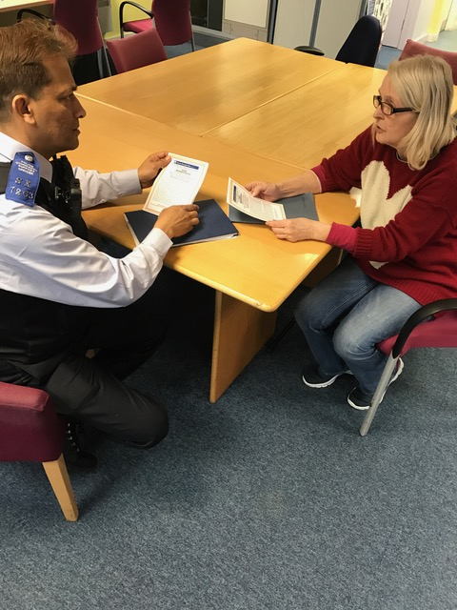

There is nothing more frightening than when a loved one, friend or neighbour fails to return when they should. For people living with dementia, this could be quite common and The Herbert Protocol could give you some peace of mind.

The Herbert Protocol is a national scheme being introduced by the Metropolitan Police and other agencies which encourages carers to compile useful information which could be used in the event of a vulnerable person going missing.

The Herbert Protocol will put systems in place to allow for early interventions when vulnerable people go missing.

The idea is to complete a form recording all vital details such as medication required, mobile numbers, places previously located, a photograph etc.

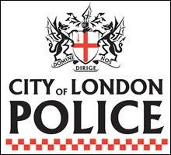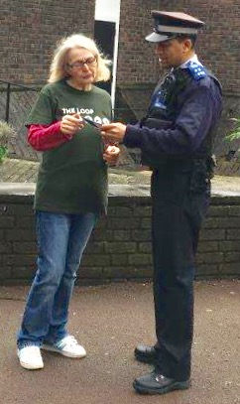

**DO YOU CARE FOR SOMEONE WITH DEMENTIA AND WORRY THEY MAY GO MISSING?**

**WE ARE HERE TO HELP**

Give copies of the completed form to other family members, friends and neighbours with an up to date photograph attached. If your loved one goes missing and the information is handed to a police officer, the photograph can be circulated to all police officers and PCSOs on the front line via their Tablets or Mobil Data Terminals.

Once the person is located the form & photo are not stored or kept by Police but returned.

Forms and leaflets can be downloaded from:-

[www.met.police.uk/herbertprotocol](http://www.met.police.uk/herbertprotocol)

*‘Alzheimer’s Society is very pleased to be working with the Metropolitan Police on rolling out the Herbert Protocol in London as part of creating a Dementia Friendly capital city.*

*This initiative will enable the Met to respond more quickly and efficiently if a person living with dementia goes missing. This means that they are more likely to be found safe and sound. Alzheimer’s Society values greatly our partnership with the Met as part of creating a Dementia Friendly London. This practical initiative is one of many to make London a better place for people with dementia and carers to live’*

**Tim McLachlan B.Sc (Hons) MBA  
Operations Director – Greater London**