  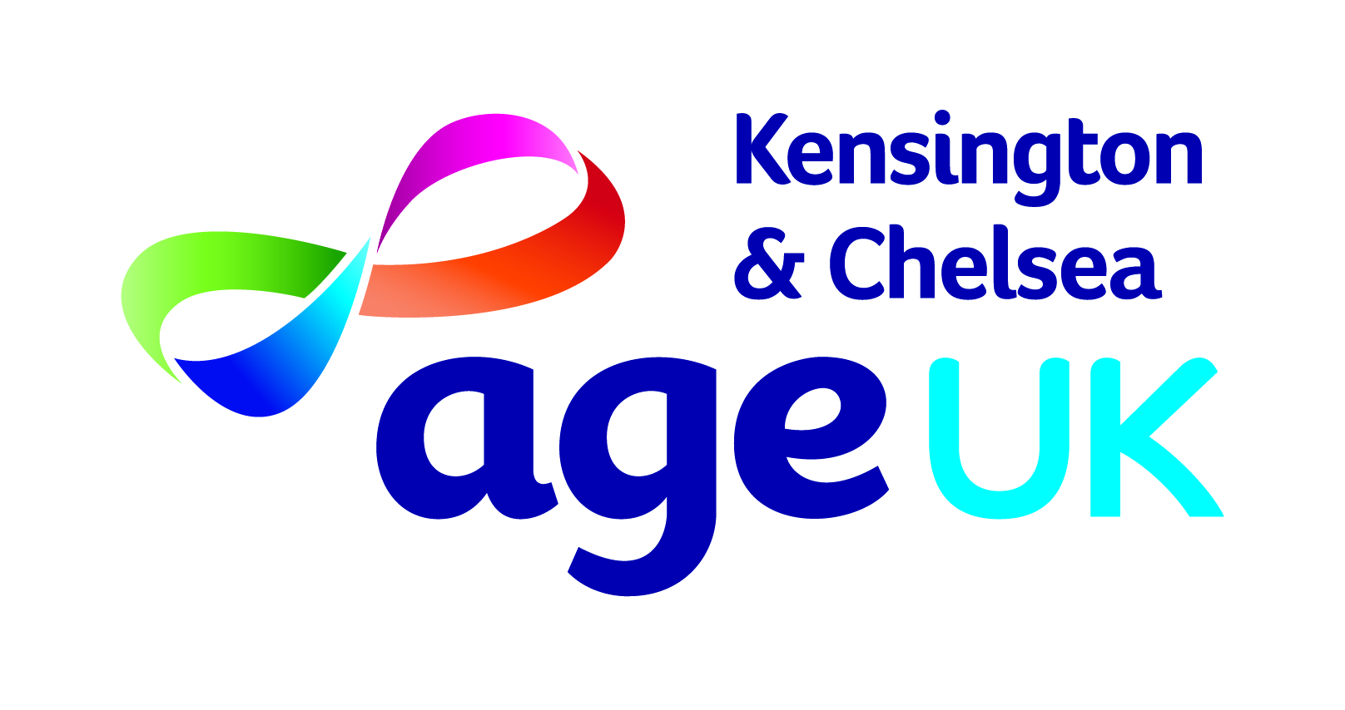
EMERGENCY CALL LIST
AGENCY | EMERGENCY / OUT OF HOURS | NON-EMERGENCY | NOTES
POLICE | 999 / 112 | 101 | 112 is the FREE emergency number that you can call 24/7, from a landline or mobile phone, in all 28 member states of the European Union, and some other countries, to get immediate assistance.
AMBULANCE | 999 / 112
FIRE | 999 / 112
BRITISH TRANSPORT POLICE | 999 | 0800 40 50 40
NHS | 999 | 111 | 111 should be used when you need immediate medical advice and guidance but it is NOT a life-threatening situation.
SOCIAL SERVICES | 020 7373 2227 | 020 7361 3013 | Statutory Mental Health Assessments, vulnerable adults and elderly residents, child protection emergencies and other children and family issues. The Tri-Borough documentation relating to safeguarding adults can be found at: M:\Core\Admin\Reception\Useful Contacts\EMERGENCY CONTACT DETAILS\Tri-borough Safeguarding Information
SOCIAL SERVICES | Email: socialservices@rbkc.gov.uk
GAS | 0800 111999
WATER | 0800 714 614 | 0800 714 614 | Reporting a leak
 | 0800 316 9800 | 0800 316 9800 | Sewer issues
ELECTRICITY | 0800 028 0247 |  | UK Power Networks (London Area)
Anti-terrorist Hotline |  | 0800 789 321
CrimeStoppers |  | 0800 555 111
National Crime Agency |  | 0370 496 7622
NSPCC Helpline  Victim Support Line |  | 0808 800 5000  08081689111
TRADING STANDARDS |  | 0207 361 3002

