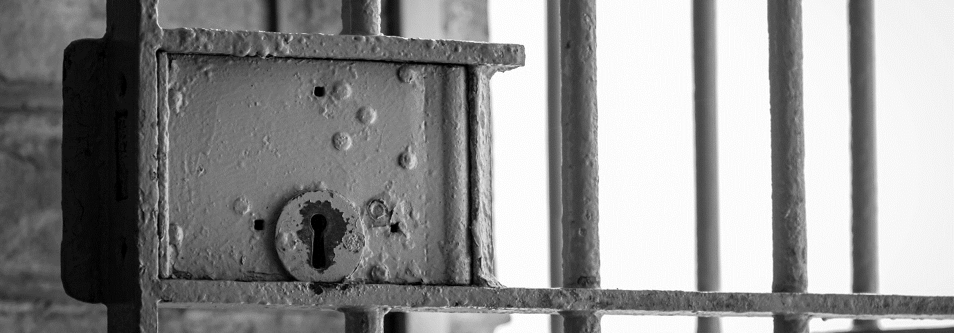
Break Out
Application Form:
Thank you for your interest in our Break Out event. Please read the following information and complete the application details. Once completed please email to dward@ageuklancs.org.uk
Event overview:
Break Out has been created to raise money for Age UK Lancashire and give you as a local business the opportunity to promote your brand to a wider audience. Taking place in a secret location in Lancashire, we will ‘lock up’ the participant with only their phone available to them.
In order to Break Out, the participant must use their family, friends and business contacts to raise bail of £1000. They will do this using their mobile phone, social media accounts and with support from their workplace (hopefully!). Once £1000 has been raised, the prisoner will be released back into the world.
During the day, as well as contacting their network to ask for help to raise their bail, they will be given some fun tasks to complete for rewards of food and luxury items!
Throughout the day we will be sharing updates on social media to encourage support and recommend your organisation work with us to generate more interest and support for the release of the prisoner. Full guidance and support on how to do this will be provided. We will also set up the fundraising page which will be live on the day and regularly checked to monitor the progress of reaching the bail target.
Date: Tuesday 23rd June 2020
Time: 9.00am – 4.30pm (before if bail is reached!)
If Break Out sounds like an event you would like to be part of then simply nominate your boss, or other member of your business, to be locked up!
If you would like more details before completing this application form, then please call David Ward on 01257 444410 or dward@ageuklancs.org.uk
--------------------------------------------------------------------------------------------------------
You must ask the permission of the person you are nominating before completing this form.

Name of Prisoner:

Company:

Company Address:

Facebook:

Twitter:

Instagram:

LinkedIn:

Prisoner contact details:

Telephone:

Email:
Nominator (your) contact details:

Name:

Telephone:

Email:

Position in company:

Nominee signature: ____________________ Date: ________________
Nominator signature: ___________________ Date: ________________

