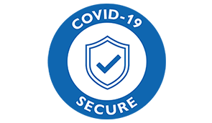

Age UK Lancashire Home Help Service
Health Professional External Referral Form

Name of Organisation
Referrer Name & Job Title
Contact Number & E-mail
Date
Consent Given to Contact, ( please answer Yes if consent has been given, a no answer will mean we cannot proceed with the referral

Service User Information
Name
Address
Including Postcode
Telephone No & E-mail
D.O.B

Page 1 of 2
Reason for Referral ( Please give brief details of service user requirements)

Privacy & Sharing Information
Age UK Lancashire is committed to protecting your privacy and takes its data protection responsibilities and obligations seriously in compliance with data protection law. The personal data we collect for the Home Help Service will be processed under the lawful basis of our contract with you and in the vital interests of the client and in accordance with our Privacy Policy. For further information on how Age UK Lancashire processes personal data, please read our Privacy Policy which is available at https://www.ageuk.org.uk/lancashire/privacy-policy/
By signing this form, you confirm that all information provided is accurate, and that the person being referred has been made aware of this process.
Signature: |  | Date:

What happens next?
We aim to contact the older person you have referred to the service within 5 working days to confirm that they would like to engage with the service.
Once we have been in touch with the person you have referred, we will not share any of their information without their permission and all the information provided will be stored securely and kept confidential.
Please Email to: homehelp@ageuklancs.org.uk
(If you need to contact Age UK Lancashire for information or advice please call 03003031234 between 9am & 5pm Monday to Friday. If you need to speak to someone outside our opening hours you can contact the national Age UK Advice line on Freephone 0800 678 1174 which operates 365 days a year from 8 am - 7 pm)
Page 2 of 2

