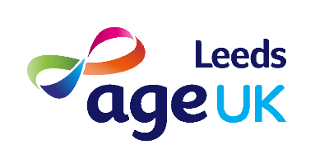
Older Peoples Engagement Group
The purpose of our Older People’s Engagement Group is to support the charity to involve older people in the development and delivery of our services and projects.
The group is made up of volunteer client representatives who link with older people, our staff and volunteers, our partners and other organisations in a variety of ways to represent the views of older people.
Our aim is to involve older people in all aspects of the organisation and we are always looking to improve what we do as a group. Some ways that the group are already providing support includes:
Staff Recruitment
Members of the Older Peoples Engagement Group can sit in on candidate interviews and have a valuable input into staff recruitment.
Feedback
Guided conversations: developing a model to collect client feedback and using this to inform how we develop and deliver our services
Developing new and existing projects and services including
- Development of our mental health work
- Input to funding applications and tenders
- Linking with our services, attending team meetings twice a year and shadowing our staff and volunteers
- Providing feedback on our Strategic Plan
Campaigns
Working on local and national campaigns.
https://www.ageuk.org.uk/our-impact/campaigning/
If this is something you think you would like to be involved in please have a look at the role description and complete a volunteer application form.
To find out more please email Julie.skelton@ageukleeds.org.uk or call 0113 389 3000 and speak with our Front of House team and leave a message and someone will call you back.

