About Us

Age UK Leeds is a local, independent charity established in 1975, our aim is to help older people be valued, to have their voices heard and to be able to enjoy positive, independent lives.

Age UK Leeds has over 60 staff, full and part time and is supported by over 50 volunteers. It is managed by a Board of Trustees.

Age UK is a national network of brand partners whose common aim is “help more people love later life”. Age UK England, the national organisation, gives advice and support, but every local Age UK is an independent charity run by local people, raising their own funds to provide the services required within their own area. What we raise in Leeds, stays in Leeds!

Age UK Leeds is funded from a variety of sources including the NHS, local authority and other grants. However, like most charities, we also rely on donations and corporate partnerships. For more information about Age UK Leeds, take a look at our website: https://www.ageuk.org.uk/leeds/

Our Vision
Older people living in Leeds will be valued, their voices will be heard and they will be able to enjoy positive, independent lives
Our Mission
We will influence, shape and deliver responsive services, supporting the independence and wellbeing of older people in Leeds to positively improve their quality of life.
Our Strategic Aims
- Independence: Older people living with frailty or with a range of physical and mental health long term conditions (and disabilities) will be enabled to maintain their independence
- Social Connections: Everyone should have someone; older people who experience loneliness and social isolation will be provided with a range of tailored opportunities to link with others in their community
- Health and Wellbeing: Older people, including those living with frailty and long-term health conditions or disabilities, will sustain their optimal physical, mental, emotional health and well-being

- Resilience, choice and control: The resilience of older people and their carers has been severely tested over recent years, our aim is to help to re-build their capacity to better cope with future challenges, to make informed decisions, and exercise choice and control in how to live their later life
- Positive contribution: Older people will positively contribute through being active, engaged, heard, respected and their opinions being valued
Age UK Leeds works across the city providing a range of services for older people, these include:

- Hospital to Home: based at St James University Hospital supporting older people to avoid hospital admissions and enable them to have a safe discharge from hospital after treatment

- Home Comfort: working in partnership with Leeds Community Health Trust and as part of the Enhanced Care at Home service, Home Comfort provides home-based support to older people being supported and cared for in the community

- Leeds Oak Alliance Hub: based at St James University Hospital a single point of access to information about a range of third sector organisations working across Leeds (in partnership with Carers Leeds, Care & Repair Leeds, St Gemma’s Hospice and Wheatfield’s Hospice)

- Enhance: through provision of in-home and community services supporting safe and sustainable discharge from hospital and Community Health Neighbourhood Teams into a secure home environment. Age UK Leeds is one of 14 third sector Enhance delivery partners.

- Social Prescribing: Linking Leeds is a consortium of Age UK Leeds, Community Links, Leeds MIND, Leeds Irish Health & Homes, Feel Good Factor, Barca and Better Leeds Communities. We have a team of Wellbeing Coordinators who are based in GP surgeries across the City.

- Ways to Wellbeing: help with a variety of wellbeing needs such as increasing social connections, being more physically active, finding new hobbies, learning new skills or getting more involved in your local community.

- Advocacy: focused on championing the rights of older people provided in partnership with Advonet.

- Information Services: enabling access to a range of welfare benefits and other support and advice on a wide range of issues facing older people. Information services also include; Home Plus delivered in partnership with Care & Repair Leeds and Groundworks, as well as Scams Prevention – supporting and advising groups and individuals

- Help@ Home: Help at Home is a paid for service offering a range of support to people in their homes and out in the community.

- Sanctuary Support: Age UK Leeds is one of eight partner organisations located across the city who work closely together to deliver support and safer housing for people and families recovering from Domestic Violence and Abuse

- Prosper: developing and testing a new model of care, the research project aims to improve the quality of life for people with frailty by giving them choice and control over decisions about their health and wellbeing.

Staff Wellbeing and Participation:

As an employer we recognise that our paid staff and volunteers are most important asset, as a ‘Mindful Employer’ we are specifically committed to creating a supportive and open culture, where colleagues feel free to talk about mental health confidently.

We also actively encourage staff from across the organisation to take an active role in shaping and improving the quality of the services we provide and the experience of working at Age UK Leeds. This commitment is demonstrated by the following examples;

- Annual Staff Survey
- Monthly Staff Wellbeing Hour
- Additional day’s birthday leave
- Regular Staff Away Days
- Staff Wellbeing Group
- Equality, Diversity and Inclusion Staff Network Group
- Hybrid Working policy
- Menopause Policy
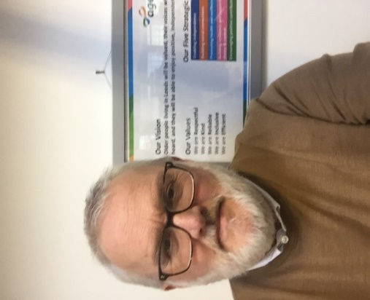
Message from the Chief Executive:

“I have the great pleasure of being the Chief Executive at Age UK Leeds which is I am pleased to say a trusted and valued local charity that provides invaluable support to the 20,000 older people of Leeds with whom we have contact each year.

As an organisation we are committed to creating an inclusive working environment. We take the well-being of our staff group seriously, offering flexible working in addition other initiatives. Most importantly of all we an organisation full of compassionate and dedicated colleagues”

Iain

