Walking more can help:
- Prevent illnesses like heart disease, diabetes and high blood pressure
- Improve mobility and flexibility
- Give you that feel good factor, reduce stress and improve your sleep
- Keep yourself at a healthy weight

For more information please contact:
Sam Coates
Age UK Leeds
The Bradbury Building, Mark Lane
Leeds, LS2 8JA
Tel: 0113 3893007
Mob: 0751 40382270
Email: Sam.coates@ageukleeds.org.uk

Or visit the Age UK website: www.ageuk.org.uk/leeds

For more information on Walking for Health visit: www.ramblers.org.uk and search for Wellbeing Walks
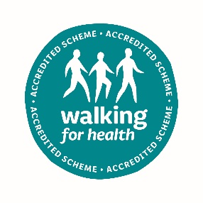
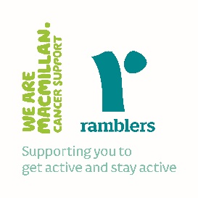

Age UK Leeds is a registered charity and company limited by guarantee, (registered charity number 504899, registered company number 1236909) Registered office: Bradbury Building, Mark Lane, Leeds, LS2 8JA
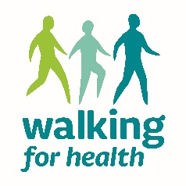

Walking for Health

The Age UK Leeds Walking for Health group has restarted and is welcoming new and existing members. The walks are led by a great team of experienced walk leader volunteers.

All walks are risk assessed and walkers are encouraged to bring a face mask for when social distancing isn’t possible and hand sanitizer to use after touching shared surfaces, such as road crossings or gates.
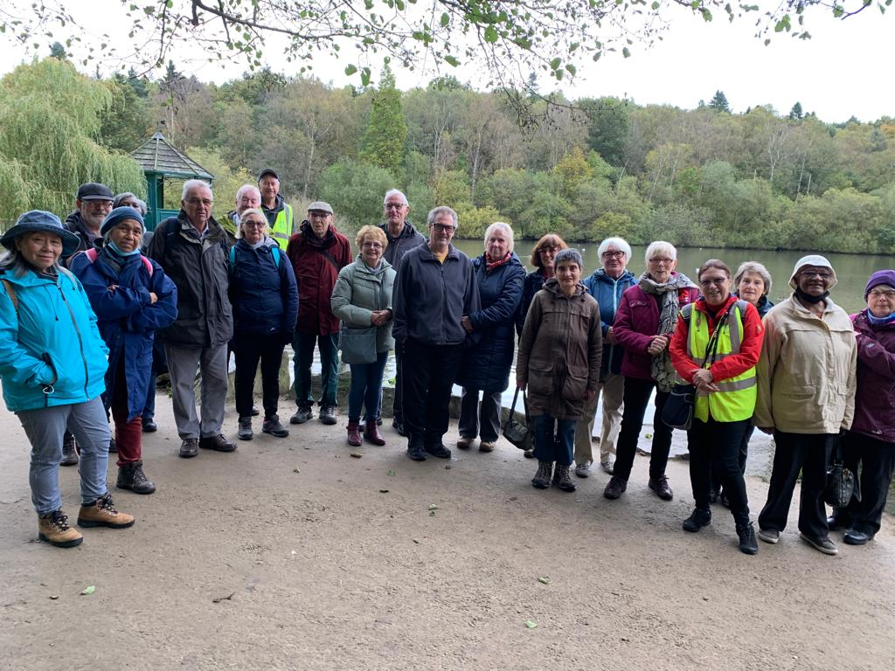
Tuesday 19th April | NO WALK EASTER BREAK
Tuesday 26th April | Spiritual Leeds
Tuesday 3rd May | Roundhay Route TBC *
Tuesday 10th May | Southern Owls
Tuesday 17th May | Armley Canal to City *
Tuesday 24th May | Tetley Walk and Exhibition
Tuesday 31th May | Bramley Fall *
Tuesday 7th June | Central River Side
Tuesday 14th June | Woodhouse Ridge *
Tuesday 21th June | Blue Plaques 3
Tuesday 28th June | Primrose Valley *

Walks marked with an * indicate that this walk involves a bus route. For more info please speak to the walk leader.

If you would like to attend please meet from 10:15am for a 10:30 start. The walkers will meet at Age UK Leeds, Bradbury House and registration will be in the Harrison Room.

Please note that sadly, the Age UK Leeds Arch Café has closed down and is no longer open to the public.

Before you attend please be prepared to keep yourself and others safe by staying at home if you are displaying any COVID systems:

A new continuous cough
A high temperature
A loss or change in taste and smell

Although COVID 19 restrictions will be lifted from 19 July we still want to keep you as safe as possible whilst enjoying the walks.

Please be aware that you will be expected to keep a social distance away from other people and where this is not possible you will be expected to wear a face mask. Walk leaders will have hand gel and face masks available to use should you need them. Please don’t forget to use hand sanitiser if you have touched shared surfaces.

