Walking more can help:
- Prevent illnesses like heart disease, diabetes and high blood pressure
- Improve mobility and flexibility
- Give you that feel good factor, reduce stress and improve your sleep
- Keep yourself at a healthy weight

For more information please contact:
Rachel McHale
Age UK Leeds
The Bradbury Building, Mark Lane
Leeds, LS2 8JA
Tel: 0113 3893007
Mob: 07432 477529

Email: rachel.mchale@ageukleeds.org.uk

Or visit the Age UK website: www.ageuk.org.uk/leeds

For more information on Walking for Health visit: www.walkingforhealth.org.uk
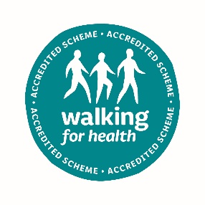
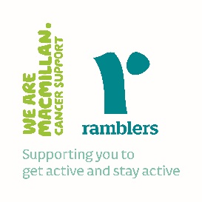

Age UK Leeds is a registered charity and company limited by guarantee, (registered charity number 504899, registered company number 1236909) Registered office: Bradbury Building, Mark Lane, Leeds, LS2 8JA
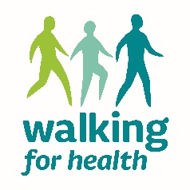

Walking for Health

The Age UK Leeds Walking for Health group are restarting and walks will be running in June and July 2021 for older adults to enjoy based around Leeds City. The walks are led by a great team of experienced walk leader volunteers.

All walks are risk assessed and walkers are encouraged to bring a face mask for when social distancing isn’t possible and hand sanitizer to use after touching shared surfaces, such as road crossings or gates.

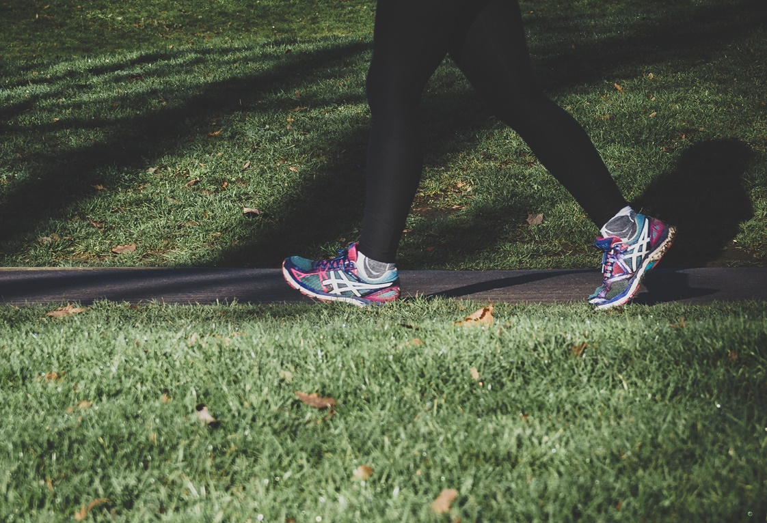

1st June | Rose Bank Millennium
8 June | Royal Armouries
15 June | Medieval Leeds
22 June | Blue Plaques 1
29 June | Potts and Clocks
6 July | Theatres through time
13 July | Mabgate
20 July | Leeds Street Art
27 July | St Georges Field

If you would like to attend please meet from 10:15am for a 10:30 start. The entire activity will be outdoors and walkers will meet in the Peace Garden at the side of Bradbury Building, where seating is available.

Please note that sadly, the Age UK Leeds Arch Café has closed down and is no longer open to the public.

Before you attend please be prepared to keep yourself and others safe by staying at home if you are displaying any COVID systems:

A new continuous cough
A high temperature
A loss or change in taste and smell

Please be aware that you will be expected to keep a social distance away from other people and where this is not possible you will be expected to wear a face mask. Walk leaders will have hand gel and face masks available to use should you need them.

