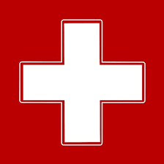
My Emergency Plan
I am a carer

Place photo here

My Name

My details
My full name
My preferred name
My date of birth
My address
My phone number
Professionals involved in my care
My Health needs
My medication
Things that are important to me

Who to contact if I need help
Name
Relationship to me
Phone numbers
Name
Relationship to me
Phone numbers

Notes
Details of the person I care for
Place photo of cared for person here

Their full name
Their preferred name
Their date of birth
Their address
Their phone number
Professionals involved in their care
Things that are important to the person I care for
What help the person I care for will need if I cannot care for them

Who can help the person I care for
Name
Relationship to me
Phone numbers
Name
Relationship to me
Phone numbers

Notes

Version: 09/2021

