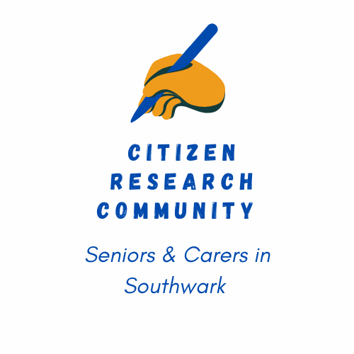 **Tell us a bit about yourself** (such as your interests) and include where you live in Southwark. *(If you are a carer tell us where the person you care for lives and how long it takes you to travel to support them).*

**Expression of Interest/MEMBERSHIP form**

**My name:**

**How did you hear about this project?**

**What issues are important to you. Do you have a top priority?**

Everyone will bring lots of skills and their own life experience. Have you thought about **what training and/or support you might need** to be an active member of this **Citizen Research Community?**

**Anything else you wish to share with us at this stage** e.g. do you have any support needs e.g. sensory impairments, access to internet/smartphone?

**Please tell us the best way to contact you** (phone number, address and/or email address).

Carers can be 60 or over and/or caring for an older person.

**Information shared with us will only be used by the project.** No personal information will be shared with anyone else.

Information passed to the council for monitoring reports will be anonymised.

Please **underline or circle** the view that you most agree with

**How aware are you of services to help with healthy living in the borough?**

Unaware Limited knowledge Good level of information

Very knowledgeable

**And how do you feel about your ability to influence what goes on**

No influence Limited influence Some influence

A great deal of influence

**Can you say at this stage what you hope to get from being involved?**

**Membership Sign Up**

**I commit to becoming an active member of this Citizen Research Community for the next 6 months. I will review my membership in six months' time to see if I wish to continue.**

**Signed:**

**Date:**



**Contact:**

**Barbara Wilson at AUKLS** **0207 358 4077** [crc@ageuklands.org.uk](mailto:crc@ageuklands.org.uk)





**CRC funded by Southwark Council’s** *Common Purpose Fund*.