Requirements for DBS Checks of Job Applicants

DBS =Disclosure & Barring Service the new name for the CRB

Several jobs carried out by Age UK Lincoln & Kesteven involve working with persons at risk in a regulated and controlled activity. It is a requirement of these jobs that a suitable enhanced DBS disclosure is provided.

The job description you received with your application form states whether a DBS check is needed for the job in question.

*Should you be offered employment you will be offered a DBS application form which should be completed without undue delay.

On completion of the DBS form you should return it to our Park Street offices with the suitable identification documents requested.

Please contact the office prior to bringing in the documents to ensure that someone will be available to check the form and that the identification you brought in is suitable.

You will be able to start work upon the receipt of two satisfactory written references. The DBS application form must be issued back to the office before your induction.

Attached is the applicants guide to the Disclosure & Barring Service.

If you wish to discuss any concerns about this matter please contact:
Clare Oxby, Human Resources Manager 01522 696000 (ext.1102)
Liz Edwards, Human Resources Administrator 01522 696000 (ext. 1115)

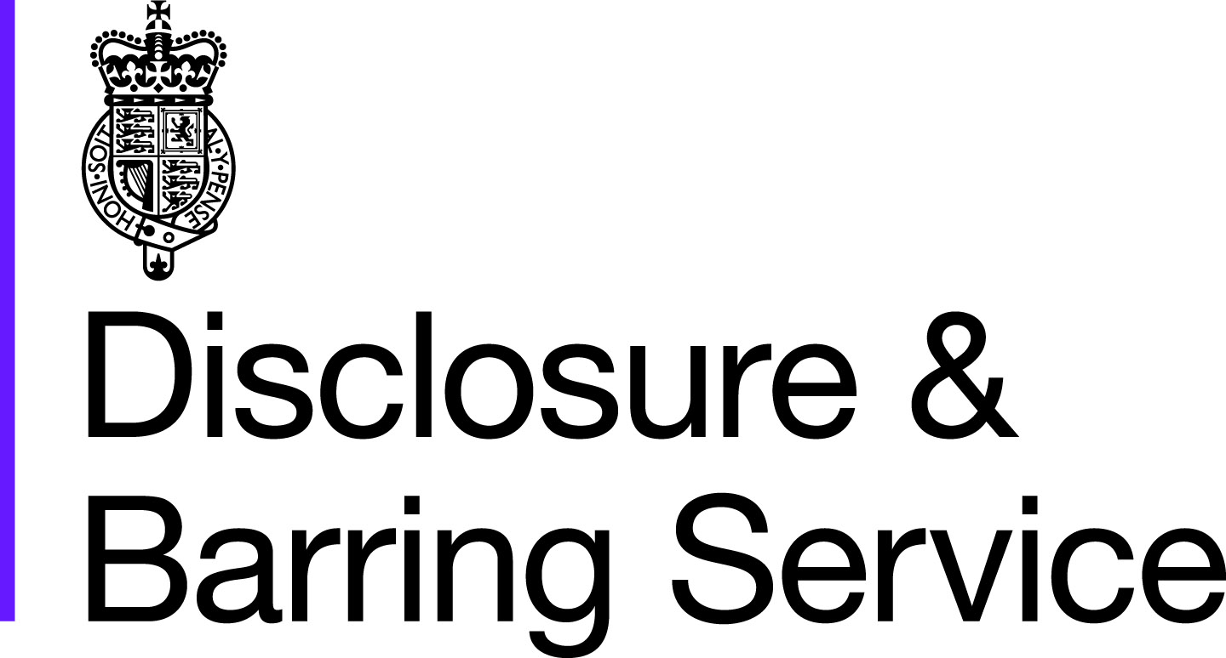

From 29 May 2013, the DBS will be removing certain specified old and minor offences from criminal record certificates issued from this date.

Filtering rules for criminal record check certificates

For those 18 or over at the time of the offence:
An adult conviction will be removed from a DBS criminal record certificate if:
- 11 years have elapsed since the date of conviction; and
- it is the person’s only offence, and
- it did not result in a custodial sentence.
Even then, it will only be removed if it does not appear on the list of offences relevant to safeguarding. If a person has more than one offence, then details of all their convictions will always be included.
An adult caution will be removed after 6 years have elapsed since the date of the caution – and if it does not appear on the list of offences relevant to safeguarding.

For those under 18 at the time of the offence:
- The same rules apply as for adult convictions, except that the elapsed time period is 5.5 years
- The same rules apply as for adult cautions, except that the elapsed time period is 2 years.

The filtering rules and the list of offences that will never be filtered are now available for you to view.
https://www.gov.uk/government/publications/filtering-rules-for-criminal-record-check-certificates
https://www.gov.uk/government/publications/dbs-list-of-offences-that-will-never-be-filtered-from-a-criminal-record-check

Information/ Documents needed when applying for DBS.

You will need to bring original documents, not photocopies.

Route One
Can the applicant produce a Group 1 document? If yes, then the applicant must produce 3 documents:
o 1 document from Group 1 (refer to list of Valid Identity Documents); and
o 2 further documents from Group 1 or 2; one of which must verify their current address.

NOTE - Non-UK/Non-EEA Nationals:
All Non-UK/Non-EEA Nationals should be validated via Route One by supplying the following combination of documents:
o Current Passport; and
o Biometric Residence Permit OR Work Permit/Visa (UK); and
o 1 further document from Group 2a or 2b (refer to list of Valid Identity Documents), which verifies their current address.

If the applicant cannot produce a Group 1 document then go to Route Two.
Route Two

The applicant must produce:
- 3 documents from Group 2 comprising of;
▪ 1 document from Group 2a; and
▪ 2 further documents from Group 2a or 2b; one of which must verify their current address.

ROUTE THREE
If the applicant cannot meet the requirements of Route One or Two, you should have a discussion with them to establish why they could not meet these requirements and whether there has been a recent or previous change of name that has not been declared.

For Route Three, the applicant must produce:
A certified copy of a UK birth certificate ; AND 4 further documents from Group 2 comprising of:
- 1 document from Group 2a; and
- 3 further documents from Group 2a or 2b; one of which must verify their current address.
- If the applicant fails to produce the required document set at Route Three, they will need to go for fingerprinting. This may add delay into the overall application process. Please refer to Question 9 in the FAQ’s for more information.
- All copies of UK birth certificates state ‘certified copy’ when issued by the General Records Office.

- What if I cannot establish the applicant’s ID using one of the three routes?
- If you or your ID checker cannot establish an applicant’s identity in accordance with DBS ID guidelines then you should mark W59 on the application form with a NO. Applicants who are unable to provide the required documents will then be asked to give their consent to have their fingerprints taken in line with the current procedure. Registered Bodies should be aware that this will require attendance by the applicant at a Police Station at an appointed time, and may add delay into the overall application process.

Group 1 – Primary Trusted Identity Credentials
▪ Current valid Passport – UK or EEA (or Non-EEA in combination with a Biometric Residence Permit or current Work Permit/Visa)
▪ Biometric Residence Permit (UK)
▪ Current Driving Licence (UK) (Full or provisional) Isle of Man /Channel Islands;
Photo card only (a photo card is only valid if the individual presents it with the associated counterpart licence; except Jersey)
▪ Birth Certificate (UK & Channel Islands) - issued within 12 months of date of birth;
Full or short form acceptable including those issued by UK authorities overseas, such as Embassies, High Commissions and HM Forces

Group 2a – Trusted Government/State Issued Documents
▪ Current valid Passport (UK, EEA or Non-EEA)
▪ Current UK Driving licence (Photo card or old style paper version)
▪ Biometric Residence Permit (UK)
▪ Birth Certificate (UK & Channel Islands) - issued within 12 months of date of birth
▪ Certified copy of Birth Certificate (UK and Channel Islands) – issued after 12 months of date of birth
▪ Marriage/Civil Partnership Certificate (UK)
▪ Adoption Certificate (UK)
▪ HM Forces ID Card (UK)
▪ Fire Arms Licence (UK)

Group 2b – Financial/Social History Documents
▪ Mortgage Statement (UK)**
▪ Bank/Building Society Statement (UK)*
▪ Credit Card Statement (UK)*
▪ Financial Statement ** - e.g. pension, endowment, ISA (UK)
▪ P45/P60 Statement **(UK & Channel Islands)
▪ Council Tax Statement (UK & Channel Islands) **
▪ Work Permit/Visa (UK) (UK Residence Permit) **
▪ Utility Bill (UK)* – Not Mobile Telephone
▪ Benefit Statement* - e.g. Child Allowance, Pension
▪ A document from Central/ Local Government/ Government Agency/ Local Authority giving entitlement (UK & Channel Islands)*- e.g. from the Department for Work and Pensions, the Employment Service , Customs & Revenue, Job Centre, Job Centre Plus, Social Security
▪ EU National ID Card
▪ Cards carrying the PASS accreditation logo (UK)

Please note:
If a document in the List of Valid Identity Documents is:
▪ denoted with * - it should be less than three months old
▪ denoted with ** - it should be issued within the past 12 months
▪ not denoted – it can be more than 12 months old.

Applicants Guide to the Disclosure & Barring Service

Introduction
The Disclosure & Barring Service (DBS), an executive agency of the Home Office; provide access to criminal records and other information to organisations in England and Wales through a service called Disclosure. Its specific purpose is to help organisations make more informed decisions when recruiting people that will be in placed in positions or trust.

The Disclosure service is also available to other professional licensing and regulatory bodies whose volunteer, employees and licensees are not necessarily in direct contact with persons at risk but still need to uphold the highest standards or professional performance and Disclosure can help improve these recruitment decisions as well.
Through the Disclosure service, organisations can provide greater protection for the persons at risk members of our society and afford greater protection to the customers, staff, volunteers and ultimately their organisation.

What information is available through the Disclosure service?
The Disclosure & Barring Service provides access to a range of different types of information, such as:
- Held on the Police National Computer (PNC), such as convictions, cautions, reprimands and warnings in England Wales and those recorded from Scotland. There is also some Northern Ireland conviction data held on PNC.
- Held by local police forces relating to relevant non-conviction information.
- From Government’s Protection of Children Act List (PoCA)
- From Government’s Protection of Vulnerable Adults List (PoVA)
- Held by the department for Education and Skills (DfES) under Section 142 of the Education Act 2002 (formerly known as list 99)

Levels of Disclosure
To provide this service the DBS offers two levels of Disclosure, each representing a different level of check. The two levels of Disclosure are Standard and Enhanced.

These disclosures cannot be obtained by members of the public and they are only available to organisations for those professions, offices, employments, work and occupations listed in the Exceptions Order to the Rehabilitation of Offenders Act 1974.

Standard Disclosures are primarily for posts that involve working with children or persons at risk, Standard Disclosures may also be issued for people entering certain professions, such as members of the legal and accountancy professions.

Standard Disclosures contain the following:
- Details of all convictions, cautions, reprimands and warnings held on the Police National Computer (PNC); and if the position involves working with children or vulnerable adults and the relevant boxes have been marked on the application to indicate this.
- Information from Protection of Children Act List (PoCA)
- Information from Protection of Vulnerable Adults List (PoVA)
- Information held by the DfES under Section 142 of the Education Act 2002 of those considered unsuitable or banned from working with children.

Why might I be asked to apply for a Disclosure?
You might have been asked to apply for a Standard or Enhanced Disclosure if you will be working:
- With children or vulnerable adults.
- In an establishment that is wholly or mainly for children.
- In healthcare.
- Have applied to be a foster carer, adoptive parent or childminder.

A Disclosure may also be required for a range of other types of job or licences. To find out more please contact the DBS information line or alternatively visit our website.
SEE OVER PAGE

Can I refuse to apply for a Disclosure?
Yes, however, there are some posts for which a Disclosure is required by law. If you refuse to apply for a Disclosure in this instance, the organisation would be well within their rights to not take your job or licence application any further.
If you are currently working and your employer asks you to apply for a Disclosure, you may be able to refuse if your contract of employment does not refer to a criminal record check.

I already have a Disclosure, can I use it again?
If you are asked to apply for a Disclosure and you already have one from a previous role, ask if the organisation are willing to accept it. When making this decision the organisation will take into account the length of time that has elapsed since that Disclosure was issued, the level of Disclosure, the nature of the position for which the Disclosure was issued, and the nature of the position you are now applying for. Ultimately, it will be the organisations decision whether to accept it or not.

What if I have lived overseas?
If you have lived overseas for a substantial period of time, it may not be worth applying for a Disclosure, as the DBS does not generally have access to overseas criminal records. However, some organisations have a legal responsibility to check if a person is banned from working with children or vulnerable adults and can only do this through the Disclosure service. We can also advise on how to obtain equivalent information from the overseas authorities, where available. You may wish to discuss this with your prospective employer.

How do I apply for a disclosure?
You will be asked to complete a paper application form handed to you by the person who asked you to apply.

Who will receive my Disclosure?
When the application is processed, the DBS sends out a copy of the Disclosure containing any information revealed during its searches, to you.

How do I know that the information contained on my disclosure form will remain confidential?
An organisation using the Disclosure service must comply with the DBS code of practice, which is there to make sure the whole practice works fairly and that any information revealed is treated fairly and securely. Also, the DBS is committed to compliance with the Data protection Act. This means that any personal information that you submit to us will be protected.
Under the provisions of the Code, sensitive, personal information must be handled and stored appropriately and must be kept for as long as is necessary. The Code is published on the DBS website, or you can also request a copy from the person who asked you to apply for the Disclosure.

What if I have a criminal record that may not be relevant to the position for which I am applying?
Safe guards and guidelines have been introduced to ensure that conviction information is not misused and that ex-offenders are not treated unfairly. Ex-offenders will retain the protection afforded by the Rehabilitation of Offenders Act 1974. In addition, the DBS and the Chartered Institute of Personnel and Development (CIPD) have developed guidance information on this matter.

What if things go wrong?
The DBS has established a comprehensive complaints process and as a part of our commitment to provide a high standard of customer service we will always:
- Act fairly and impartially.
- Communicate effectively.
- Deal promptly with all enquiries.
- Endeavour to learn from our mistakes.
For how long will Disclosures be valid?
Each Disclosure will show the date on which it was printed. Disclosures do not carry a pre-determined period of validity because a conviction or another matter could be recorded against the subject of the Disclosure at any time after it is issued.
For further information:
If you would like further information about the Disclosure & Barring Service why not visit our website?
http://www.homeoffice.gov.uk/dbs or give us a call on 0870 90 90 811

