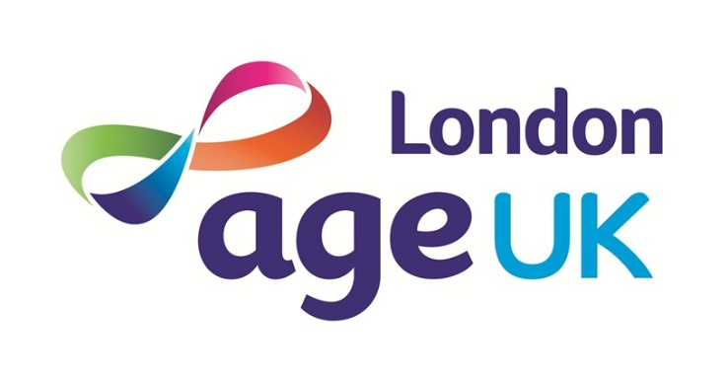
‌

Age UK London

Ageism Survey

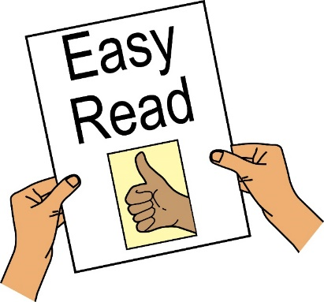

Please return to Age UK London, Arc House, 82 Tanner Street, London SE1 3GN by 12th December 2025.

Ageism Survey

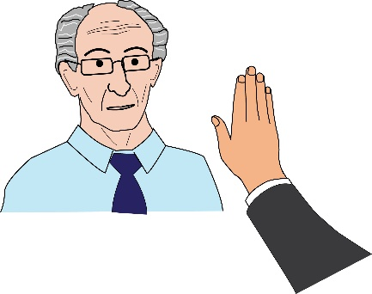
What is ageism?

Ageism means when a person is treated unfairly because of their age, usually because they are older.

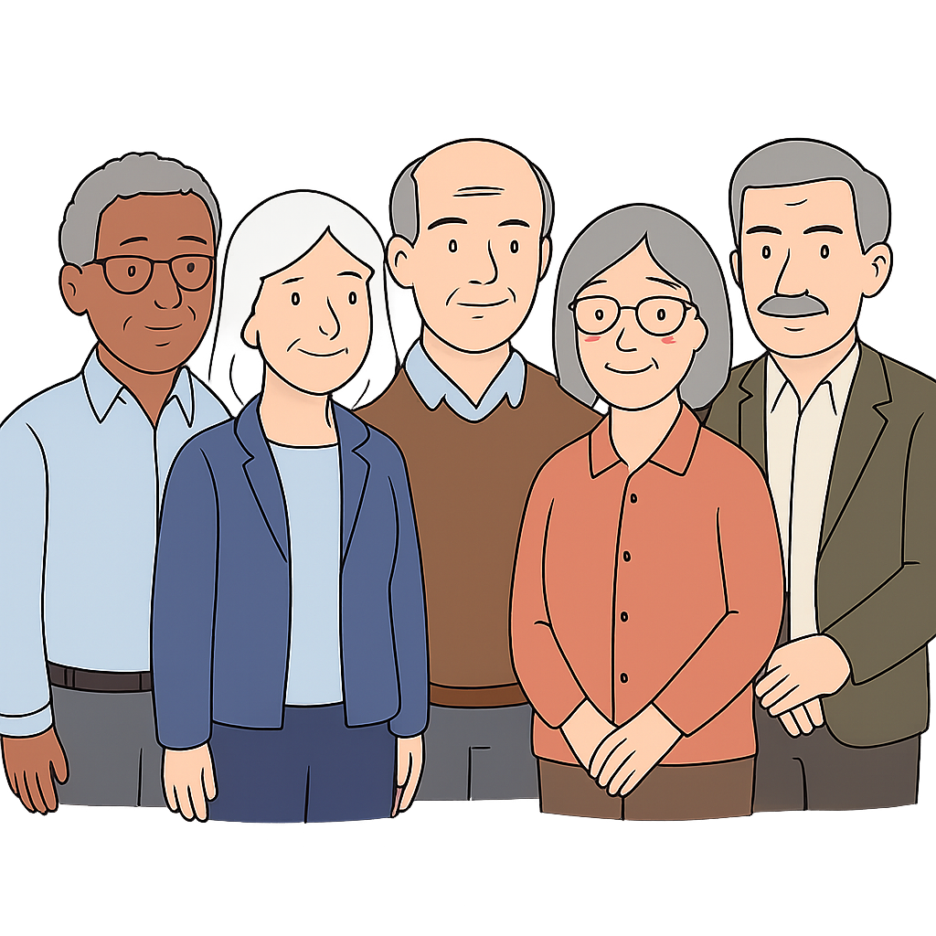
Why are you doing this survey?

Age UK London wants to find out more about ageism in London. We want to hear from older Londoners about their experiences of ageism.
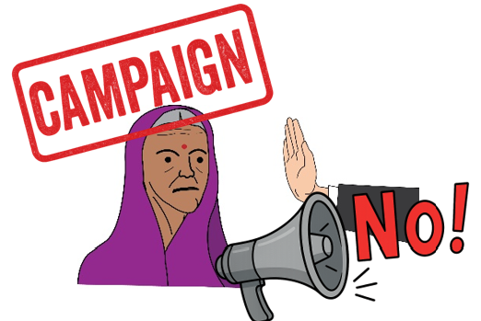
We are doing a campaign to try to help stop ageism in London. We will use the information from the survey to make the campaign the best it can be.

If you have any questions, please contact us at: campaigns@ageuklondon.org.uk

Questions about you

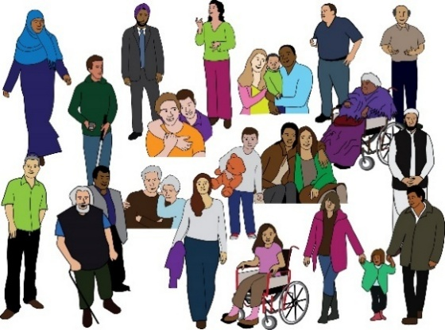
People can experience ageism differently. This can be because of 1 or more of their characteristics.
A characteristic is a feature or a part of someone, for example, their religion, race or sexuality.
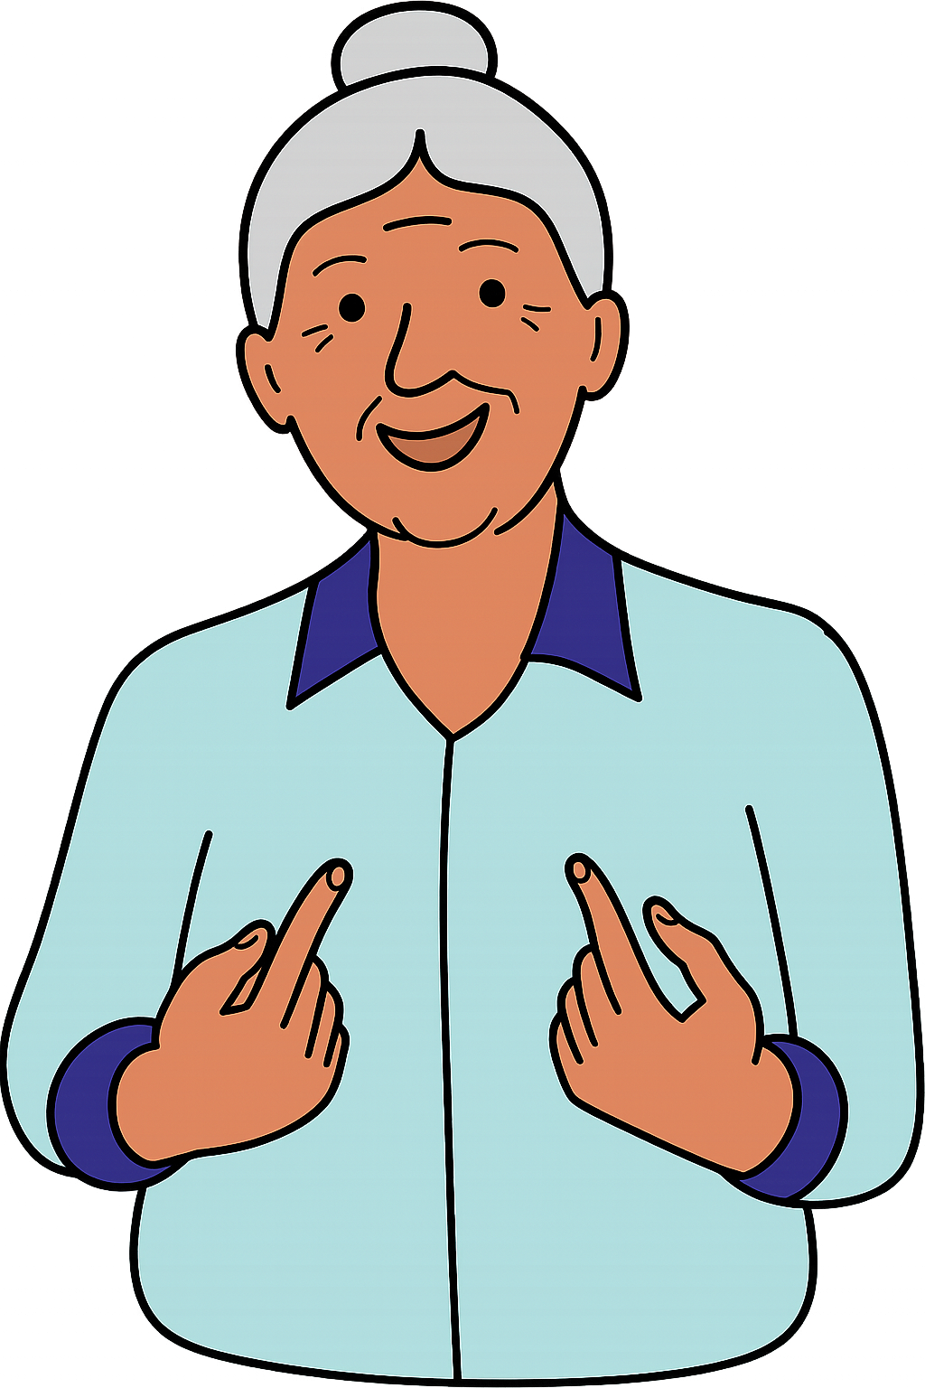
We will now ask you some questions about your own characteristics (features about yourself).This is to find out more about how different types of people experience ageism.

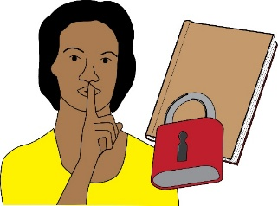

You can answer the questions with "prefer not to say” if you want.

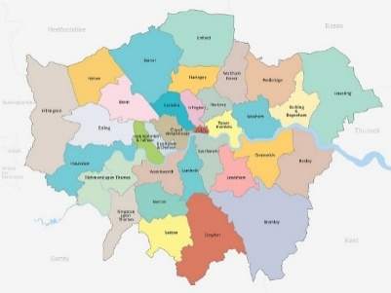
Question 1

Which London borough do you live in?

Question 2

Which age group are you in?
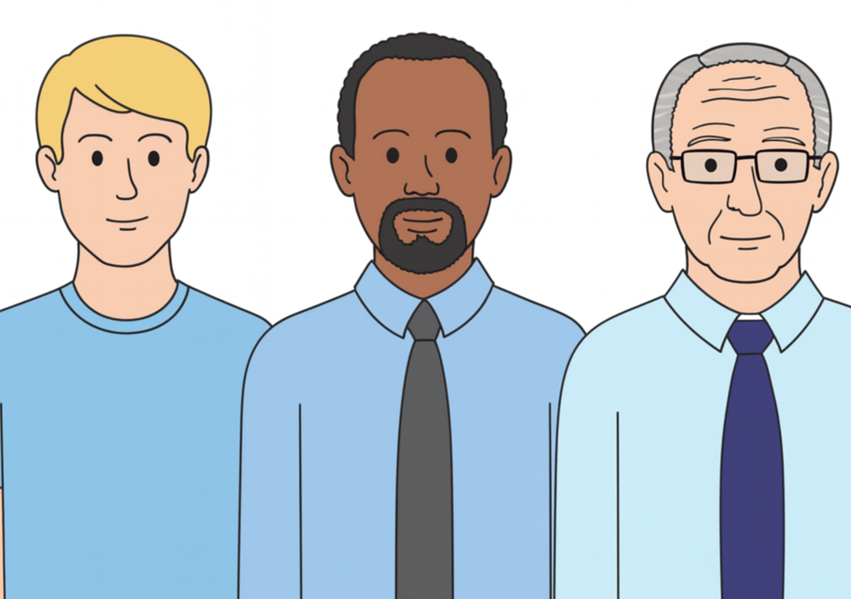
☐ 18 to 49 years old
☐ 50 to 64 years old
☐ 65 to 74 years old
☐ 75 to 84 years old
☐ 85+ years old
☐ prefer not to say
Question 3
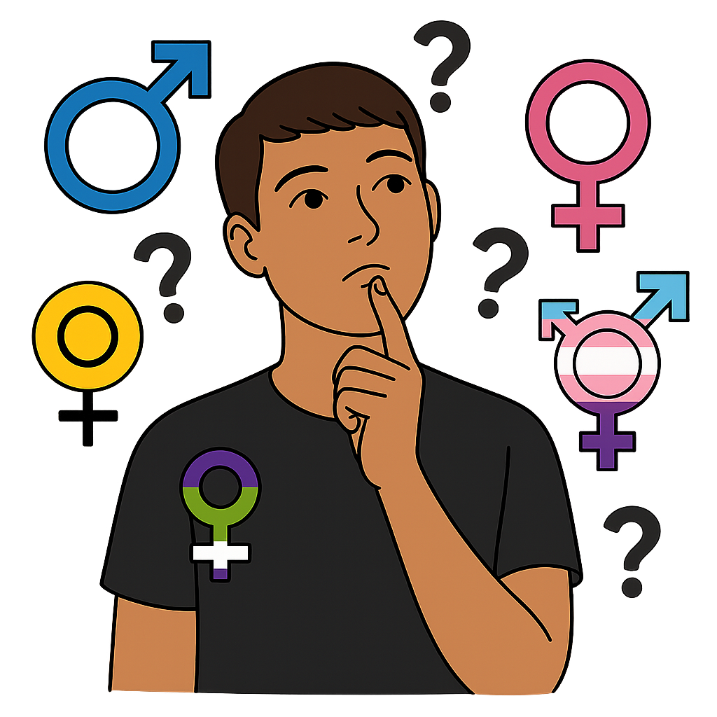
Which of these best describes your gender identity?

Gender identity - this means how a person feels about being male, female, both or neither.

☐ female
☐ male
☐ non-binary (I do not feel female or male)
☐ prefer not to say
☐ other (please say in your own words):

Question 4



Some people change genders from what they were born as. For example, a person who was born a male might now identify as a female (called a trans woman).

Is your gender identity the same as your sex at birth?

☐ yes
☐ no
☐ prefer not to say

Question 5

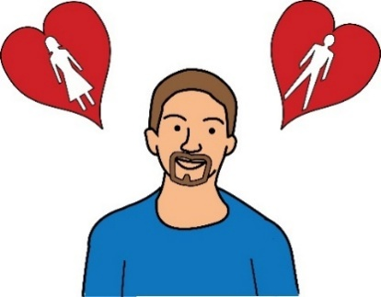
How do you describe your sexual orientation (or sexuality)?

Sexual orientation: this means who you are attracted to in a sexual way. It might be men, women, both or neither.
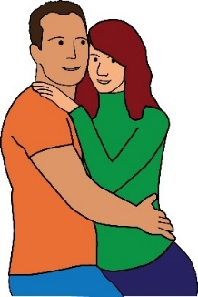
☐ asexual (I am not sexually attracted to anyone)
☐ heterosexual (I am attracted to the opposite sex)
☐ bisexual (I am attracted to both men and women)
☐ gay man (I am a man attracted to men)
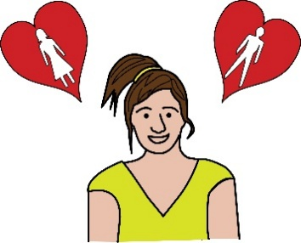
☐ lesbian (I am a woman attracted to women)
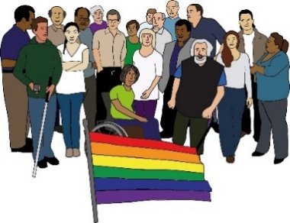
☐ pansexual (I am attracted to all kinds of genders)
☐ prefer not to say
☐ other (please tell us in your own words):

Question 6


What is your religion or belief?
☐ no religion or belief
☐ Hinduism
☐ Buddhism
☐ Agnosticism (I don’t know if there is a god or not)

☐ Judaism
☐ Sikhism
☐ Atheism (I do not believe in a god)
☐ Islam
☐ Christianity
☐ Humanism (I can live a good life without needing a religion or belief)

☐ prefer not to say
☐ other (please tell us in your own words):

Question 7

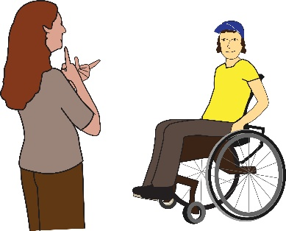
Are you a Deaf and/or Disabled person?

☐ yes
☐ no
☐ prefer not to say

Question 8

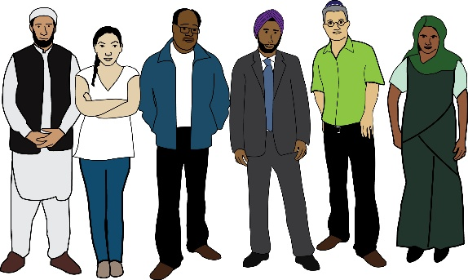
How would you describe your ethnic group or background?

Ethnic group or ethnic background means a group you feel you belong to. It’s a group who you share culture or a language with. This may be different to your nationality, place of birth or where you live now.
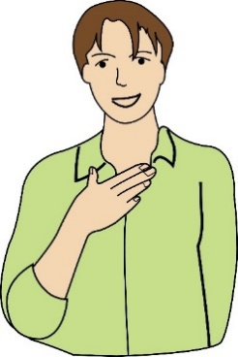
☐ White British
☐ White Irish
☐ Other white background (please tell us in your own words below)

More options are on the next page.
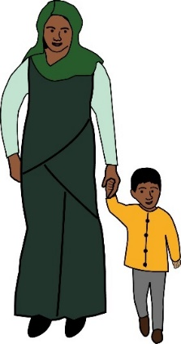
☐ Asian British
☐ Bangladeshi
☐ Indian
☐ Pakistani
☐ Other Asian background (please tell us in your own words below)

☐ Black African
☐ Black British
☐ Black Caribbean
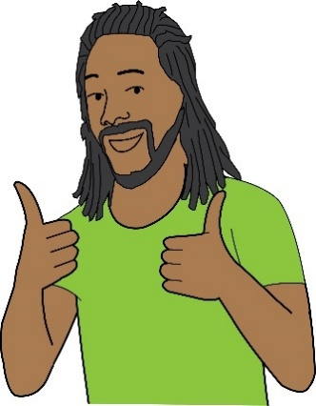
☐ Other Black, African or Caribbean background (please tell us in your own words below)
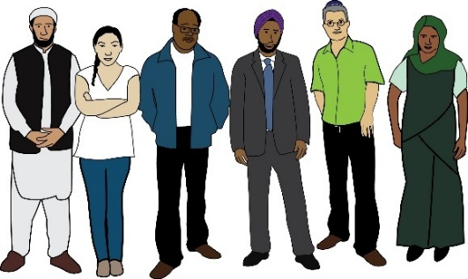
☐ Chinese
☐ Latin American
☐ Arab
☐ Middle Eastern
☐ Gypsy, Roma or Traveller
☐ Mixed Heritage (please tell us in your own words below)
☐ Other ethnic background (please tell us in your own words below)
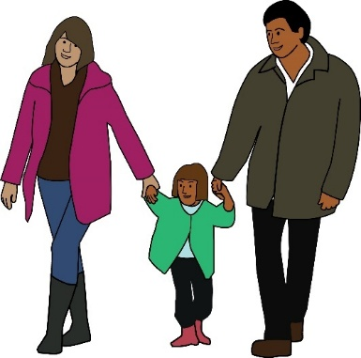
☐ Prefer not to say

If you ticked “Other”, please tell us about your ethnic group here:

Questions about your
experiences with ageism

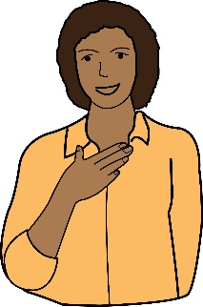
Please answer the next questions as honestly as you can. Only answer them if you feel comfortable.

Question 9


How often do you experience ageism in your daily life in London?


(Tick 1 box only)

☐ never
☐ rarely
☐ sometimes
☐ often
☐ always

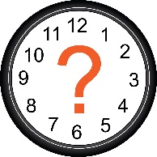

Question 10

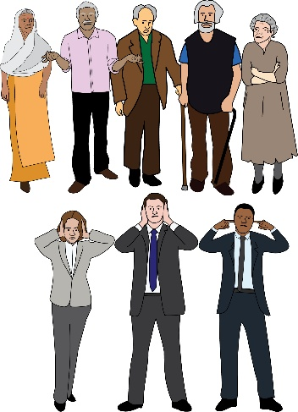
How often do you feel ignored because of your age?

(Tick 1 box only)

☐ never
☐ rarely
☐ sometimes
☐ often
☐ always


Question 11
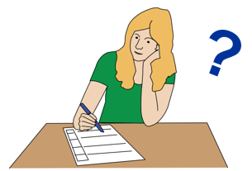
If you can, please tell us why you answered like that for questions 9 and 10 above.

(This question is optional which means you don’t have to answer it if you don’t want to).

Question 12

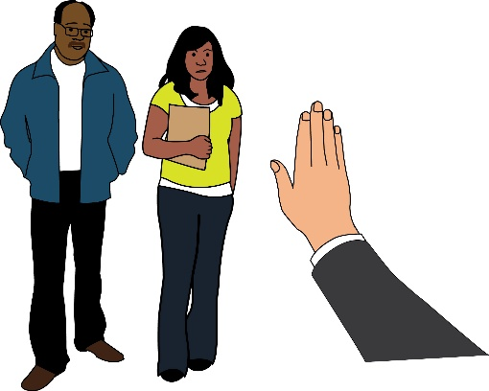
People can treat other people unfairly for many reasons. Some of these reasons are listed below.

Do any of these things change how people treat you because of your age?

Answer this statement: (you can tick more than 1 box)

Yes, I feel that because of my age, people also treat me worse:
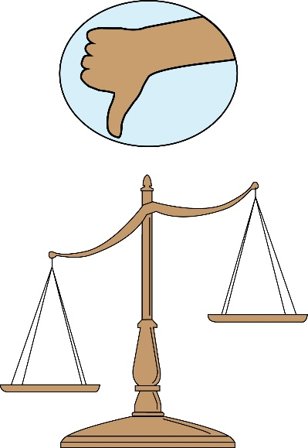
☐ because of my gender
☐ because of my ethnic background
☐ because I am Deaf and/or disabled
☐ because I am from the LGBTQ+ community
☐ because of my religion/belief
☐ I don’t feel people treat me worse because of any of the above reasons

Question 13
If you can, please tell us why you said that in question 12.
(This question is optional which means you don’t have to answer it if you don’t want to).

Question 14

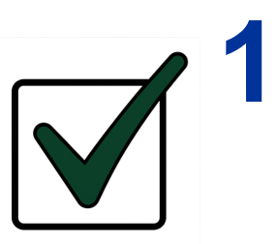
Below is a statement about ageism. Please complete it by ticking only 1 box that you agree with the most.

Answer this statement: (please tick only 1 box)

Compared with the rest of the country:
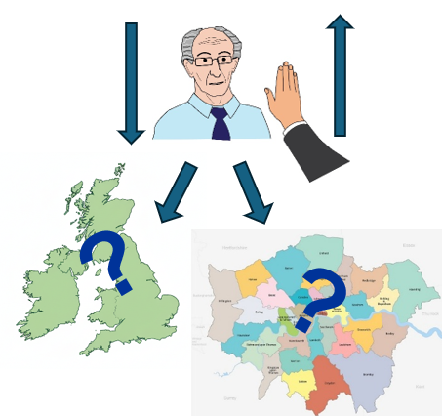
☐ Ageism is worse in London
☐ The amount of ageism in London is about the same
☐ There is less ageism in London
☐ I don’t know if there is less or more ageism in London compared with the rest of the country

Question 15
If you can, please tell us why you said that in question 14.
(This question is optional which means you don’t have to answer it if you don’t want to).

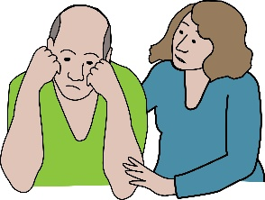
Question 16

How does ageism make you feel? (Please tick your top 3 reasons.)
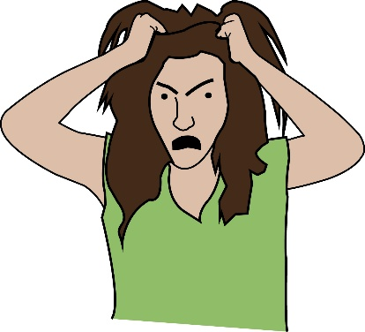
☐ disempowered (takes away my power)
☐ devalued (makes me feel less)
☐ frustrated
☐ upset
☐ angry
☐ anxious
☐ amused
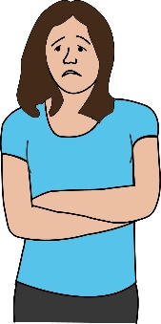
☐ lonely
☐ it doesn't bother me
☐ other/none of these (please tell us):

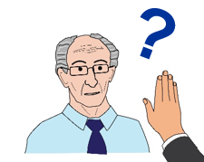
Question 17

When have you experienced ageism in London?

(Tick as many boxes as you want.)
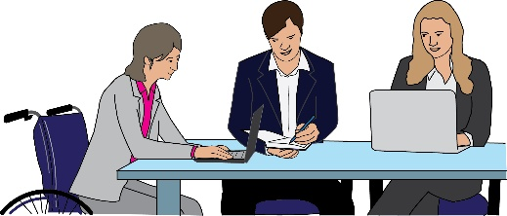
☐ at work
☐ looking for jobs
☐ volunteering and/or applying for volunteering roles
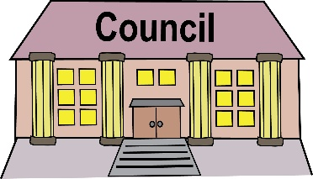
☐ applying for extra help with money, for example trying to get lower Council Tax
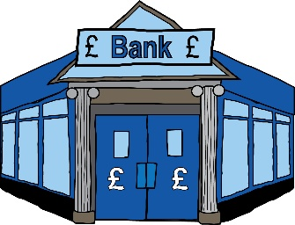
☐ contacting companies, for example banks or utility companies (like about electricity bills)
☐ contacting public services, for example my local council
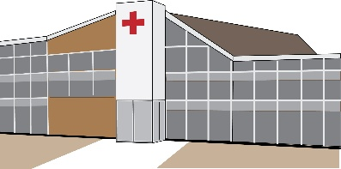
☐ talking with or being at health services, for example at the doctor’s, hospital or chemist
☐ out and about, for example shopping, going to the cinema, at the gym
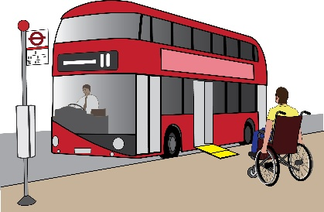
☐ using public transport and/or driving
☐ with my friends and family

Question 18

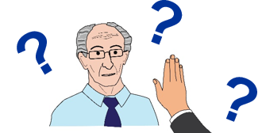
(This question is optional which means you don’t have to answer it if you don’t want to).

If you can, please tell us the detail of your experiences of ageism. When? Where? How? How did you feel?

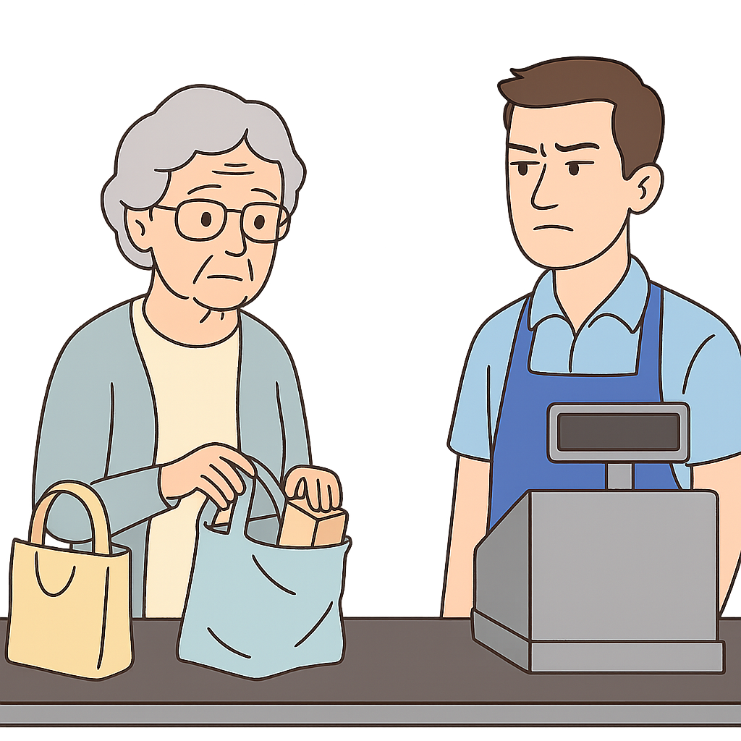
For example: I have experienced ageism when doing my food shopping. The shop assistants always act like I don’t exist. They seem impatient when I take a while to pack my shopping away at the till. I feel like I’m in the way.

Question 19

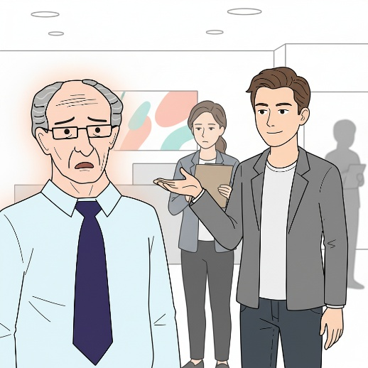
When you have experienced and/or seen ageism, did you say something at the time?

☐ Yes, I reported it to an organisation/professional body
☐ Yes, I called out a person’s behaviour
☐ No, I did not feel comfortable to do so

Question 20

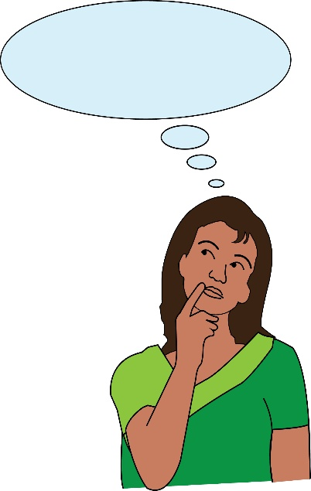
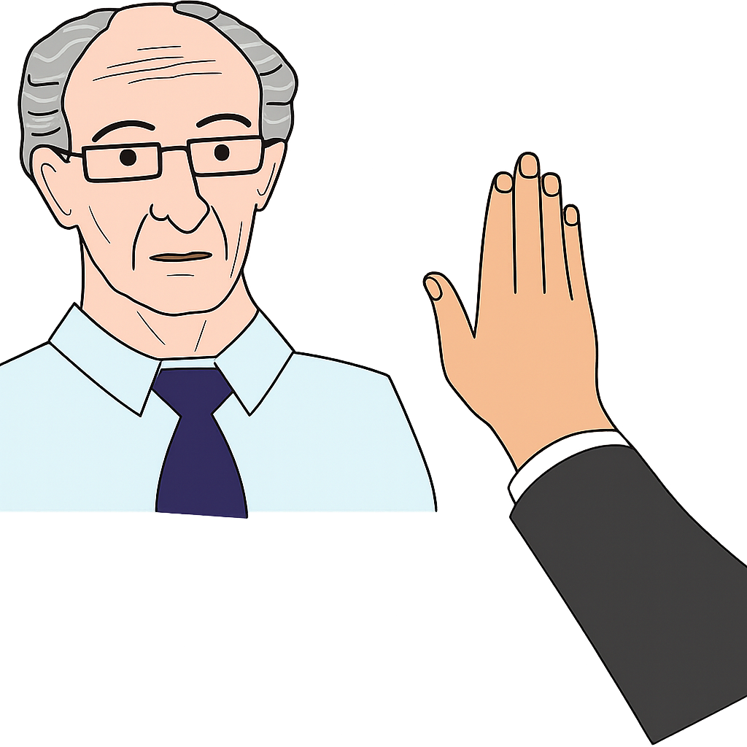
We are doing this survey to make our campaign to stop ageism in London better.

We want to know what you think about ageism in London. What do you think needs to change? Please tell us as much as you want to. (This question is optional which means you don’t have to answer it if you don’t want to).

Question 21
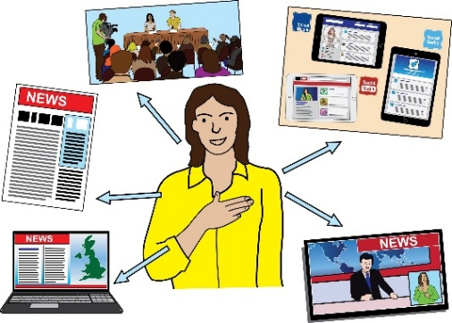
Would you be happy to tell your story about ageism in the media? That means would you be comfortable with sharing your story online or in a newspaper?
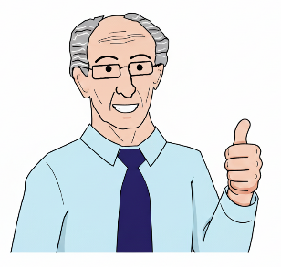
If you would, it will help our campaign. It will help make other people see what ageism is really like in London.

If you would be happy to share your story with us, please give us your name and email address here and we will contact you:

This document was put into Easy Read by the Empower Team at People First.

You can visit their website here:
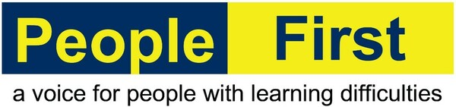
www.peoplefirstltd.com

Information is Power!

