Report London Fire Brigade - Conference with Age UK London - ‘Supporting Vulnerable Londoners ’
10th October 2019

1. Background
Following a series of meetings with London Fire brigade (LFB) in 2019, it was agreed to jointly undertake a Conference in October 2019 to highlight support available to vulnerable older Londoners to reduce the risk of fire. This aim ties in with AUKL’s public health health campaigning to support older Londoners to age safely and well.

2. Aims of Conference
The jointly agreed aims of the Conference were:

- Increased understanding by older Londoners of the fire safety risks for older people and the means by which to significantly reduce these risks..
- Increased Age UKs in London and older people organisations understanding of:
- The current structure of the London Fire Brigade in relation to fire safety for older Londoners
- Resources available from the LFB
- LFB is Targeting of those at highest risk including in relation to mobility difficulty, sensory impairment, cognitive / mental health issues.

- Creation and strengthening of links at central and borough level between local Age UKs and LFB - to create a wider network of leaders in the area of fire safety for older people; including to enable local level liaison
- Enabling access from amongst Age UK’s service users and staff to :
- LFB’s Older People’s Forum. – Which may become area based.
- LFB’s Dementia Forum planned for later this year.

3. Target Audience
The primary target audience was older Londoners organisations, including 23 local Age UK charities, who are well placed to promote information and support targeted at vulnerable older Londoners

4. Conference Content
The conference programme was interactive and a balanced mix of:
- Presentation by Fiona Twycross, the Deputy Mayor for London (Fire and Resilience) on the role of the GLA at a strategic level and plans to improve regulations.
- Presentation by the LFB, Deputy Assistant Commissioner, Operational Policy and Assurance Spencer Sutcliff on their structure and who to contact in your areas to build relationships
- Good practice in a London borough (Kensington and Chelsea) of partnership working with local older peoples organisations - led by LFB Station Manager in Kensington and Chelsea
- Information on how reduce fire risk and resources available including, Fire Safety Visits and addressing hoarding
- Small groups’ discussion and plenary feedback on how local organisations working with older Londoners can use their varied networks to promote support for vulnerable customers.

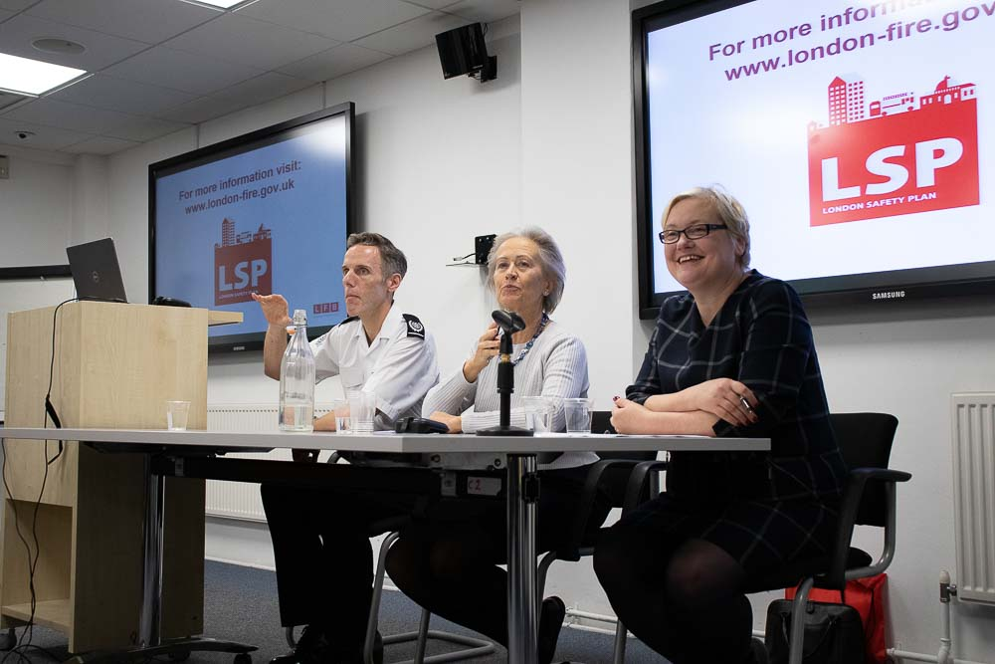
Spencer Sutcliff, Deputy Commissioner LFB, , Elizabeth Sparrow AUKL and Deputy Mayor Fiona Twycross

5. Resource Pack
Each attendee for the session received a Resource Pack with information on hoarding, fire safety visits and a map of local contacts. NB All the slides for the Conference are now on Age UK London’s website under Age Friendly Resources

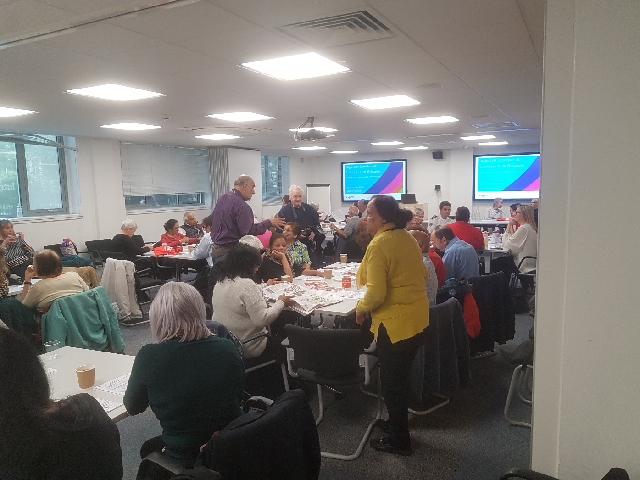
Group Discussions on getting the message out

6. Conference Participants
68 individuals attended the conference representing a wide range of organisations working with older Londoners including;

- Local Age UKs (10)
- Older person’s forums
- BAME and faith-led organisations
- Housing Associations
- Carers support Organisations
- Healthwatch and health support organisations.

7. Evaluation
Participants were asked to complete an evaluation form. 42 participants completed an evaluation form. The responses were analysed to ascertain the satisfaction levels for each of the question areas. The questions on the form focused on:

- Increased understanding of support to vulnerable Londoners to reduce fire risk - 92% of respondents reported they were very satisfied the conference achieved this.

- Resources available and how useful they are
-95%of respondents reported that they were very satisfied with the resources available

- Follow on actions by the respondents
30 respondents (71%) said they would undertake some follow action including highlighting the information and learning they had received in their local group and/or organising a local event to reduce fire risk.

Comments on the evaluation forms (which were very positive) included:

Inform staff at meetings when visiting clients at home
Speak at Sutton Seniors Forum
We will increase our community reach through our partnership to reach more people who can benefit from our priority services
Sharing via members network
I attend various communty working/steering groups and am happy to link LFB into any they are not already involved in
We will invite our local LFBG to do a session at a meeting
Use into our signposting directory when we meet older people during outreach
Deliver a presentation to estate managers in Hackney on how we can support our residents to be safer and more fire aware
Cascading the information to staff, volunteers and members
Have copies of LFB HFSV form in reception and at other awareness raising events
Will inform as many people as possible including Health Service staff. Will be invited LFB + Power Network
Bring to our meetings as we have a really good attendance
Ask the LFB to attend our forum meetings
Give a talk to a group in my Temple to elderly people. Must include topic on digital culture and mobile phones Laptops and chargers should not be left on all night
Inform resident’s one to one basis. Request each to get fire alarm fitted free by LFB
Organise for feedback to be given to the group "Merton BAME Voice". May be if the group feel it necessary
I will share information via my church, vocal community groups, friends and family

8. Equalities Analysis
36 attendees of the 68 attendees completed the anonymous, voluntary, Equalities form, of which:

- 14/36 were from a BAME background i.e. 39%
- 22/36 were female i.e. 61%
- 8/36 stated they had some form of disability i.e. 22%
- 3 /36 stated they were lesbian, gay man or bisexual i.e. 8%

27 people filled in the age category on the Equalities form of which
23% aged under 55 years
1% (2 people) aged 55-64
52% aged 75-84 years
33% aged 65-74 years
1% (2 people) aged over 85 years

Therefore the event had a reasonably diverse attendance in relation to BAME communities, ages, disabled older Londoners and the LGBT community, but we need to do more to target older men. This is particularly significant given the fact that single men over 55 years living alone are the highest risk group for fire according to the LFB.

9. Conclusion and Key Findings
This was a successful event in relation to achieving its objectives. The conference was energetically participative with a high level of engagement and ongoing interest, as evidenced by qualitative and quantitative analysis of the evaluation forms and verbal feedback during and at the end of the event.

Key Learning
Collectively we need to target single men over 55 living alone as the highest risk group. Additionally, given one third of those who die from fire each year have some form of care package the message needs to get out to care homes. The link with hoarding is a key issue in relation to fire risk.

Follow on activities include:
- LFB to attend a Regional meeting of London based Age UKs to promote fire risks - to be considered
- AUKL to promote the conference material and report and LFB Resources via all its media outlets including website and social media
- LFB to liaise with local organisations who have agreed to support local promotion of resources to reduce fire risk.

