The ULEZ Expansion – What older Londoners need to know
The ULEZ is expanding from 29 August 2023 across all London boroughs. (See map below). You can find out more about these areas here https://tfl.gov.uk/modes/driving/ultra-low-emission-zone/ulez-expansion-2023

According to TfL more than four out of five vehicles already meet the emissions standards.

Firstly and most important check whether your vehicle is exempt or not.

To see if your vehicle meets the ULEZ emission standards, you can check your vehicle here https://tfl.gov.uk/modes/driving/check-your-vehicle/

The ULEZ operates 24 hours a day, 7 days a week, every day of the year, except Christmas Day (25 December).

If your vehicle doesn't meet the ULEZ emission standards and isn't exempt, you need to pay a £12.50 daily charge to drive inside the zone. This applies to:
- Cars, motorcycles, vans and specialist vehicles (up to and including 3.5 tonnes) and minibuses (up to and including 5 tonnes)
Exemptions and Discounts
Blue Badge Holders
Blue badge holders can apply for the grace period if
- They are over the state pension age, have a non compatible vehicle and are either
in receipt of Attendance Allowance or have 'disabled' or 'disabled passenger vehicle' tax class.
In addition new categories will soon be added to this grace period's eligibility criteria.
These include categories for:
- People with a terminal illness
- Those registered blind or severely sight impaired

Full details of discounts and exemptions (including grace periods) are here https://tfl.gov.uk/modes/driving/ultra-low-emission-zone/discounts-and-exemptions

Scrappage scheme
From 21 August 2023 all Londoners across all boroughs can apply to the Mayor of London's £110 million scrappage scheme. Eligible applicants could receive a payment to scrap their vehicle, or choose a lower payment plus one or two TfL Annual Bus & Tram passes worth more than the payment alone.

There are also ULEZ support offers for successful scrappage scheme applicants, as well as offers for all Londoners to take advantage of, whether eligible for a scrappage payment or not. You can get money off things like hire and/or subscription services for bikes, cargo bikes, e-bikes and e-scooters. There are also discounts on car clubs with fleets which meet the ULEZ emissions standard, and other offers.

Cars, motorcycles and wheelchair accessible vehicles

Eligible applicants can get up to £2,000 for scrapping a car or up to £1,000 for scrapping a motorcycle. For wheelchair accessible vehicles there is a payment of £to scrap £10,000 or £6,000 to retrofit to the ULEZ standard. You can apply for the grant based on the following:

You will need to live within one of the 32 London boroughs or the City of London and receive certain benefits to be eligible for the ULEZ car and motorcycle scrappage scheme.

You can only apply for a grant payment to scrap a vehicle that does not meet the ULEZ emissions standards.

The vehicle must be registered with the Driver and Vehicle Licensing Agency (DVLA) to you or someone you live with. If you are claiming disability benefits it can also be registered to your nominated driver.

Discounts and exemptions
To help disabled Londoners and community transport providers prepare for the expansion, the existing ULEZ grace periods (temporary exemptions) have been extended, and new grace periods have been introduced.

Some drivers and vehicles qualify for at least a temporary 100% discount from the Ultra Low Emission Zone charge (ULEZ). Others are entirely exempt

Vehicles for disabled people
Blue Badge holders need to pay the ULEZ charge unless their vehicle meets the ULEZ emission standards or is registered for one of the following three grace periods (temporary exemptions).

'Disabled' and 'Disabled Passenger Vehicle' Tax Class grace period
Disabled people whose vehicles are registered with the DVLA as having 'disabled' or 'disabled' passenger vehicle tax class benefit from a grace period which exempts them from paying the ULEZ charge until 24 October 2027. This is valid as long as their vehicle doesn't change tax class.
If your 'disabled' or 'disabled passenger vehicle' tax class vehicle is registered in the UK, you don't need to register with us to benefit from the grace period. If your vehicle is registered outside the UK, you are still exempt from paying the ULEZ charge during the grace period, but you will need to register with TfL
From 24 October 2027 you will need to pay the daily ULEZ charge for your 'disabled' or 'disabled passenger vehicle' tax class vehicle if it does not meet the ULEZ emission standards.
Disabled people over state pension age whose vehicle does not have 'disabled' or 'disabled passenger vehicle' tax class can apply directly to us for the grace period if they:
- Are in receipt of Attendance Allowance AND
- Hold a Blue Badge

Wheelchair accessible vehicles (WAV) grace period
This grace period is open to wheelchair-accessible cars and vans that do not meet ULEZ emissions standards and that have been converted by mobility experts to allow a disabled person to access the vehicle as driver or passenger. To be eligible, the WAV needs to be fitted with one of the following adaptations:

- A permanently fitted foldable ramp or a powered lift allowing the wheelchair user to enter the vehicle
- An electric or hydraulic hoist to lift a person or wheelchair into the vehicle
- A swivel seat on either the passenger or driver side of the vehicle
- An accelerator ring permanently fitted to the steering wheel of the vehicle
The vehicle must be registered with the DVLA (or equivalent EEA body) in the name of the applicant. To apply for this grace period, you will need to provide images of your vehicle's logbook (V5C), a photo ID of the applicant and three images of your vehicle's permanent conversion for a disabled person's use.
You can only apply for a grace period for one WAV. Successful applicants will not need to pay the ULEZ charge for their vehicle until 25 October 2027.

Auto Pay and Penalty Charge Notice changes
The £10 annual fee to register a vehicle for Auto Pay has been removed. Auto Pay lets drivers who register their vehicles avoid the risk of forgetting to pay the daily ULEZ charge and incurring a penalty charge.

The value of ULEZ and Congestion Charge penalty charges incurred have increased from £160 to £180 (reduced by 50% if paid within 14 days).

NHS patient reimbursement
If you are clinically assessed as too ill to travel to an appointment on public transport, you may be eligible to claim back any ULEZ charge and/or Congestion Charge you paid from your treating hospital. Your hospital will tell you if you are eligible.

If you have any questions about any of the Terms or any element of the Service, please:
- Make an enquiry online Help & contacts - Transport for London (tfl.gov.uk)
- Call customer services on 0343 222 2222 (TfL call charges)
- Write to: Customer Services, Congestion Charging and ULEZ, PO Box 344, Darlington DL1 9QE
You and also contact the advice and information service across the London Age UK network. You can find your local Age UK in London here: https://www.ageuk.org.uk/london/about-us/local-age-uks-in-london/
Where will ULEZ operate
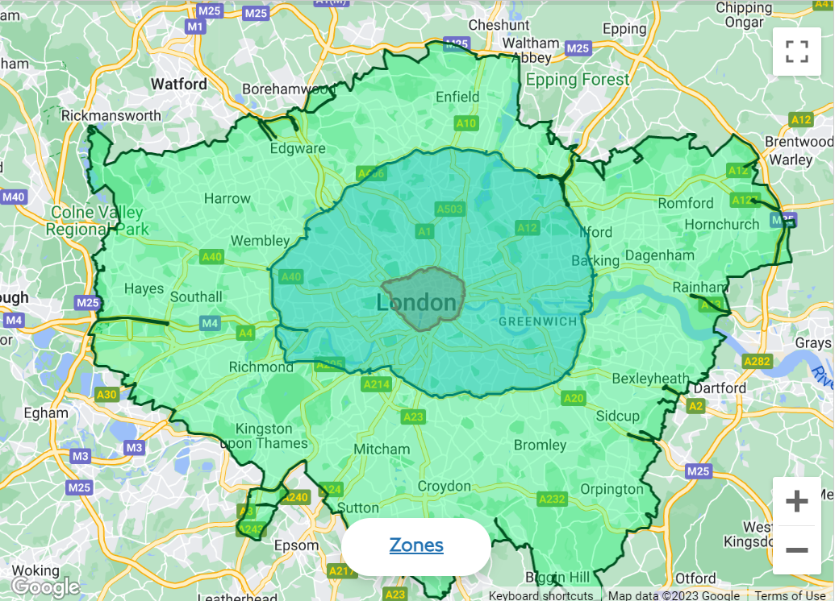
All highlighted areas show the Ulez Zone after 29 August 2023
https://tfl.gov.uk/modes/driving/ultra-low-emission-zone/ulez-expansion-2023

