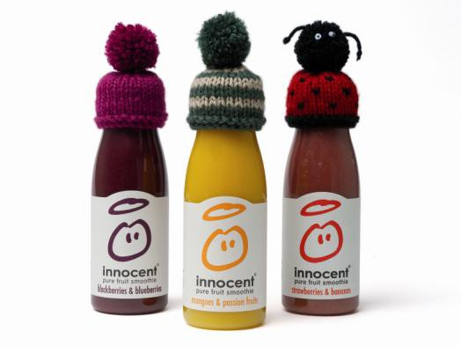
1

Completed hats form

Date:……………………………………….
Contact name……………………………………………………………..…………………………….

Address…………………………………………………………………………………………..………

……………………………………………………………………………………………………………

…………………………………………………………………………………………………………… Number of knitted hats enclosed…………………………………………………………………….. Why did you decide to take part in the Big Knit?........................................................................
………………………………………………………………………………………………………….. How did you hear about the Big Knit?.....................................................………………………… Anything else you would like to tell us?......................................................................................
…………………………………………………………………………………………………………………………………………………………………………………………………………………………………………………………………………………………………………………………………………………………………………………………………………………………………………………………………………………………………………………………………………………………………

