PART 3
Equality and diversity monitoring form | 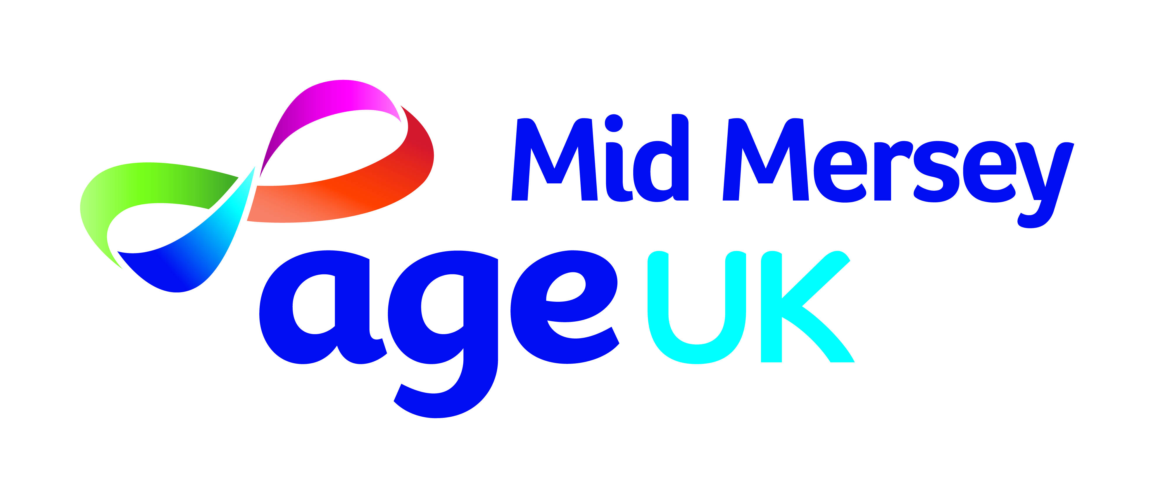
Age UK Mid Mersey is committed to eliminating discrimination and encouraging diversity amongst the workforce. Our aim is that our workforce will be truly representative of all sections of society.

As part of our monitoring processes we ask for your co-operation in completing the questions on this form. The Organisation is committed to the principles of fairness, consistency, meritocracy and equality of opportunity. No applicant will be discriminated against regardless of their age, colour, disability, ethnicity, gender or gender identity, race, religion or belief and / or sexual orientation or if you do not wish to complete this form.

The information you enter on this form will be used for monitoring purposes only.

Gender:  Male Female  Age Group:  16-25 26-35 36-45 46-55  56 -65 65 and over  Do you live and work in a gender other than that assigned at birth?  Yes No Prefer not to disclose  Please select the option which best describes your sexuality  Lesbian / Gay Heterosexual  Bisexual Prefer not to disclose  The Equality Act 2010 protects disabled people.  Do you consider yourself to have a disability?  Yes No Prefer not to disclose  If you ticked yes, please state the impairment(s) which apply to you  Physical Impairment  Sensory Impairment  Mental Health Condition  Learning Disability/Difficulty  Long-Standing illness  Other ______________________ |  | How would you describe your religion or belief:  Atheism Islam Other  Buddhism Jainism Christianity  Judaism Hinduism Sikhism  Prefer not to disclose  I would describe my ethnic origin as:  Asian  Bangladeshi Indian  Pakistani Other  Black  African Caribbean Other  White  British Irish Other  Mixed  Asian & White Black African & White  Black Caribbean & White Other  Other Ethnic Group  Chinese Other ethnic group  Undisclosed  I do not wish to disclose my ethnic origin  Thank you for taking the time to complete this form  Date completed ___________________________

