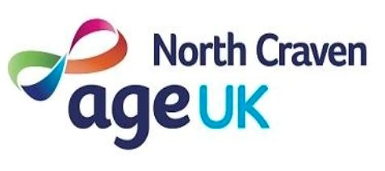

Not happy with us?
Three simple steps to follow:-

1. Most complaints and comments can be resolved by talking informally to a member of staff. Just pick up the phone or call into the office between 9.00am and 1.00pm, Monday to Friday and we will try to resolve the matter within five working days.

2. If this has not resolved your concern, make your complaint or comment to the Chief Officer in writing or by email. Use the attached form if you wish. We will investigate and give a written response within 20 working days. In exceptional circumstances a written explanation will be given within 10 working days and a full response within three months.

3. If you are still not happy you should write within 20 working days to the Chief Officer requesting a review. The review panel will consist of three people from Age UK North Craven’s Board of Trustees. The panel will meet with you within 20 working days of the request being received and will give you at least 10 days notice. You may bring a friend or relative with you. The Panel’s decision is final.

You have the right to withdraw a complaint at any stage.

Jonathan Kerr
Chief Officer
Age UK North Craven,
Cheapside,
Settle
North Yorkshire
BD24 9EW
Telephone: 01729 823066
Email: jkerr@ageuknorthcraven.org.uk

AGE UK NORTH CRAVEN

Complaints / Comments

Name: ………………………………………………………………………………….

Address: ……………………………………………………………………………….

……………………………………………………………Post Code………………...

Telephone ……………………………………………………………………………

Details of Complaint or Comment: (continue on a separate sheet if necessary)

……………………………………………………………………………………………………………

……………………………………………………………………………………………………………

……………………………………………………………………………………………………………

……………………………………………………………………………………………………………

……………………………………………………………………………………………………………

……………………………………………………………………………………………………………

……………………………………………………………………………………………………………

……………………………………………………………………………………………………………

Signature…………………………………………Date………………………….....

Jonathan Kerr
Chief Officer
Age UK North Craven,
Cheapside,
Settle
North Yorkshire
BD24 9EW
Telephone: 01729 823066
Email: jkerr@ageuknorthcraven.org.uk

