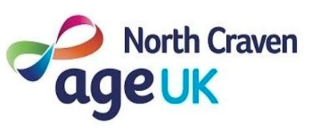

Subject Access Form to be used by third parties acting on behalf of individuals

*Please note that all fields are mandatory

Name: | Organisation:
Department: | Contact number:
Type of Request: (Report name if known) | Contact Email:
Intended Data Use: | Is the data to be shared with anyone else?
*Age UK North Craven shall respond to all data requests within 30 working days. Should you require a more urgent response, please state the reasons and timescale below:

Have you attached a copy of any documents relevant to this request? | Yes / No
If yes, please state what document(s) have been included:

Details of Data Analysis

Details of the requirement:

Date Ranges: | From: | To:
Other information:

Age UK North Craven takes its responsibilities seriously, to ensure that commercially sensitive data remains secure. We will monitor and decline requests for data if we believe it to be commercially sensitive.

Please email completed form to: | Email:  info@ageuknorthcraven.org | Telephone:  01729 823066

