AGE UK
NORTH CUMBRIA

FUNDRAISING
POLICY

Adopted March 2009
Reviewed: Jan 2025
Next Review Date: Jan 2026

Reg Charity No 1128565

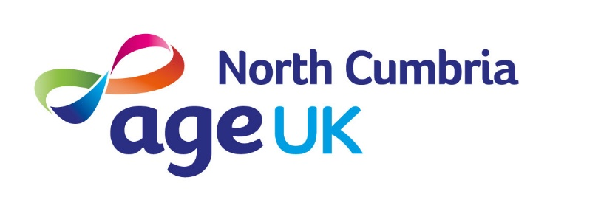

FUNDRAISING POLICY

INTRODUCTION

The Board of Age UK North Cumbria is committed to ensuring all fundraising activities are carried out in an ethical manner.

This policy applies to the Board, Employees and Volunteers of Age UK North Cumbria.

PURPOSE

The purpose of this document is to identify Age UK North Cumbria’s position on fundraising practice and to document the standards expected in raising funds.

POLICY

Age UK North Cumbria’s guiding fundraising principle is a simple one – we will only use techniques that we would be happy to be used on ourselves.
In doing so, the Organisation will adhere to the following standards:

- Fundraising activities carried out by Age UK North Cumbria will comply with all relevant laws and adhere to the Fundraising Regulators standards.
- Any communications to the public made in the course of a fundraising activity shall be truthful and non-deceptive.
- All monies raised via fundraising activities will be for the stated purpose of the appeal and will comply with the Organisation’s stated mission and purpose.
- All personal information collected is confidential and adheres to our Data Protection policy.
- No general solicitations shall be undertaken by telephone, door-to-door or approaching people in public places.
- Fundraising activities should not be undertaken if they may be detrimental to the good name or community standing of Age UK North Cumbria.
- All funds raised will be documented and audited.

CHARITY COLLECTION BOX/BUCKET PROCEDURE

All collection vessels (boxes /buckets) are the property of Age UK North Cumbria and will remain so. Collection vessels will only ever be placed in Age UK North Cumbria premises apart from special circumstances. Special circumstances will include use at external fund-raising events and activities. Permission from event / activity organisers must be sought prior to any fund-raising activity taking place.
All charity collection vessels will be supplied with a dated security seal which will only be broken by an appointed person. When full all vessels must be returned to 20 Spencer Street for emptying, this will be undertaken by an appointed person who will reseal and sign vessels for reuse.
The opening or tampering of any charity collection vessel unless authorised will be deemed as misconduct and appropriate action will ensue.
This procedure should be used in conjunction with Age UK North Cumbria’s Cash Handling Policy.

