JOB ROLE PROFILE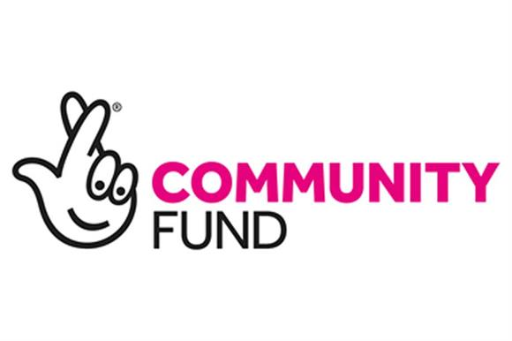
JOB ROLE Benefits Advice Worker
Responsible To Information and Advice Manager & Chief Officer
Based At Age UK North East Lincolnshire, 20 Wardall Street, Cleethorpes & 27 Osborne Street Grimsby
Hours of work 21 hours per week, worked over 3 days per week
Salary £10 per hour
Travel Allowance 45 pence per mile

Overall Role

Helping older people who want to know if they could claim welfare benefits is the most common advice enquiry that Age UK Information and Advice services deal with. The welfare benefit system is complex and older people often feel uncomfortable about discussing their circumstances and finances with government departments. Because of this it is estimated that in excess of one and half million pensioners may not be claiming the Pension Credit that they are entitled to and up to two and a quarter million are not claiming the Council Tax Benefit they are due. Age UK have developed a software package that calculates older people’s likely entitlement to welfare benefits. This role will involve you being trained and supported to provide welfare benefit checks and advice on entitlements, using this software, for older people at Age UK North East Lincolnshire. We have been very lucky to have been successful in gaining a Community Fund to provide this service ‘Coping with change’ along with funding from The Henry Smith Foundation to make sure older people who are experiencing life changes receive the knowledge, confidence and understanding to claim all entitlements and engage again into society. These life changes could be as a result of a partners death, move into permanent care, divorce, family breakdown etc. All of these changes have significant changes to peoples’ financial situation and we want to enable people to deal with these changes with all the support and help possible by our fully trained staff. .

Key Responsibilities

- Interviewing & advising older people and their carers or family about their full benefit entitlements face-to-face, over the phone and in their own homes. The completion of the welfare benefit calculation will be using Age UK’s software package
- Helping to complete claim forms for client’s e.g. Attendance Allowance, pension Credit, Blue Badge, Council tax reduction etc.
- Providing guidance to clients on ‘next steps’ to be taken after the completion of a claim form to progress their application. (mandatory reconsiderations & appeals)
- Using an in-house IT package to record all contacts with our older people called Charity Log for which training will be provided.
- Completing records of client interventions and liaising with the Information and Advice Manager & the Engagement Officer.

Previous Experience and Role Requirements

Specific previous experience is essential within a similar role or environment, along with a full working knowledge of Older Peoples Welfare Benefits. The role would suit somebody with previous experience of completing complex forms or supporting individuals with advice queries. People who have previously worked in the public sector, such as the local council, advisory services, the Department for Work and Pensions, the Health Service, emergency services or in a regulated care setting would be particularly suited to the role. Any potential employee will need to be able to demonstrate:

- Strong literacy and basic numeracy skills
- Basic IT skills
- The ability to understand written information and explain things clearly without using jargon or being patronising
- A commitment to ensuring that clients are provided with accurate, relevant and timely information and support
- The ability to write clear notes and records
- A methodical and orderly approach
- An open minded approach to individuals, avoiding judgement and stereotyping while demonstrating patience and empathy
- Provide benefit advice sessions per week whether in an office setting or at clients homes
- You will also be required to attend training and supervision meetings at Age UK North East Lincolnshire in Grimsby when needed & must be flexible to work across both the Grimsby and Cleethorpes sites when necessary
- Clean driving licence with business use for the home visiting & use of their own car
- DBS – this can be provided by ourselves
- A qualification in information, advice & guidance is preferred.
- A good geographical knowledge of the Cleethorpes and surrounding areas
- File checks & reviews
- Clean driving licence for home visiting with a good geographical knowledge of the local area

For further details and an application please either email helen@ageuknelincs.org.uk or ring and ask for an application on 01472 344976 option 1.
Closing date is strictly Friday 13th March 2020 . Please note - only those showing the essential criteria for the role will be offered an interview.

