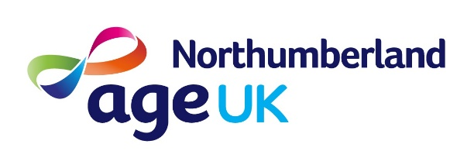

Fancy Making a Difference to older people in Northumberland?

Imagine a day when...
…you didn’t see anyone,
…no one called in,
…no one phoned, or emailed or texted or Tweeted or Facebooked you
…you had no contact with anyone else from getting up to going to bed
…you were constantly worried about food, heating, money and your safety
Now… imagine that the next day was the same, and the next and the next….
This is the reality for over 5000 older people in Northumberland.

Age UK Northumberland is the largest Charity in our County focused on improving the lives of older people in Northumberland. In 2017 we;
- secured £1.6m in benefit entitlements that would otherwise not been received
- received over 1750 enquiries to our Information and Advice Line
- delivered over 390,000 care hours
- provided over 4,000 day care services and meals
- provided over 40 exercise classes per week, helping over 11,000 people to keep fit

We are keen to add to our dynamic and committed Board and would particularly welcome more Trustees with a variety of skill sets and experiences from home care, medical and NHS backgrounds

The Board meets 4-5 times per year and Trustees are invited and encouraged to support one of our Sub-Committees.

If you would like to support us, and be part of something great for older people in our community then please get in touch. In the first instance, please contact
Andrew Marsh, Chair of Trustees at andrew.marsh@ageuk-northumberland.org.uk

