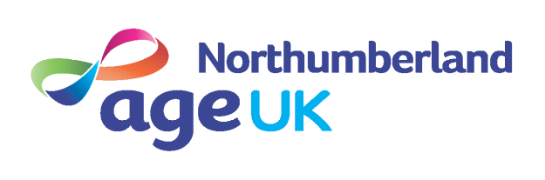

VOLUNTEER ROLE DESCRIPTION
Volunteer Receptionist

Age UK Northumberland’s (AUKN) mission is to promote the well being of people over the age of 50 in and around the County of Northumberland, helping to make life enjoyable and fulfilling.

We are looking for friendly, confident volunteers who are comfortable with being the first point of contact for Age UK Northumberland visitors to the Roundhouse in Ashington. No Experience is necessary as full training will be provided.

Anticipated Time Commitment: |  | There are a range of days (Monday to Friday) and times (10am to 4pm) available.  Volunteers also need to attend four to five meetings per annum (approx. one and a half hours) - free lunch is provided.
Expenses: |  | Travel expenses to the AUKN office. Car parking costs where appropriate.
Location: |  | Ashington : The Round House, Lintonville Parkway, NE63 9JZ
Responsible to: |  | Information & Advice Manager

Purpose of Role:
To be the first point of contact for visitors and customers to the Roundhouse in Ashington.

Expected tasks:

- Meeting and greeting visitors to the building and notifying the relevant staff when their visitors have arrived.
- Help to deal with requests from visitors and staff.
- Assist with incoming and outgoing post.
- Provide administrative support as and when required.
- Help to keep the reception areas clear and tidy at all times.
- Answering incoming calls and making outbound calls as and when required.
- Help with ordering stock.

- To attend team meetings and all necessary training, where possible.

- To comply with Age UK Northumberland’s Confidentiality, Data Protection and Safeguarding Policies and relevant Data Protection legislation.

- Comply with all other Age UK Northumberland’s policies and procedures.

- To liaise with the Administrator about rotas and inform them of any foreseeable absences such as holidays, providing as much notice as possible.

- To discuss any problem/ issues with their allocated Manager and inform them of any change in circumstances that may affect the volunteer’s ability to participate on the project or when the volunteer no longer wishes to be involved, with as much notice as possible.

- To be committed to Equal Opportunities and have an open minded approach to individuals, avoiding judgement and stereotyping while demonstration patience and empathy.

Personal Attributes

Applicants must:
- Possess a pleasant, friendly and outgoing manner.
- Have a flexible approach to work with the ability to work on own and as part of a team.
- Possess good interpersonal skills with an excellent telephone manner.
- Be able to communicate effectively (written & verbal).
- Be able to use a computer.
- Be interested in learning about Northumberland services and activities
- Be interested in learning about people’s rights and entitlements
- Be committed to continuous improvement of the Information & Advice Service.
- Have an understanding of the importance of maintaining confidentiality at all times.
- Have an understanding of and empathy for people with different backgrounds and life experiences to your own.
- Be reliable, trustworthy, honest and committed to the volunteer role
- Possess GCSE’s or equivalent in Maths and English.

Training provision: (Lisa please add what training will be provided to volunteer).

All of these arrangements are binding in honour only and not intended to be legally binding. AUKN will seek a Disclosure & Barring Service criminal record check if relevant to the volunteer role.

Please contact the Susan Chrisp, Volunteering Coordinator on 01670 784800 if you wish to discuss the role further and/or visit the office and meet some of the team.

