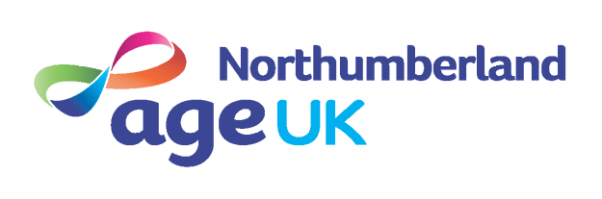

VOLUNTEER ROLE DESCRIPTION
Living with and beyond cancer Holistic Volunteer

Age UK Northumberland’s (AUKN) mission is to promote the well being of people over the age of 50 in and around the County of Northumberland, helping to make life enjoyable and fulfilling.

Anticipated Time Commitment: |  | Most volunteers commit one day per week, with additional expectation to attend team meetings and training sessions as required.
Expenses: |  | Travel expenses to the AUKN office to staff the advice line, attend meetings and attend training. Car parking costs where appropriate.
Location: |  | Ashington : The Round House, Lintonville Parkway, NE63 9JZ
Responsible to: |  | Project Co-ordinator

Living With and Beyond Cancer – Purpose of the role

Due to significant improvement in cancer survival rates over the last 15 years there are currently 2.5 million people living with cancer in the UK. More than half of people receiving a cancer diagnosis will now live ten years or more and need to live well.
The Living With and Beyond Cancer Project is a national transformation programme which aims to improve patient experience by introducing The Recovery Package, a combination of different interventions which when implemented can improve outcomes and co-ordination of care. We are looking for volunteers to work across Northumberland to support this national initiative.

Volunteers will receive the relevant training and support to enable them to carry out this role

Main duties
- To undertake individual holistic health needs assessments in hospital, primary care and community settings.
- To undertake care and support plans in collaboration with a health professional which will be agreed with the patient and shared with the local health professionals
- To signpost patients to services in the community which help maintain their lifestyle, health and wellbeing such as finance, physical and mental health.
- To adhere to relevant Age UK Northumberland policies and procedures such as confidentiality, health and safety, and equal opportunities

Your role will require you to:
- Establish and maintain an effective working relationship with patients living with a cancer diagnosis and their carer/s, to enable you to provide appropriate support.
- Undertake holistic needs assessment training and any other necessary training required to support the role.
- To act as a conduit to community support for those living with a cancer diagnosis
- Engage and participate in training sessions organised generally for Age UK volunteers (e.g. safeguarding) and more specifically for Living Well Link Service volunteers.

Person specification
- A keen interest in supporting patients Living with and Beyond Cancer
- Excellent inter-personal and communication skills
- An understanding of the need for confidentiality
- To be reliable and trustworthy
- Ability to keep clear and concise records
- Willingness to engage in training and attend an induction meeting
Expenses
- Expenses incurred via the volunteering role will be reimbursed in relation to travel and any other agreed expense.
Training provision: Training in the use of Age UK’s computer record system will be given.

All of these arrangements are binding in honour only and not intended to be legally binding. AUKN will seek a Disclosure & Barring Service criminal record check if relevant to the volunteer role.

Please contact the Volunteer Co-ordinator, Susan Chrisp on 01670 784 800 or email susan.chrisp@ageuk-northumberland.org.uk if you wish to discuss the role further and/or visit the office and meet some of the team.

