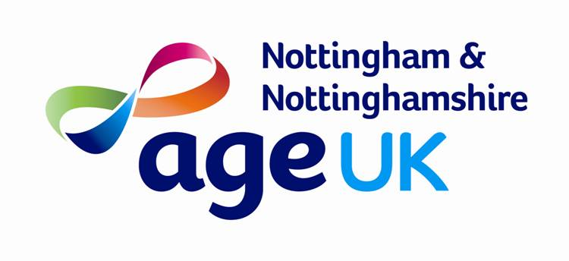

About Age UK Nottingham
& Nottinghamshire

Age UK Nottingham & Nottinghamshire (formally known as Age Concern Nottingham and Nottinghamshire) is the largest independent local charity providing direct services to older people from all communities and backgrounds in the city and county. We aim to enhance the quality of life and promote the health and wellbeing of all older people.

Age UK Nottingham & Nottinghamshire are partnered with Age UK nationally. As part of the family of over 400 Age UK and Age Concern charities we work at a local level for all older people. We support our local communities with a range of dedicated support services, from Advocacy and Health & Wellbeing, to Information & Advice and Home Safety.

The Age UK Nottingham & Nottinghamshire Philosophy

Age UK Notts is committed to our Mission Statement which is to “enhance the quality of life and promote the health and well-being of all older people in Nottingham & Nottinghamshire”. This is why the charity exists and all staff and volunteers, no matter what their role is, contribute to the fulfillment of this mission.

Age UK Nottingham and Nottinghamshire (Age UK Notts) is very much a people orientated business driven by core values that focus on dignity and respect for older people – and for our employees and volunteers. Which means we are looking for individuals who can safeguard this commitment. We aim to ensure that all people with whom we work are valued for their contributions and are given the opportunity to realise their full potential within the organisation.

The quality of what we do is very important and we see our staff and volunteers as the key to our success. We have been awarded the Queens Award for Voluntary Service, the highest award a voluntary group can receive in the UK. We have passed the Age UK quality assessment (which is recognised by the Charity Commission), which has meant that we have held the “Members Quality Standard” endorsement since 2008. We also have the Mentoring & Befriending Approved Provider status for our Visiting Services, are recognized by the Armed Forces Covenant scheme (Bronze Award) for our commitment as an employer for defence personnel, and are proud to be a Living Wage employer.

Furthermore, in line with current legislation, as an employer of staff and as a deployer of volunteers, we aim to ensure that all job applicants, staff and volunteers do not experience unfair discrimination. Recruitment, selection and other procedures try to ensure that individuals are given equal opportunity in recruitment, training and promotion, and are treated on the basis of their relevant abilities and merits according to the requirements of the job. As such, we are proud to be a member of the Disability Confident scheme.

What we do

In 1942, Age Concern Nottingham and Nottinghamshire was born, with only a handful of committed volunteers. Today, Age UK Nottingham & Nottinghamshire employ nearly 100 staff, have over 400 dedicated volunteers and we help over 40,000 people every year.

This last year has seen continued growth of the charity with more services and support being given to local older people. Age UK Notts has provided direct support and independent advocacy services, housing services and enabled over £2.2 million of benefit gain for local older people through our benefit advice services. As well as this we continue to encourage older people to have a voice, either directly or via Age UK Notts.

Age UK Notts is also proud to have established the Age UK Business Directory in 2008, the first web-based directory to be developed specifically for older people by Age UK. The website is designed to connect older people to a wide variety of local companies and organisations offering reasonable, reputable and reliable products and services. It can be found at:
www.aubdnotts.co.uk

