Invitation to Tender for a Furniture Collection & Delivery Service
Background
Age UK Nottingham & Nottinghamshire (Age UK Notts) - registered charity number 1067881 - enhances the quality of life and promotes the health & wellbeing of all older people.
We are the largest local independent charity providing a wide range of services for older people from all communities and backgrounds in the city and county.
Last year we helped over 42,000 older people.
Age UK Notts runs a charity shop at 26-28 Regent Street, Mansfield, Nottinghamshire, NG18 1SS which sells second hand furniture. The furniture is donated by members of the public and then sold at the shop, all of the profits go to Age UK Notts to enable it to provide help and support to older people across Nottingham & Nottinghamshire.
Current Furniture Collection & Delivery Service
Age UK Notts currently owns a Luton van with a tail-lift which it uses to collect and deliver furniture. The collection & delivery service is provided by one paid member of staff and a team of volunteers. We currently pick up around 25 items of furniture each week and make around 25 deliveries per week. The items of furniture include wardrobes, beds, shelf units, tables, chairs, arm chairs, settees, etc.
Future Furniture Collection & Delivery Service
We will be changing the model that we use to collect and deliver furniture. We will be out-sourcing this service to several delivery companies. The model for the collection and delivery will be decided by those tendering for the service the following are areas that either must be provided and areas where the delivery company who tenders has the option of using the existing resources if they wish.
Optional areas – please indicate in your tender whether you intend making use of these:
- Age UK Notts has a team of volunteers, we can provide at least one volunteer to support the collection and delivery of furniture between 9.00 and 2.00 Monday to Friday, and we will endeavour to provide cover for occasional Evenings and Weekends. Age UK Notts will ensure any vacancies amongst the volunteer team are filled as quickly as possible, the charity will also provide training and will provide the formal support for the volunteers.
- Age UK Notts has a Luton van with a tail-lift which could be made available to the delivery company, the charity will provide a substitute vehicle if this is off the road for any reason. The charity will keep the vehicle in good, safe repair, it will pay for any repairs, servicing MoT and insurance but NOT fuel.

Essential areas
- If the delivery company decides that it will use Age UK Notts volunteers they will ensure the volunteer is supported and valued during the time they are volunteering for this service. The delivery company must report any concerns about a volunteer to the shop manager as soon as they come to light. The delivery company will work with the shop manager to ensure volunteers operate in a safe way and that they enjoy their volunteering.
- If the delivery company uses the charity vehicle it will pay for fuel. The delivery company must also store the vehicle in a safe, off the road location which is agreed by the charity.
- Collection of furniture and smaller items from anywhere within a 15 mile radius of the shop (see Appendix 1).
- Assessment of the furniture which is being donated to ensure the items are appropriate - stock which will sell and has fire safety label attached, where appropriate (see appendix 2).
- Promoting the Gift Aid scheme and completion of paperwork when making a collection, including Gift Aid details. Ensuring all furniture is marked with the Gift Aid reference number.
- Delivery of the collected items to the Charity Shop.
- Collection of purchased items from the Charity Shop and delivery to the customers house.
- Excellent customer service is essential, whilst we are contracting out our collection and delivery service the contractor will be acting on behalf of the charity and we expect them to have high standards of customer care.
- The delivery company must ensure they drive in a safe and courteous manner as they will be providing this service on behalf of the charity.
- The delivery company must complete all the paperwork requested, we will seek to keep this to the minimum required to run an effective and efficient service.
Pricing Structure
The tender must specify whether the delivery company will be using:
- the charity volunteers
- the charity vehicle
The delivery company must submit a price based on either:
- The number of miles travelled to collect and deliver items of furniture
- A fixed hourly rate to provide a collection and delivery service for an average of 20 hours per week, the hours of operation are usually 9.00 and 1.00 Monday to Friday, however, Evening and Weekend Service would also be required, should demand necessitate thisAppendix 1
Map showing places within a 15 mile radius of the shop
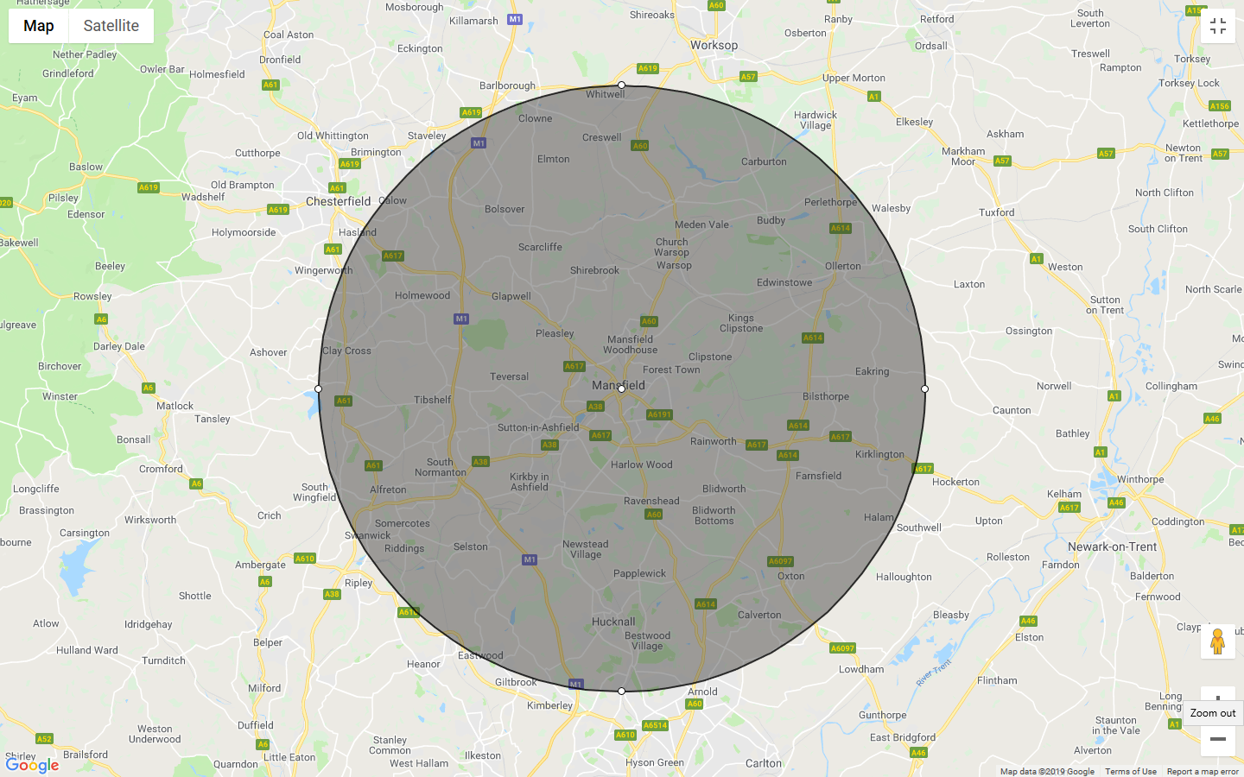

Appendix 2
Fire Safety Labels
In order for us to be able to sell the items that are being donated, some of them have to meet certain safety standards.
British safety specification
We can only accept upholstered items if there is a label attached that lets us know it meets UK safety standards.
Mattresses and upholstered bed bases have to be in a good clean condition with no rips, tears or stains. The items must also have a fire label sewn in, which refers to BS7177 - which is the British safety specification for resistance to ignition of mattresses, divans and bed bases.
Fire safety labels
There are two versions of a fire label as shown below. They are permanent and will be sewn into or stapled to the item.
We cannot accept items where the labels are not on each individual item. The fire label may be on any external surface of the item including underneath removable seating and cushions. Batch numbers must be present and legible on fire labels.

