Gift Aid Declaration Form

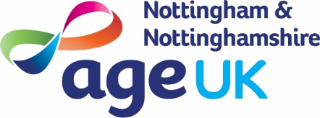
Please complete this form using a ballpoint pen, and post to: FREEPOST License No. RSXB-LZBY-TCSS, Age UK Nottingham & Nottinghamshire, 12 Shakespeare Street, Nottingham, NG1 4FQ (You can help us save money by using a stamp, please omit the Freepost line in the address).
Your details (please use BLOCK CAPITALS)
Title | First name | Surname
Address |  | Date of birth
 | Postcode | Telephone
Save us money*
Email and text are inexpensive ways for us to keep you updated about our work. Please provide your email address and/or mobile number if you’re happy for us to contact you in this way*.
Email |  | Mobile

You can make your gift worth even more, without costing you a penny!
Simply tick the Gift Aid box. 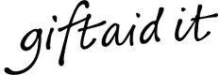

□ I declare that I want Age UK Notts to treat all donations that I make now, in the future and any made in the past 4 years as Gift Aid donations until I notify the Charity otherwise.
We will be able to claim tax back if you pay an amount of Income Tax and/or Capital Gains Tax in each tax year (Council Tax and VAT do not count) at least equal to the tax that we will claim from HM Revenue & Customs on your Gift Aid donation(s), e.g. 25p of tax on every £1 you donate.

Signature | Date

Please notify us if you:
Wish to cancel this Gift Aid declaration Change your name or home address
No longer pay sufficient tax on your Income Tax and/or Capital Gains Tax

If you’re a higher rate taxpayer, you must include all your Gift Aid donations on your Self-Assessment tax return if you want to receive the additional tax relief due to you.

*Just to let you know that we will hold the information that you give us securely. We will not share your information with other companies, outside Age UK, without your permission. We would like to keep in touch with you to let you know about the vital work we do for older people, our products and our services. You can tell us anytime if you no longer want us to keep in touch with you: info@ageuknotts.org.uk or by phone on 0115 844 0011. Our full privacy notice can be found on our website.

We, and those we support, greatly appreciate

Age UK Nottingham & Nottinghamshire is a registered charity number 1067881 and company limited by guarantee, registered in England and Wales no. 3455485. Registered office: 12 Shakespeare Street, Nottingham NG1 4FQ. Royal Patron HRH: the Prince of Wales KG KT GCB.

V2.1/2019.03.18

