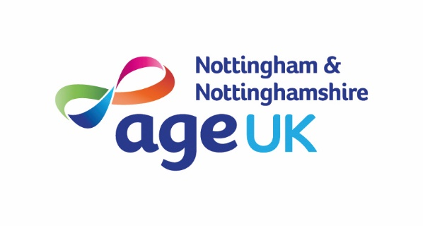
Sponsorship Form
Please sponsor me to (event) ……………………………………………………………………………….…………………………..
on (date of event) ………. / ………. / ………. in aid of ……………………………………………………………………………….
Please help me reach my target of £ ………………..

How to use your sponsorship form…  - Please ensure you fill out each section in full.  - Please ensure the details of each donation are recorded accurately by your sponsors in their own handwriting – forms in the same handwriting or printed are not valid for Gift Aid purposes.  - Please ensure each sponsor ticks the Gift Aid box if eligible.  - In order for us to claim Gift Aid, we need each sponsor’s title, first name, surname, full home address, postcode, Gift Aid declaration and donation amount (N.B. We cannot claim Gift Aid on business addresses or on multiple sponsors e.g. Mr & Mrs Bloggs). |  | Gift Aid – Very Important!  Age UK Notts can claim an extra 25% back from the government on every donation, without costing you a penny extra.  Please tick the box below if you would like us to Gift Aid your donation. Please make sure we can read your full name, home address and postcode. This supports our tax claim and will not be used to contact you.  By ticking the Gift Aid box you declare that you want Age UK Notts to treat all donations that you make now, in the future and any made in the past 4 years as Gift Aid donations until you notify the charity otherwise.  We will be able to claim tax back if you pay an amount of Income Tax and/or Capital Gains Tax in each tax year (Council Tax and VAT do not count) at least equal to the tax that we will claim from HM Revenue & Customs on your Gift Aid donation(s), e.g. 25p of tax on every £1 you donate .  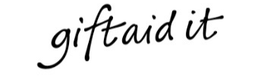  Tick here for Gift Aid
YOUR DETAILS
Full Name
Home address
Postcode | Telephone
Email

SPONSOR DETAILS (must be completed in your sponsor’s own handwriting to qualify for Gift Aid)
Title | First name | Surname | Full Home address | Postcode | Amount | Gift Aid | Date Paid
Mr | Joe | Bloggs | 1 Any Road, Town | AB1 2CD | £20.00 |  | 05/06/19
Title | First name | Surname | Full Home address | Postcode | Amount | Gift Aid | Date Paid
Mr | Joe | Bloggs | 1 Any Road, Town | AB1 2CD | £20.00 |  | 05/06/19
I’ve raised a total (not including gift aid) of |  |  |  |  | £
Total Gift Aid Donations |  |  |  |  | £
NEXT STEPS
Simply collect your donations from your sponsors and send us a cheque made payable to
‘Age UK Nottingham & Nottinghamshire’ (please do not send cash) along with this Sponsorship Form and the Paying-In Form to: Age UK Notts, The Lifestyle Centre,16-18 Bridgeway Centre
Nottinghamshire, NG2 2JD
We would like to keep in touch with you to let you know about the vital work we do for older people, our products and our services. We will hold the information you give us securely. We will not share your information with other companies, outside Age UK, without your permission. You can withdraw your consent to be contacted at any time by calling 0115 8440011 or email info@ageuknotts.org.uk.
Please see our privacy policy at https://www.ageuk.org.uk/notts/privacy-policy/ for full details. Let us know how you would like us to keep in touch by ticking the relevant boxes:
POST: □ Yes □ No E-MAIL: □ Yes □ No TEL: □ Yes □ No SMS: □ Yes □ No
Thank you for your support

