Volunteering Opportunities Matrix October 2021
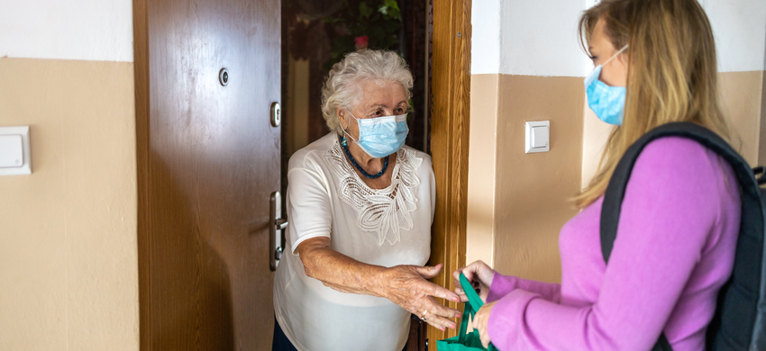

You can make a difference to the lives of older people in Nottingham and Nottinghamshire.

People of all ages and all walks of life volunteer for Age UK Nottingham & Nottinghamshire and we couldn’t do our work without them. Below are all the volunteering opportunities that the charity currently offers.

Role  Title | Volunteer Shop  Assistants  (West Bridgford)
Location | Age UK Notts, 28a Gordon Road, West Bridgford,  Nottingham, NG2 5LN
Time Commitment | A minimum of a morning or an afternoon –during shop opening hours which are 9.30am – 4.00pm Tuesday -Saturday  We are not looking for Saturday Volunteers at the moment
Tasks | - Ensuring customers experience excellent customer service  - Maintaining the look of the shop displays so that customers have a positive shopping experience  - Restocking shelves and rails as and when needed  - Maintaining a tidy, clean and safe shopping / working environment  - Taking and processing payments from customers (including card payments following appropriate training)  - Sorting through donations  - Using the internet to share real-time information on Social Media
Skills / interests needed | - An enjoyment of chatting with customers and offering good customer service  - An ability to get on well with others and to volunteer as part of a team  - A calm, sensitive, personable and positive approach  - A willingness to learn how to use the shop tills and to process card payments  - Ability to use/willingness to learn and have access to the internet to share information on social media
Process | Application Form  Interview  References will be taken  Basic DBS check
Training | Induction plus online training specific to the role

Role  Title | Dementia Support Volunteers  (required for a January 2022 start with applicants being taken now)
Location | The Sybil Levin Day Care Centre is located approximately 3 miles outside of Nottingham City Centre (NG8 6AD) and is easily accessible by car, bus and tram.
Time Commitment | A minimum of either one morning or one afternoon on a weekly basis (Mon-Fri). Specifics to be discussed at interview.  Please note that this role requires volunteers who can support on a long-term basis (min 6 months). This volunteer role is not suitable for students seeking work experience placements who only require a specific number of hours volunteering.
Tasks | The Sybil Levin Day Service is a specialist SPECAL-Led day service supporting people with dementia and their carers using the SPECAL method.  The tasks you may be involved with include the following:  - Assisting centre attendees to engage in activities  - Serving meals and drinks.  - Helping to set up and clear away activities  - Engaging in conversation with centre attendees.
Skills / interests needed | - People with a genuine interest in the wellbeing of people with dementia.  - A friendly, sensitive and kind approach.  - Being comfortable in small groups or on a one to one basis.  - People with a commitment to using the SPECAL method at all times whilst at the centre.
Process | Application Form  Interview  References will be taken  Basic DBS check
Training | Induction plus online training specific to the role  You will also receive SPECAL training prior to commencing your role

Role  Title | Volunteer Befrienders (Visiting)
Location | Service User will be local to your post code  We are recruiting for volunteers in selected poscodes with good weekday DAYTIME availability
Time Commitment | Minimum of one hour per week, every week
Tasks | - Visiting older person/s in their own home/s (or telephoning them) on a regular basis  - Providing friendship and companionship  - Chatting and socialising  - If possible and where mobility of older person allows it you can :-  - Go on a walk with an older person in the local community  - Take the older person out for a cuppa and a chat  - Shop with them (not for them)  - Encourage them to take up new activities if they would like to and if you have the time to, accompany them on their first visit
Skills / interests needed | - Individuals with a genuine interest in the wellbeing of older people  - Flexibility  - Ability to travel to individual addresses in the local community either by car or by public transport
Process | Application Form  Interview  References will be taken  Enhanced DBS check
Training | Induction plus online training specific to the role

Role  Title | Volunteer  Big Knitters
Location | Wherever you love to knit
Time Commitment | As and when you choose
Tasks | For each hat knitted, Innocent give 25p to Age UK Notts. Knit as many little hats as you can – we provide the patterns!
Skills / interests needed | An ability to knit
Process | None
Training | None

For more information about any of these roles, please contact:

Vicky Pearce (Volunteering Co-ordinator)

Tel: 0115 8414 464

Email: volunteering@agekuknotts.org.uk

is the highlight ”

