
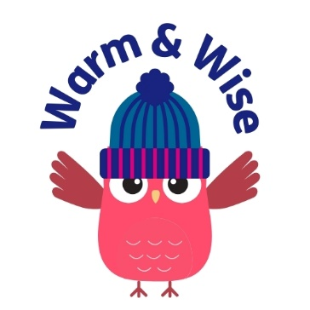

Name of Referrer
Organisation
Date of Referral

Contact Email Address
Contact Telephone Number
Has the individual consented to be referred to Warm & Wise?
(Yes/No and additional comments)

Individual Being Referred Contact Details
Name
Telephone Number(s)
Email Address

Address
Date of Birth
Best Time to Contact
Preferred Method of Contact

Does the individual have any additional needs relating to e.g. health, communication, neurodiversity?

Alternative Contact Person (If required)
Name and Contact Number

Risk Assessment (please detail anything that Age UK Notts needs to know prior to visiting the person at home so that we can ensure the health and safety of our lone workers)
Smokers In the House?
Pets In the House?
Any Known Safeguarding Issues?
Any other known risks, please give more detail?

Accommodation Detail
Tenure?
Property Type?
How Many People in Household?
How Many Bedrooms?

Reason for referral to Warm & Wise (please specify any specific concerns)

Please return via email to: warmandwise@ageuknotts.org.uk
Should you require assistance or have any questions, please call:

0115 8599 209

