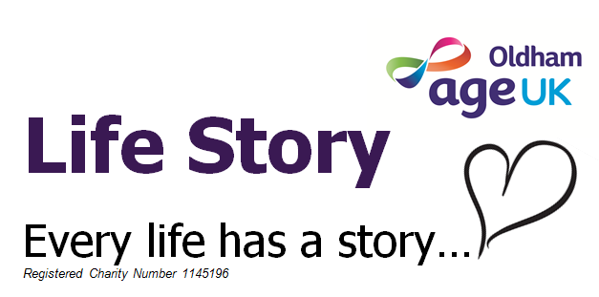

Life Story

Everyone’s life story is individual and important and we would like these stories to come together in a personalised Life Story Book that can be shared with families, friends and Care Staff time & time again….

Use this form to record details about your relative, friend or resident from conversations you have with them, helping them to share memories, feel valued and chat with someone who is interested in finding out about their life.

Include any details they or you would like to be included in their own Life Story Book. You don’t need to include everything on this form, use it just as a guide. Include as much or as little information as you like and feel free to include stories or any info that isn’t prompted in the form as well.

We would also love to include photographs and/or documents that would aid memories and conversations. Any photographs etc. passed to us will be handled carefully, scanned and returned to you as soon as possible. Don’t worry if you don’t have many /any photographs, our volunteers will ensure the book has relevant illustrations appropriate to the personal life story.

Once this form has been completed, please return it to one of our Life Story Project Workers here at Age UK Oldham – Life Story Project, 10 Church Lane, Oldham OL1 3AN - who will arrange for the Life Story book to be produced and after a final check a bound copy can be presented to the recipient to keep and share

Name |  | Date of Birth
Name |  | Age
Address

Person Completing Form:
Name
Relationship
Contact – telephone
Contact - email
Date From Completed

Are they: | Visually impaired? | Yes No | Have any hearing impairment? | Yes No
Size of font required for the book (use font size guide on back page)

Birth, Parents, Home & School
Birth
- When were you born?

- Where were you born?

- Which hospital were you born in?

- Do you remember the address where you were born?

- Did you have any brothers or sisters?

- What are their names and ages?

- Were they older or younger than you?

- How did you get on with each other?

- Any other details you remember?

Parents

- What were your parents called?

- How did they meet / when did they marry?

- What jobs did they have, where did they work / when?
- Which company? Did they work together?

- Did they work in a mill? Which room did they work in, what was their role?

Home
- What sort of house and neighbourhood did you live in?

- What was your address?

- Did you have other family members living nearby? If so, where did they live?

- If they didn’t live nearby where did they live?

- Who were your friends near where you lived?

Education

- Which schools did you attend?

- Where were they?

- Did you like school?

- Do you remember any of your teachers? Did you have a favourite teacher?

- Who were your friends at school?

- What games did you play?

- Where you in any teams or clubs at school?

- Did you learn to play a musical instrument or have singing lesson at school?

Teens / Young Adult Life
- What did you do as a teenager?

- Interests, hobbies, activity

- Were you in any clubs or associations? E.g. guides, scouts, sports, etc.

- Where? – e.g. which dance halls? Where was your favourite fishing place? Where did you like to go walking, which cinemas did you go to?

- Where did you live? What was your address? Which street did you live on?

- Did you still have the same friends that you had at school?

- Did you have other friends outside school? If so, who were they?

- Do you have any funny stories from this time? Choose the most memorable!

Working Life
- Where did you work?
What was the organisation called, how long did you work there?

- When was that?

- What was your job, what was your position?

- What did your job entail? Did you have to have any training for your job?

- Were you happy there?

- Why/not?

- People you remember

Adult Life
Social life and friends
- Where did you go socially as an adult?

- Did you meet Boys / Girls?

- Did you get married?

- What is/was your husband/wife called?
- How did you meet?

- What are your memories of your wedding day?

- Did you have a wedding reception?

- What did you wear?

- Who were your bridesmaids / Bestman? What did they wear?

- Divorced/widowed?

- Important dates i.e. wedding anniversary

- What were your interests & hobbies

- Who were your friends?

Own family

- Do you have any children?

- What are they called?

- When were they born?

- Where were they born?

- Where did you go on holidays, outings?

- Which resort or hotel?

- Did you go abroad?

- Do you have any grandchildren?

- Please give details about who the parents of the grandchildren are.

- What are they called/how old?

- Where do they live?

- Did you have any pets?
What were they called? What breed of dog?
What colour?
Big, small?

- Give some examples of special events you remember, e.g. birthdays, anniversaries, etc?

PRESENT DAY LIFE

Present Day Life
- What are your interests / activities? E.g. reading, knitting, watching sport?

- What are your favourite things? Activities or objects, trinkets, jewellery, photos, art, etc?

- What is your favourite colour?

- What are your favourite flowers?

- What is your favourite sport? Rugby, football, cricket, athletics? Do you support a particular team?
- What foods do you like / dislike?

- Do you enjoy watching TV, films etc? Which ones?

- How about listening to music? What type of music do you like?

- Who are your favourite artists or bands?

- What would be your perfect day?
- Where would you go?
- What would you do?
- Who would be there?

- Who are the important people in your life?

- If you could learn something new today like a new skill or a hobby, what would it be?

- If you could go somewhere you have always wanted to go, where would it be?

Please also include anything else you would like to be included in your Life Story book

Have you included any photographs with this form? | Yes / No | How many?
Where shall we return the photograph to?

My Family Tree

Mum |  |  |  |  | Dad
 | Me |  |  | Wife / Husband
Children
Grandchildren
Great Grandchildren

This is size 16 wording. Can you read this?

This is size 18 wording. Can you read this?

This is size 20 wording. Can you read this?

This is size 22 wording. Can you read this?

This is size 26 wording. Can you read this?

This is size 30 wording. Can you read this?

This is size 34 wording. Can you read this?

This is size 36 wording. Can you read this?

OLDHAM LOCAL STUDIES AND ARCHIVES
84 UNION STREET, OLDHAM, OL1 1DN
Tel 0161 770 4654
email: archives@oldham.gov.uk

Terms of Agreement for the donation of the Life Stories

I give permission for the life story of ……………………………………………… to be donated to Oldham Local Studies and Archives

The life story will be made available for study free of charge at Oldham Local Studies and Archives

Copy right of the life story will be given to Oldham Local Studies and Archives

Oldham Local Studies and Archives may charge for any copies made from the life story

Signature……………………………………………………………………………….

Name………………………………………………………………………….………..

Date ……………………………………………………………………...…………….

