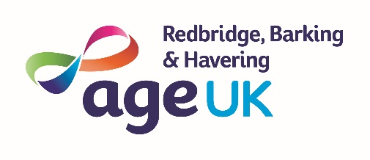
Trustee Role Description
Age UK Redbridge, Barking and Havering

Introduction

The Board of Trustees of Age UK Redbridge, Barking and Havering are collectively responsible for the overall governance, strategic direction and financial health of the charity. As a trustee, you will have the ultimate responsibility for the running of the charity, including its property, finances and employment of staff and volunteers.

Principal Responsibilities

General
- To contribute actively to the Board in giving clear strategic direction to the charity, determining policy, defining goals, setting targets and evaluating performance against agreed targets;
- To work with the Board Chairman, Chief Executive and other Trustees to develop the effectiveness of the Board;
- To act as an informed and influential ambassador for the charity externally;
- To ensure continued improvement to achieve and maintain an excellent standard of service to beneficiaries;
- To comply with the charity's code of conduct and professional standards by behaving in a professional manner at all times; promoting charity policies including equality and diversity;
- To establish a constructive relationship with, and provide support to the Chief Executive, staff and volunteers, observing proper boundaries of responsibility at all times

Governance and finance

Individual and Collective
- To ensure that governance standards comply with the NCVO Code of Good Governance 2005, the Charities Act 2011 and the Companies Act 2006;
- To ensure that the charity complies with its governing documents, and any other relevant legislation or regulation;
- To ensure the effective and efficient administration of the charity;
- To ensure the financial stability of the charity;
- To safeguard and protect the assets of the charity and ensure the proper investment of its funds;
- To monitor the use of any powers delegated to committees, the Chair, the Chief Executive and others which enable the business of the charity to be carried out effectively between meetings.

Strategy and planning

To participate in:
- Planning for the charity's future by setting strategic direction through business plans and monitoring progress on a regular basis;
- Contributing to workshops, Board meetings and external meetings that are relevant for informing the charity’s strategy;
- Developing and agreeing the Charity’s strategic plan, ensuring that is effective in meeting the needs of beneficiaries and that the resources (staff, skills, finance) are in place to deliver it.

NB - No role profile can cover every issue that may arise. The post holder would be expected to carry out other duties from time to time, which are broadly consistent with those described.

Trustee - Person Specification
- Commitment to the charity and acting as an ambassador, and in its best interests at all times
- Willingness to devote the necessary time – there are six Board meetings each year, lasting about three hours. This is the minimum time commitment.
- Ability to think strategically to further the interests of the charity
- Ability to exercise good, independent judgement
- Understanding and acceptance of the legal duties, responsibilities and liabilities of trusteeship and compliance with the policies of the charity as they apply to trustees
- Ability to work effectively as a member of a team
- Ability to exercise tact and diplomacy
- Good communication and interpersonal skills
- Impartiality, fairness and the ability to respect confidences
- Commitment to the Nolan's seven principles of public life: selflessness, integrity, objectivity, accountability, openness, honesty and leadership.

It would be beneficial for a trustee to have a general understanding of charities and the voluntary sector. It is desirable for a trustee to have some knowledge of health, social care or older people.

