Autumn Wreath Tutorial

For this week we fully came to terms with the arrival of Autumn. We actually even celebrated it with a lovely watery image inspired by the golden leaves!

For our image we started with creating one big circle- this helped us position our leaves in a wreath like shape. You can of course create a loose image of fallen leaves, so you can skip this step.

We then painted 3 types of leaves which we placed around the circle. We had oak leaves, maple leaves and almond shaped leaves.

The drawing stage was done in watered down yellow. If there were gaps we filled those in with acorns and conkers.

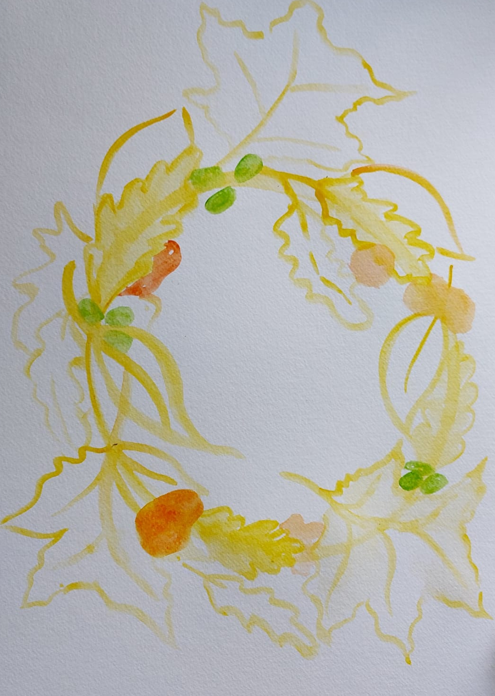

We used the wet on wet technique to paint the maple leaves.

My colour palette has yellow, orange, ochre, brown, reddish brown and green.

We went around our leaves and painted them with a first layer of colour. This was fairly watered down. For the oak and the almond shaped leaves we used a wet on dry technique.
Some leaves had more colours, others were painted with a uniform layer of colour.

This is a very organic and spontaneous process, where we allowed our creativity and imagination to lead our way.

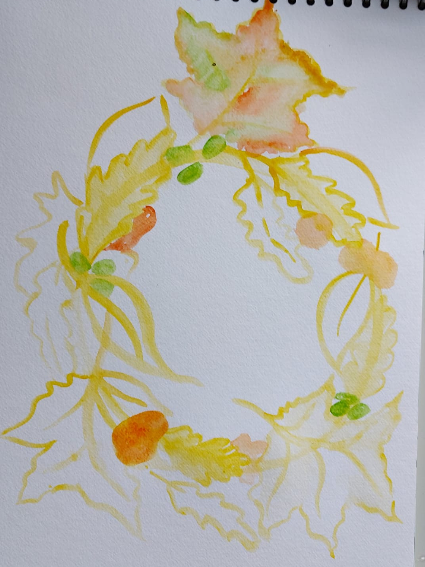

We continued to work on the leaves; when we were happy with their look we allowed the colours to dry. With this subject matter, watercolours work great.

Colours can be as fluid or as uniform as you want. It will look beautiful either way!

After the second layer dried, we went on to create some details, using bright tones such as green and yellow. We painted the leaves’ veins and added details to our conkers.

We let it dry…

I like my paintings to be very rich, so when I encountered gaps I decided to add extra leaves or acorns or conkers. This is a personal choice!

We let this layer dry as well.
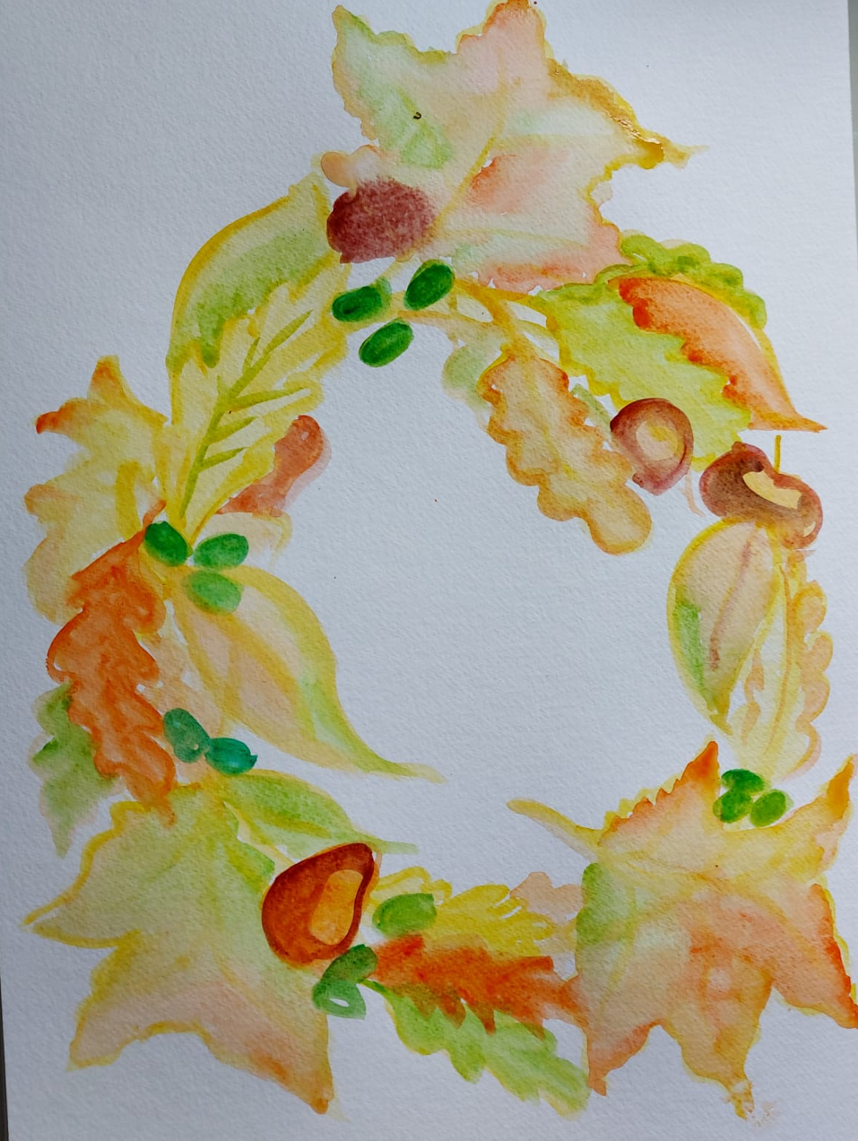
The final layer used stronger and darker colours to emphasise details. We used it in decorating some of the leaves. We also added some contours here and there to bring forwards the painted leaves, giving the sensation of light and shade.

Avoid painting dark contours around the whole painting as it then becomes cartoonish rather than three dimensional. When I add contours to the leaves I leave out some gaps. This gives a more artistic effect.
We also added some shades to the conkers and the acorns.

And Voila!

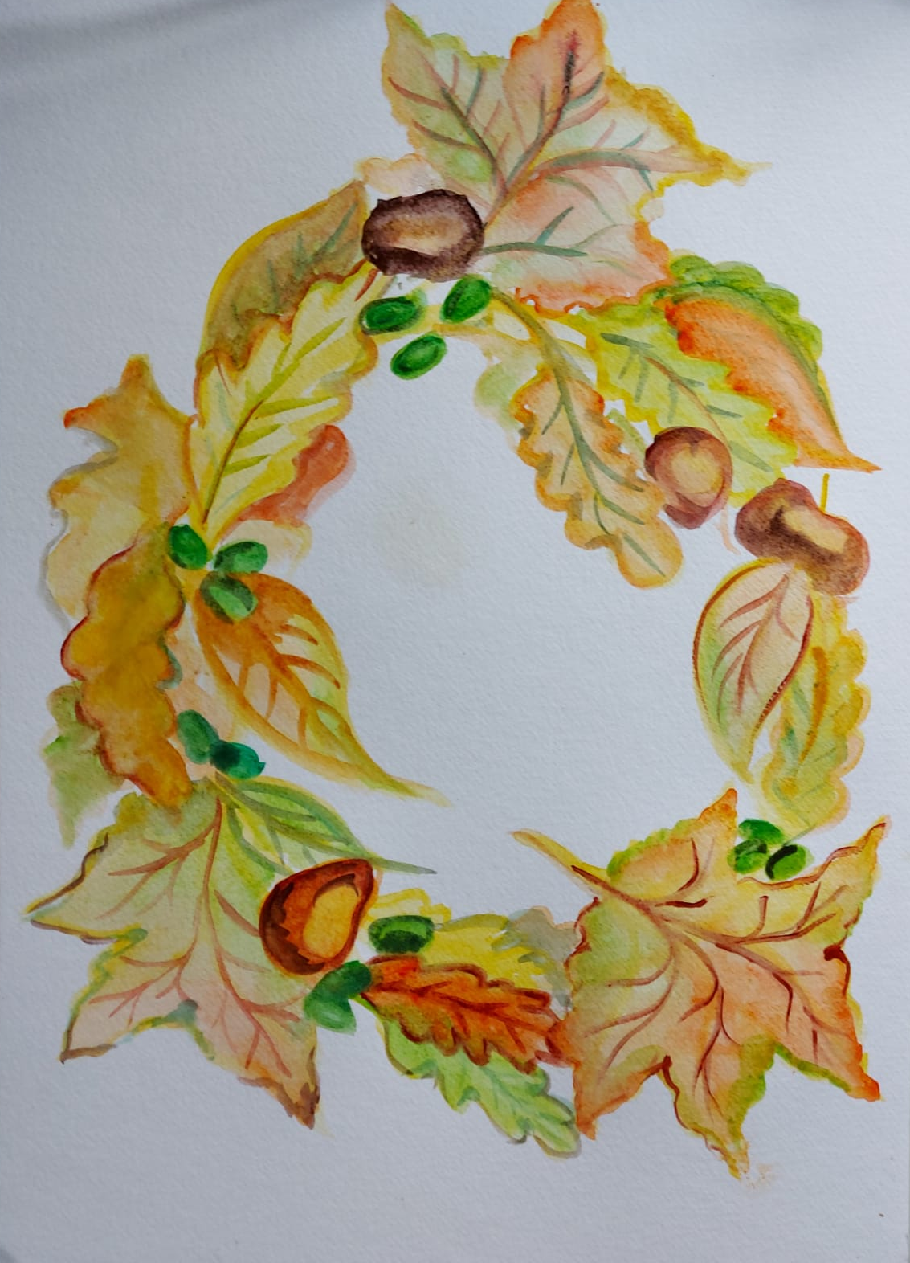
What do you think? Are you feeling inspired by autumn? Would you give this a try?
If so please share your results with us!

I am looking forward to next Monday!
Best Ioana

